AP WORLD 2021-22 - KELLY Name:

Period:

UNIT 9: Globalization
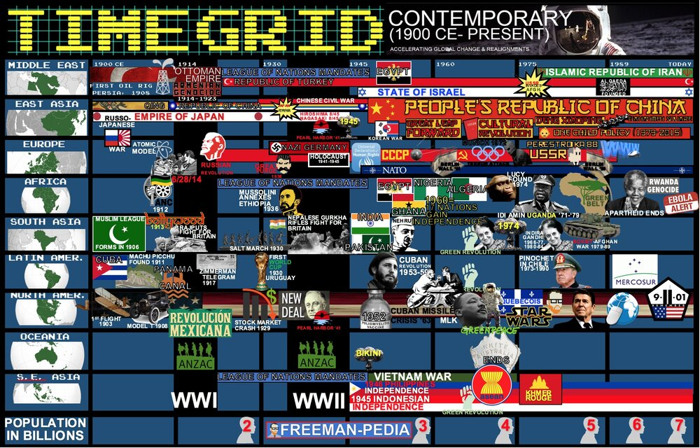

Topics of Study

Topic 9.1 Advances in Technology and Exchange After 1900 Ch. 23
Topic 9.2 Technological Advances and Limitations After 1900: Disease Ch.23
Topic 9.3 Technological Advances: Debates About the Environment After 1900 Ch. 23
Topic 9.4 Economics in the Golden Age Ch.23
Topic 9.5 Calls for Reform and Responses After 1900 Ch.23
Topic 9.6 Globalized Culture After 1900 Ch. 23
Topic 9.7 Resistance to Globalization After 1900 Ch. 23
Topic 9.8 Institutions Developing in a Globalized World Ch. 23

The World is Shrinking… Not literally. But, we are growing into a more global community. The final unit of AP World Modern breaks down the more recent world and the trends that permeate globally. Don’t overlook this unit. It basically breaks down to Global Tech, Global Econ, and Global Culture. And, don’t assume that since this is the last unit, it must be only about super recent stuff. This unit includes diseases, technology, and institutions from the first half of the Contemporary Period. So, let’s wrap up this thing by analyzing the roots of the Globalized world you live in right now.

AP WORLD 2021-22 - KELLY Name:

Chapter 23: Topic 9.1 Period:
Advances in Technology an Exchange After 1900
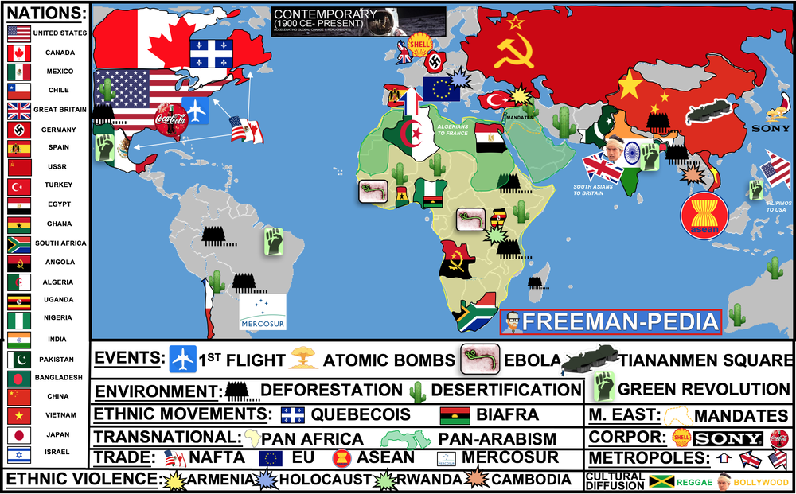

Introduction
The most distinguishing characteristic of the Contemporary Period is the technological explosion that advanced humanity exponentially from January 1, 1900 to TODAY. The College Board throws a ton of tech at you here. And, this is the easiest section to skip past… “Oh yeah, phones… internet… I get it.” BUT, THERE MIGHT NOT BE A MORE IMPACTFUL SECTION THAN THIS ONE!!!! So, make sure you know the new Communications, Energies, Birth Controls, Agricultural and Medical innovations of the Contemporary Period. New modes of communication—including radio communication, cellular communication, and the internet—as well as transportation, including air travel and shipping containers, reduced the problem of geographic distance. Energy technologies, including the use of petroleum and nuclear power, raised productivity and increased the production of material goods. More effective forms of birth control gave women greater control over fertility, transformed reproductive practices, and contributed to declining rates of fertility in much of the world. The Green Revolution and commercial agriculture increased productivity and sustained the earth’s growing population as it spread chemically and genetically modified forms of agriculture. Medical innovations, including vaccines and antibiotics, increased the ability of humans to survive and live longer lives.

Suggested Skill: Making Connections
5.A Identify patterns among or connections between historical developments and processes. See attachment titled “Sources on the Green Revolution”.

Learning Outcomes:
Thematic Focus: Technology and Innovation: Human adaptation and innovation have resulted in increased efficiency, comfort, and security, and technological advances have shaped human development and interactions with both intended and unintended consequences.
EQ #1: Explain how the development of new technologies changed the world from 1900 to present.
_________________________________________________________________________________________________________________________________________________________________________________________________________________________________________________________________________________________________________________________________________________________________________________________________________________________________________________________________________________________________________________________________________________________________________________________________________________________________________________________________________________________________________________________________________________________________________________________________________________________________________________________________________________________________________________________.

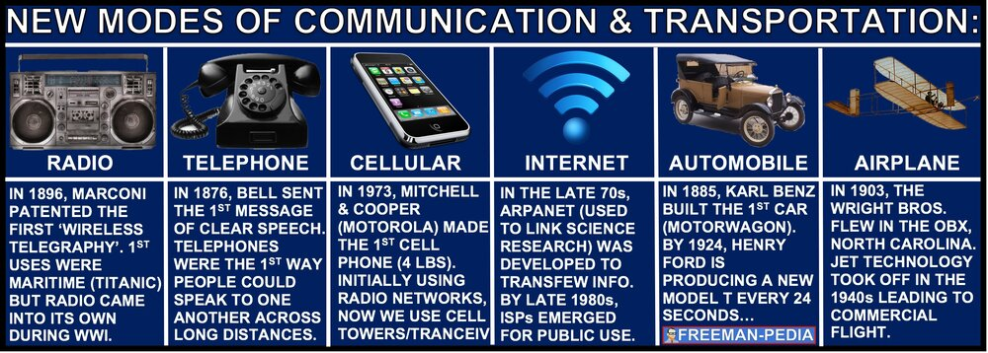
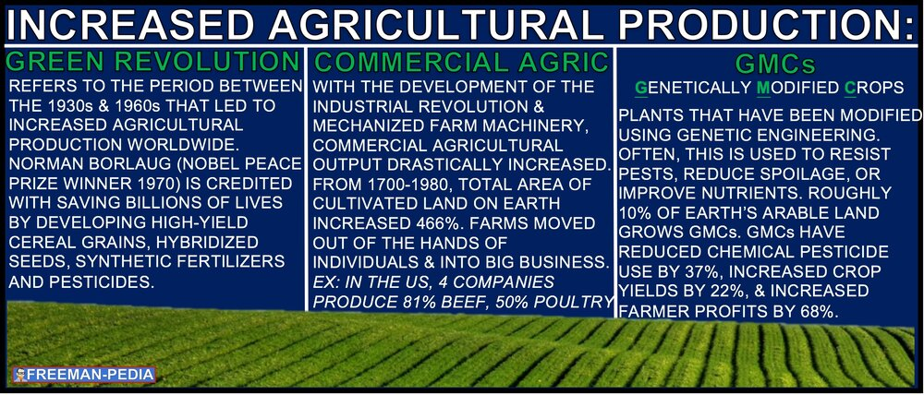
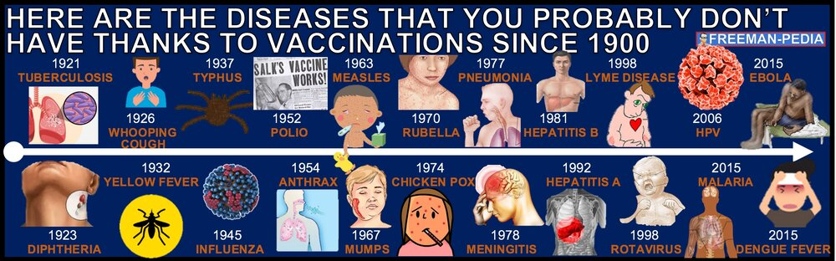

AP WORLD 2021-22 - KELLY Name:

Chapter 23: Topic 9.2 Period:
Technological Advances and Limitations after 1900: Disease
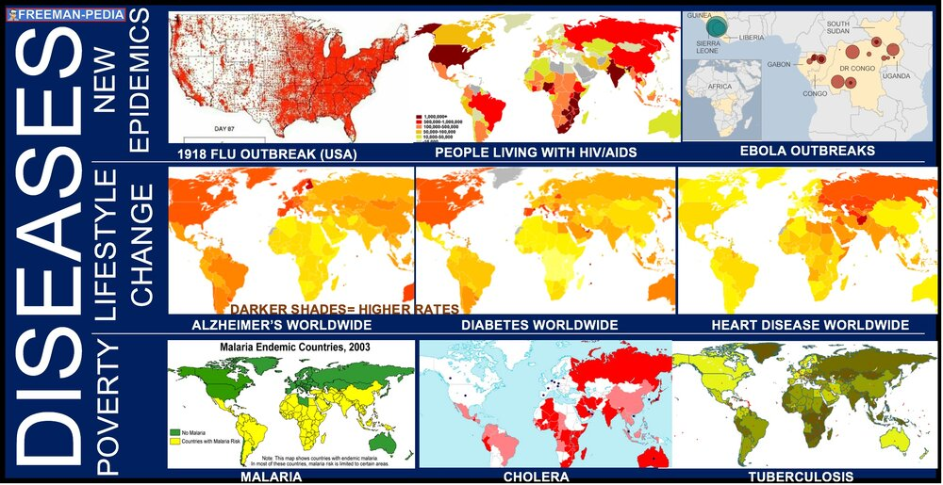

Introduction
When you think of the massive population boom of the Contemporary Period (we went from 1 BILLION to 8 BILLION); the most distinguishing feature of that population growth is the impact of modern medicine. We’ve only cured TWO diseases… ever. So, the fight and prevention of diseases worldwide is truly a Contemporary Period thing. The College Board wants you to focus on the different kinds of diseases or disease outbreaks (see the maps below). Now that we’ve all experienced a global pandemic, you should have a greater appreciation of 9.2. Diseases, as well as medical and scientific developments, had significant effects on populations around the world. Diseases associated with poverty persisted while other diseases emerged as new epidemics and threats to human populations, in some cases leading to social disruption. These outbreaks spurred technological and medical advances. Some diseases occurred at higher incidence merely because of increased longevity.

Suggested Skill: Making Connections
5.B Explain how a historical development or process relates to another historical development or process.
See attachment titled “Influenza DBQ Activity”.

Learning Outcomes:
Thematic Focus: Humans and the Environments The environment shapes human societies, and as populations grow and change, these populations in turn shape their environments.
EQ #1: Explain how environmental factors affected human populations over time.
____________________________________________________________________________________________________________________________________________________________________________________________________________________________________________________________________________________________________________________________________________________________________________________________________________________________________________________________________________________________________________________________________________________________________________________________________________________________________________________________________________________________________________________________________________________________________________________________________________________________________________________________________________________________________________________________________________________________________________________________.

ILLUSTRATIVE EXAMPLES
- Diseases associated with poverty:
  - Malaria
  - Tuberculosis
  - Cholera
- Emergent epidemic diseases:
  - 1918 influenza pandemic
  - Ebola
  - HIV/AIDS
- Diseases associated with increased longevity:
  - Heart disease
  - Alzheimer’s disease

AP WORLD 2021-22 - KELLY Name:

Chapter 23: Topic 9.3 Period:
Technological Advances: Debates About the Environment after 1900
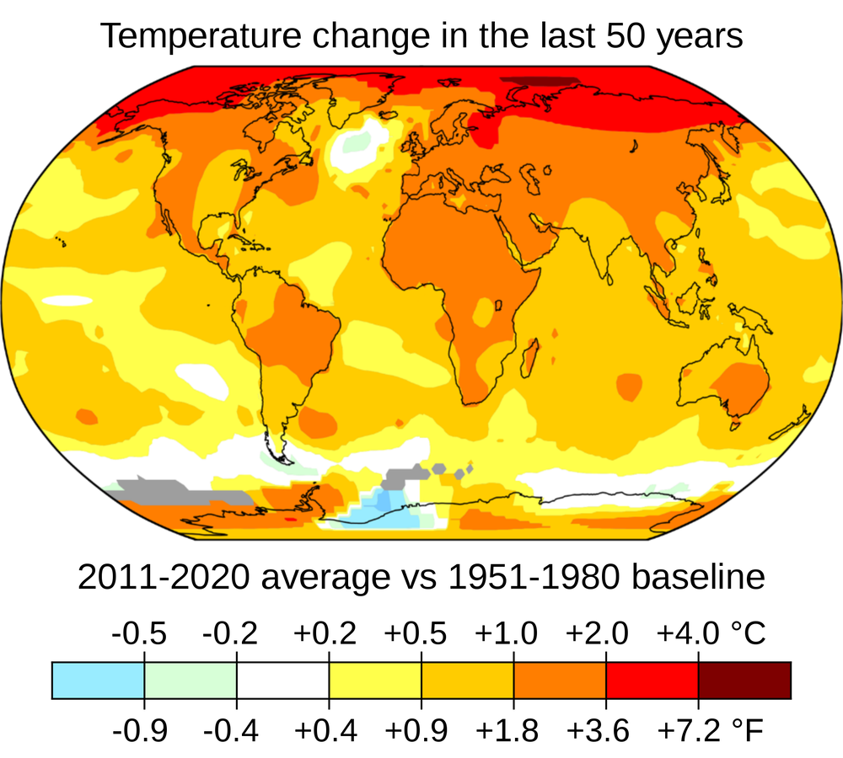

Introduction
There’s no easy way to put this… this one’s on you. Literally, people from your generation will have to make the strides necessary to clean up the effects of the Contemporary Period (and the end of the Modern Period). We made a mess. You have to clean it up. And, this one is high stakes. If you fail? Everything dies. If you succeed? Everything lives. No pressure. The College Board focuses on deforestation, desertification, air quality, fresh water and competition for resources. They also mention the catalyst for all of this: The Greenhouse Effect. As human activity contributed to deforestation, desertification, a decline in air quality, and increased consumption of the world’s supply of fresh water, humans competed over these and other resources more intensely than ever before. The release of greenhouse gasses and pollutants into the atmosphere contributed to debates about the nature and causes of climate change.

Suggested Skill: Contextualization
4.B Explain how a specific historical development or process is situated within a broader historical context.
See attachment titled “Environment in the 20th Century Telephone LEQ” Activity”.

Learning Outcomes:
Thematic Focus: Environments: The environment shapes human societies, and as populations grow and change, these populations in turn shape their environments
EQ #1: Explain the causes and effects of environmental changes in the period from 1900 to present.
____________________________________________________________________________________________________________________________________________________________________________________________________________________________________________________________________________________________________________________________________________________________________________________________________________________________________________________________________________________________________________________________________________________________________________________________________________________________________________________________________________________________________________________________________________________________________________________________________________________________________________________________________________________________________________________________________________________________________________________________.

AP WORLD 2021-22 - KELLY Name:

Chapter 23: Topic 9.4 Period:
Economics in the Global Age
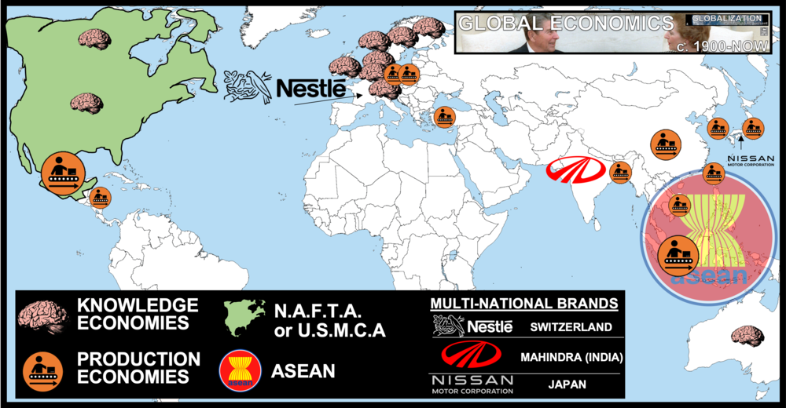

Introduction
One last look at Economics in World History. This time: How has the economy developed from 1900 to the point we are currently at? The College Board says a lot here, but it’s pretty simple. After the Great Depression interventions we saw in UNIT 7, governments began to turn back towards the Free Market and away from Keynesian interventions (they call this Economic Liberalization). As technology and modernization progressed different economies emerged: KNOWLEDGE & MANUFACTURING. Plus, as we GLOBALIZE, different nations formed localized trade blocks to help encourage trade between them. Some multinational global brands emerged like Nestle or Nissan. Finally, Global institutions were put into place to try and make it easier for the nations of the world to trade and borrow. In a trend accelerated by the end of the Cold War, many governments encouraged free market economic policies and promoted economic liberalization in the late 20th century. In the late 20th century, revolutions in information and communications technology led to the growth of knowledge economies in some regions, while industrial production and manufacturing were increasingly situated in Asia and Latin America. Changing economic institutions, multinational corporations, and regional trade agreements reflected the spread of principles and practices associated with free-market economics throughout the world.

Suggested Skill: Sourcing and Situation
2.C Explain the significance of a source’s point of view, purpose, historical situation, and/or audience, including how these might limit the use(s) of a source
See attachment titled “Globalization of Economies Videos and Discussion”.

Learning Outcomes:
Thematic Focus: Economic Systems: As societies develop, they affect and are affected by the ways that they produce, exchange, and consume goods and services.
EQ #1: Explain the continuities and changes in the global economy from 1900 to present.
________________________________________________________________________________________________________________________________________________________________________________________________________________________________________________________________________________________________________________________________________________________________________________________________________________________________________________________________________________________________________________________________________________________________________________________________________________________________________________________________________________________________________________________________________________________________________________________________________________________________.

ILLUSTRATIVE EXAMPLES
- Governments’ increased encouragement of free-market policies:
  - The United States under Ronald Reagan
    - Britain under Margaret Thatcher
    - China under Deng Xiaoping
    - Chile under Augusto Pinochet
  - Knowledge economies:
    - Finland
    - Japan
    - U.S.
  - Asian production and manufacturing economies:
    - Vietnam
    - Bangladesh
  - Latin American production and manufacturing economies:
    - Mexico
    - Honduras
  - Economic institutions and regional trade agreements:
    - World Trade Organization (WTO)
    - North American Free Trade Agreement (NAFTA)
    - Association of Southeast Asian Nations (ASEAN)
  - Multinational corporations:
    - Nestlé
    - Nissan
    - Mahindra and Mahindra

AP WORLD 2021-22 - KELLY Name:

Chapter 23: Topic 9.5 Period:
Calls for Reform and Responses After 1900
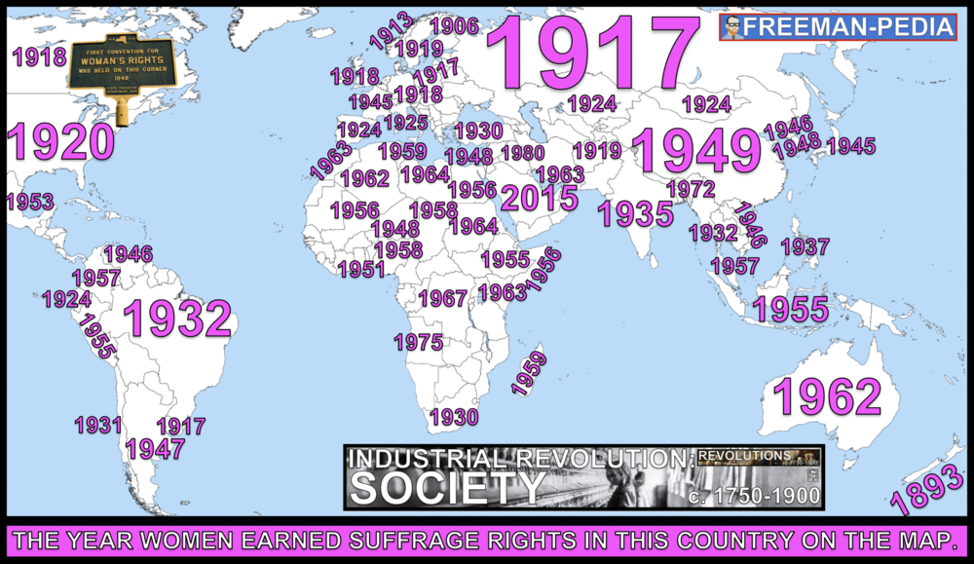

Introduction
Pretty nice planet we got here… You think all of the rights and privileges afforded to you just happened overnight? Nah, people ‘called for reforms’… That’s the College Board’s terminology. They FOUGHT for their rights. They STRUGGLED for their rights. The UN declared the rights for all of humanity in the 1940s with the Universal Declaration of Human Rights. But, other groups called for more reforms. Some movements predated the UN’s Declaration like Feminism & Civil Rights in the US. Other reforms included the Negritude Movement in Africa, Suffrage for women, the end of Apartheid in South Africa, and Environmental movements like Greenpeace & the Greenbelt Movement in Kenya. Rights-based discourses challenged old assumptions about race, class, gender, and religion. In much of the world, access to education as well as participation in new political and professional roles became more inclusive in terms of race, class, gender, and religion. Movements throughout the world protested the inequality of the environmental and economic consequences of global integration.

Suggested Skill: Contextualization
4.B Explain how a specific historical development or process is situated within a broader historical context.

See attachment titled “Negritude Literature and Paintings”.

Learning Outcomes:
Thematic Focus: Social Interactions and Organizations: The process by which societies group their members and the norms that govern the interactions between these groups and between individuals influence political, economic, and cultural institutions and organization.
EQ #1: Explain how social categories, roles, and practices have been maintained and challenged over time.
_______________________________________________________________________________________________________________________________________________________________________________________________________________________________________________________________________________________________________________________________________________________________________________________________________________________________________________________________________________________________________________________________________________________________________________________________________________________________________________________________________________________________________________________________________.

Illustratives Examples to know:
- Challenges to assumptions about race, class, gender, and religion:
  - The U.N. Universal Declaration of Human Rights, especially as it sought to protect the rights of children, women, and refugees
  - Global feminism movements
  - Negritude movement
  - Liberation theology in Latin America
- Increased access to education and political and professional roles:
  - The right to vote and/ or to hold public office granted to women in the United States (1920), Brazil (1932), Turkey (1934), Japan (1945), India (1947), and Morocco (1963)
  - The rising rate of female literacy and the increasing numbers of women in higher education, in most parts of the world
  - The U.S. Civil Rights Act of 1965
  - The end of apartheid
  - Caste reservation in India
- Environmental movements:
  - Greenpeace
  - Professor Wangari Maathai’s Green Belt Movement in Kenya
- Economic movements:
  - World Fair Trade Organization

AP WORLD 2021-22 - KELLY Name:

Chapter 23: Topic 9.6 Period:
Globalized Culture After 1900
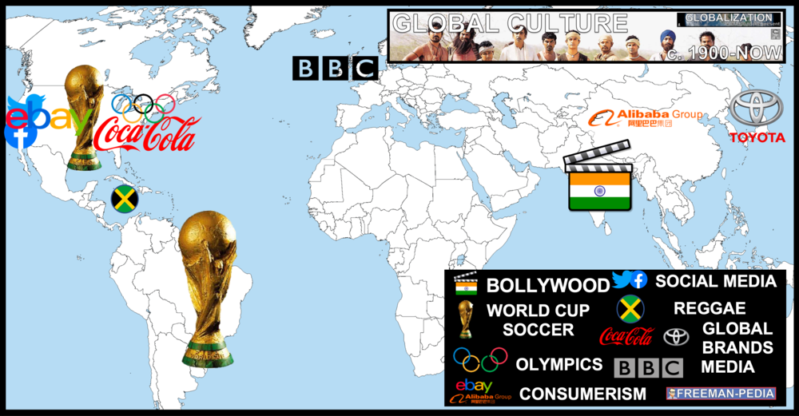

Introduction
With Globalization, comes a Global Culture. These are all of the cultural things that have permeated their borders and spread worldwide. These are things recognizable to most of the planet from all different fields: music, film, arts, media, social media, branding, consumerism. So, what may have started as something local to their region, the things on the map below all grew into global phenomenons followed by billions worldwide. Political and social changes of the 20th century led to changes in the arts and in the second half of the century, popular and consumer culture became more global. Arts, entertainment, and popular culture increasingly reflected the influence of a globalized society. Consumer culture became globalized and transcended national borders.

Suggested Skill: Contextualization
4.B Explain how a specific historical development or process is situated within a broader historical context.
See attachment titled “Globalization Images Activity” and “Blank Chart to use in class”.

Learning Outcomes:
Thematic Focus: Cultural Developments and Interactions: The development of ideas, beliefs, and religions illustrates how groups in society view themselves, and the interactions of societies and their beliefs often have political, social, and cultural implications.
EQ #1: Explain how and why globalization changed culture over time.
____________________________________________________________________________________________________________________________________________________________________________________________________________________________________________________________________________________________________________________________________________________________________________________________________________________________________________________________________________________________________________________________________________________________________________________________________________________________________________________________________________________________________________________________________________________________________________________________________________________________________________________________________________________________________________________________________________________________________________________________.

ILLUSTRATIVE EXAMPLES
- Global culture:
  - Music: Reggae
  - Movies: Bollywood
  - Social media: Facebook, Twitter
  - Television: BBC
  - Sports: World Cup soccer, the Olympics
- Global consumerism:
  - Online commerce: Alibaba, eBay
  - Global brands: Toyota, Coca-Cola

AP WORLD 2021-22 - KELLY Name:

Chapter 23: Topic 9.7 Period:
Resistance to Globalization After 1900

Introduction
Of all the sections in AP World Modern. This is the least defined…. Seriously… Here’s what the College Board says:
“Responses to rising cultural and economic globalization took a variety of forms.”
Yup… Basically, this is the Anti-Globalization movement. And, it can take many different forms. Basically, it’s the people who feel they are being left behind or overlooked in the whole Globalization process. It’s not a single movement; so, it’s hard to define. But, they essentially don’t like Multinational Corporations and the political power they wield. They don’t like big trade agreements that benefit the large economies of the world. Responses to rising cultural and economic globalization took a variety of forms at the expense of the smaller, developing economies. They don’t like the impact globalization has on the environment or the culture of the planet either. Responses to rising cultural and economic globalization took a variety of forms

Suggested Skill: Sourcing and Situation
2.C Explain the significance of a source’s point of view, purpose, historical situation, and/or audience, including how these might limit the use(s) of a source.
See attachment titled “Globalization of Economies Videos and Discussion”.

Learning Outcomes:
Thematic Focus: Cultural Developments and Interactions: The development of ideas, beliefs, and religions illustrates how groups in society view themselves, and the interactions of societies and their beliefs often have political, social, and cultural implications.
EQ #1: Explain the various responses to increasing globalization from 1900 to present.
____________________________________________________________________________________________________________________________________________________________________________________________________________________________________________________________________________________________________________________________________________________________________________________________________________________________________________________________________________________________________________________________________________________________________________________________________________________________________________________________________________________________________________________________________________________________________________________________________________________________________________________________________________________________________________________________________________________________________________________________.

Illustratives Examples to know:
- Responses to economic globalization:
  - Anti-IMF and anti-World Bank activism
  - Advent of locally developed social media (Weibo in China)

AP WORLD 2021-22 - KELLY Name:

Chapter 23: Topic 9.8 Period:
Institutions Developing in a Globalized World
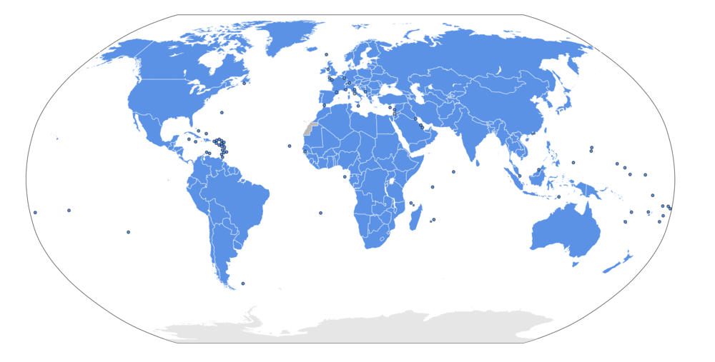

Introduction
Whoa… Is this the end? Yup. AP World Modern stops here. Kinda poetic that the GLOBALIZATION unit ends with a look at Global Institutions. And, you might expect a long list of organizations to know… Nope… Just one. THE UNITED NATIONS. And, honestly, you should’ve probably gone over the UN in Units 7 and 8… So… that’s it. That’s the content. I hope you enjoyed the ride. As for 9.8, just know the UN, and you good. New international organizations, including the United Nations, formed with the stated goal of maintaining world peace and facilitating international cooperation.

Suggested Skill: Claims and Evidence in Sources
3.C Compare the arguments or main ideas of two sources.

See attachment titled “United Nations and 20th Century Global Issues Activity”.

Learning Outcomes:
Thematic Focus: Governance: A variety of internal and external factors contribute to state formation, expansion, and decline. Governments maintain order through a variety of administrative institutions, policies, and procedures, and governments obtain, retain, and exercise power in different ways and for different purposes
EQ #1: Explain how and why globalization changed international interactions among states.
____________________________________________________________________________________________________________________________________________________________________________________________________________________________________________________________________________________________________________________________________________________________________________________________________________________________________________________________________________________________________________________________________________________________________________________________________________________________________________________________________________________________________________________________________________________________________________________________________________________________________________________________________________________________________________________________________________________________________________________________.

