AP WORLD 2021-22 - KELLY Name:

Period:

UNIT 8: Cold War and Decolonization
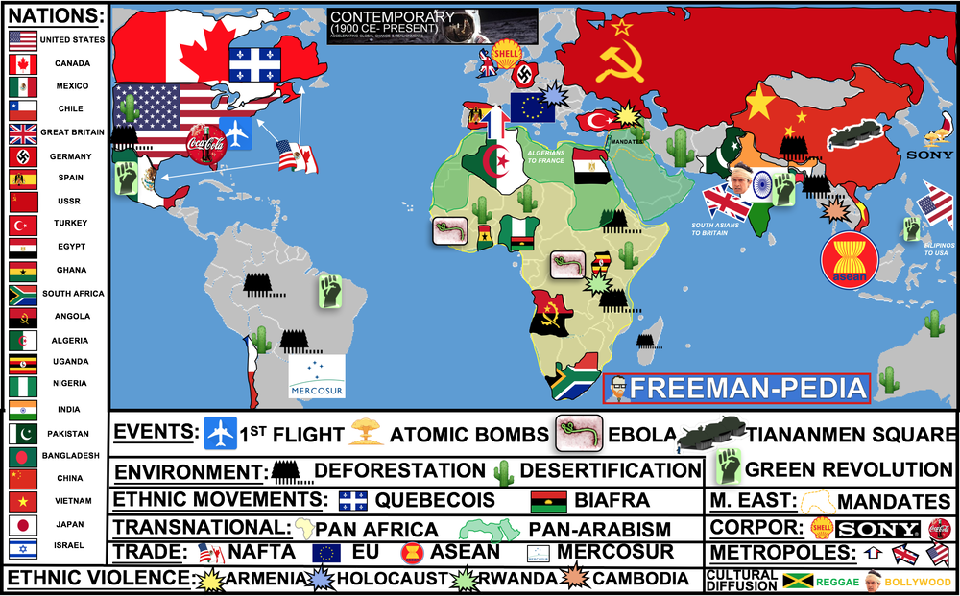

Topics of Study

Topic 8.1 Setting the stage for the Cold War and Decolonization Ch. 22
Topic 8.2 The Cold War Ch.22
Topic 8.3 The Effects of the Cold War: Ways of the World AMSCO
Topic 8.4 Spread of Communism: Ways of the World Ch.21
Topic 8.5 Decolonization after 1900: Ways of the World Ch.22
Topic 8.6 Newly Independent States: AMSCO
Topic 8.7 Global Resistance to Established Order after 1900: AMSCO
Topic 8.8 End of the Cold War: Our World’s Story
Topic 8.9 Causation in the Age of the Cold War and Decolonization: AMSCO

This unit is cray. This should be TWO units… easily. Think of this unit as surmising the major political stuff that happens AFTER 1945. And, that breaks down into the COLD WAR (USA vs USSR, Capitalism vs Communism, Proxy Wars, etc. etc. ) and DECOLONIZATION (removal of European controls of their colonies in Africa and Asia). So, the unit really splits evenly along those lines. Below are the 8 sections covering the penultimate unit in AP World Modern.

AP WORLD 2021-22 - KELLY Name:

Chapter 22: Topic 8.1 Period:
Setting the stage for the Cold War & Decolonization

Introduction
Unit 8 kicks off with an introduction section. Don’t leave this page until you have a full grasp on two concepts: THE COLD WAR & DECOLONIZATION. Basically, the Cold War is the name given to the geo-political struggle between the two remaining SuperPowers after WWII: USA & USSR. It runs from 1945-1991 and will see both sides trying to exert their influence all over the world. Decolonization is the inverse of Imperialism. In other words, all of the colonies we saw scooped up back in Unit 6, are going to gain independence. How they gain that independence and what happens after they have it, is the focus of a good chunk of this unit. So, for this section, just know the big two ideas for Unit 8 and then move on. The rest of the sections go into more detail. Hopes for greater self-government were largely unfulfilled following World War I; however, in the years following World War II, increasing anti-imperialist sentiment contributed to the dissolution of empires and the restructuring of states. Technological and economic gains experienced during World War II by the victorious nations shifted the global balance of power.

Suggested Skill: Contextualization
4.B Explain how a specific historical development or process is situated within a broader historical context.
See attachment titled “Context and Causes: Cold War Discussion/Debate”.

Learning Outcomes:
Thematic Focus: Governance: A variety of internal and external factors contribute to state formation, expansion, and decline. Governments maintain order through a variety of administrative institutions, policies, and procedures, and governments obtain, retain, and exercise power in different ways and for different purposes.
EQ #1: Explain the historical context of the Cold War after 1945.
____________________________________________________________________________________________________________________________________________________________________________________________________________________________________________________________________________________________________________________________________________________________________________________________________________________________________________________________________________________________________________________________________________________________________________________________________________________________________________________________________________________________________________________________________________________________________________________________________________________________________________________________________________________________________________________________________________________________________________________________.

1. After WWII, there are TWO major themes: The Cold War and Decolonization.

2. Unit 8 is LITERALLY divided in half between these two ideas.

3. In reality, these should be two seperate units… I mean… Come on College Board? That would have made 10 units! A nice even 10. Whatever.

4. Cold War was the ideological divide between the two new Superpowers: USA vs. USSR

5. Decolonization is the inverse of Unit 6: Colonies around the world will begin to remove the Colonizers in their countries and form ALL NEW countries.

AP WORLD 2021-22 - KELLY Name:

Chapter 22: Topic 8.2 Period:
The Cold War
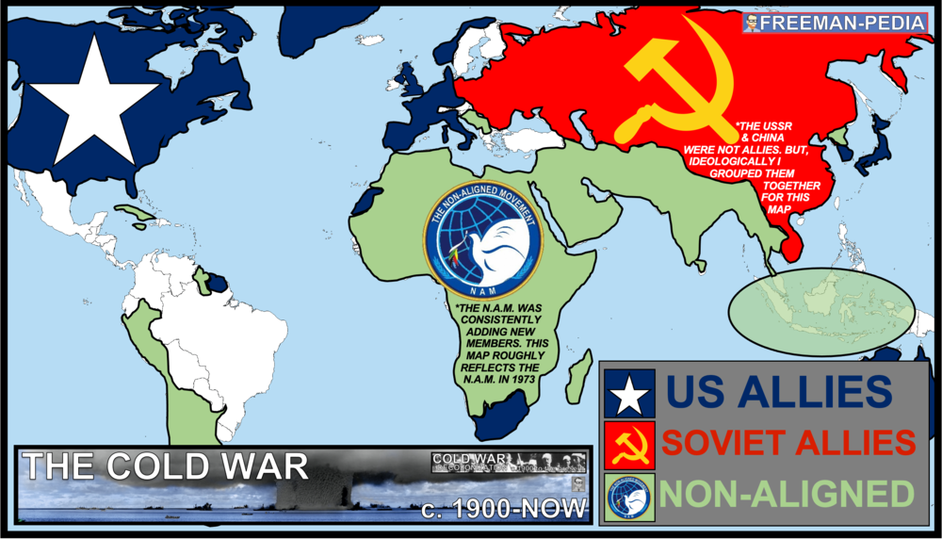

Introduction
Nearly 50 years of global division comes with a ton of history. But, I have some good news. You don’t really have to know that much here! There are a ton of examples, ideas, events, people, wars, conflicts, etc. But, the College Board wants you to just know the main ideas of the Cold War here. So, don’t get too bogged down with parallels and U2 bombers. Instead, make sure you understand the causes behind the Cold War and the THREE sides (US, USSR, & Non-Aligned). The next section will delve more into the effects and outcomes of the Cold War. The global balance of economic and political power shifted during and after World War II and rapidly evolved into the Cold War. The democracy of the United States and the authoritarian communist Soviet Union emerged as superpowers, which led to ideological conflict and a power struggle between capitalism and communism across the globe. Groups and individuals, including the Non-Aligned Movement, opposed and promoted alternatives to the existing economic, political, and social orders

Suggested Skill: Sourcing and Situation
2.B Explain the point of view, purpose, historical situation, and/or audience of a source
See attachment titled “Context and Causes: Cold War Discussion/Debate”.

Learning Outcomes:
Thematic Focus: Cultural Developments and Interactions: The development of ideas, beliefs and religions illustrates how groups in society view themselves, and the interactions of societies and their beliefs often have political, social, and cultural implications.
EQ #1: Explain the causes and effects of the ideological struggle of the Cold War.
____________________________________________________________________________________________________________________________________________________________________________________________________________________________________________________________________________________________________________________________________________________________________________________________________________________________________________________________________________________________________________________________________________________________________________________________________________________________________________________________________________________________________________________________________________________________________________________________________________________________________________________________________________________________________________________________________________________________________________________________.

ILLUSTRATIVE EXAMPLES
- Non-Aligned Movement:
  - Sukarno in Indonesia
  - Kwame Nkrumah in Ghana

AP WORLD 2021-22 - KELLY Name:

Chapter 22: Topic 8.3 Period:
Effects of the Cold War
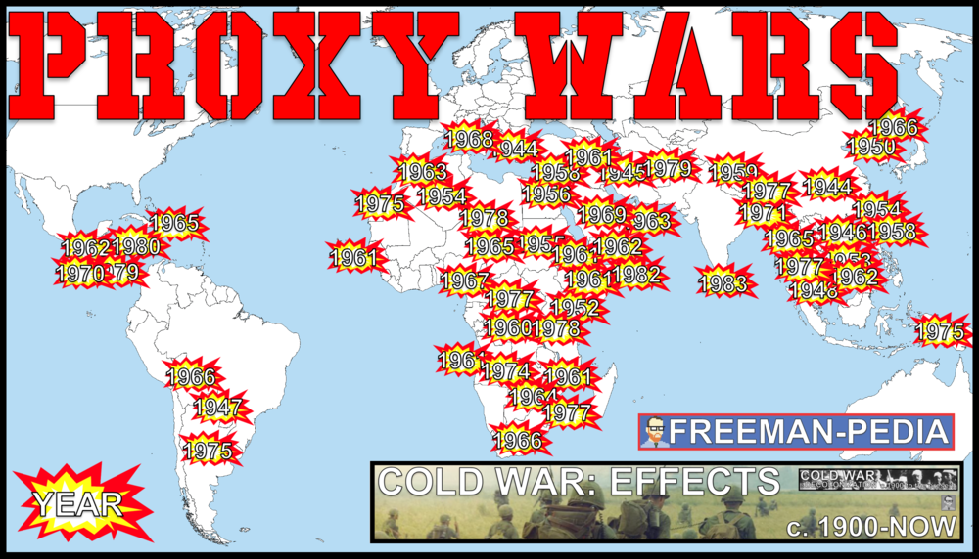

Introduction
Now that you know what the Cold War WAS. Let’s look at some effects. This is where you will run into any number of clashes between the US and her allies vs. the USSR and her allies. But, be warned. The only thing REQUIRED of you is that you understand Nuclear Proliferation and Proxy Wars. Now, there are a million different exampleThe Cold War produced new military alliances, including NATO and the Warsaw Pact, and led to nuclear proliferation and proxy wars between and within postcolonial states in Latin America, Africa, and Asia.s to be found here. So, don’t leave this page without understanding those two key concepts.

Suggested Skill: Making Connections
5.B Explain how a historical development or process relates to another historical development or process.
See attachment titled “Argument-Building -Effects of the Cold War”.

Learning Outcomes:
Thematic Focus: Governance: A variety of internal and external factors contribute to state formation, expansion, and decline. Governments maintain order through a variety of administrative institutions, policies, and procedures, and governments obtain, retain, and exercise power in different ways and for different purposes.
EQ #1: Compare the ways in which the United States and the Soviet Union sought to maintain influence over the course of the Cold War.
____________________________________________________________________________________________________________________________________________________________________________________________________________________________________________________________________________________________________________________________________________________________________________________________________________________________________________________________________________________________________________________________________________________________________________________________________________________________________________________________________________________________________________________________________________________________________________________________________________________________________________________________________________________________________________________________________________________________________________________________.

ILLUSTRATIVE EXAMPLES
- Proxy wars:
  - Korean War
  - Angolan Civil War
  - Sandinista-Contras conflict in Nicaragua

AP WORLD 2021-22 - KELLY Name:

Chapter 21: Topic 8.4 Period:
Spread of Communism After 1900
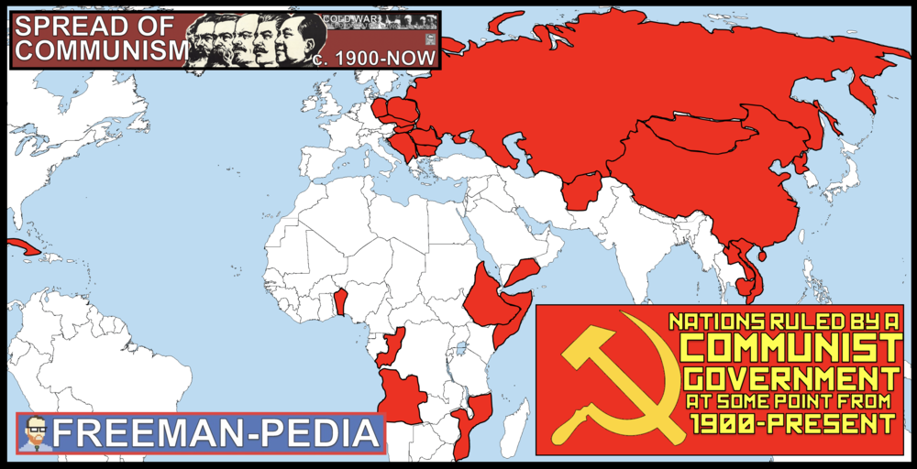

Introduction
The whole reason the Cold War exists is because Communism did not stay in the Soviet Union. This section is devoted to the impact of Communism on China. AND, how land redistribution happened around the world. As you can see from the map, it was NOT a foregone conclusion that the Democratic Capitalist states would win. Focus here on China and Land Redistribution and you should be fine (although there are a MILLION other examples that could work here as well ). As a result of internal tension and Japanese aggression, Chinese communists seized power. These changes in China eventually led to communist revolution. In communist China, the government controlled the national economy through the Great Leap Forward, often implementing repressive policies, with negative repercussions for the population. Movements to redistribute land and resources developed within states in Africa, Asia, and Latin America, sometimes advocating communism or socialism.

Suggested Skill: Sourcing and Situation
2.C Explain the significance of a source’s point of view, purpose, historical situation, and/or audience, including how these might limit the use(s) of a source
See attachment titled “Harkness/Socratic Seminar/Lit Circles etc. On Mao’s Little Red Book/Cultural Revolution”.

Learning Outcomes:
Thematic Focus: Economic Situations: As societies develop, they affect and are affected by the ways that they produce, exchange, and consume goods and services.
EQ #1: Explain the causes and consequences of China’s adoption of communism.
____________________________________________________________________________________________________________________________________________________________________________________________________________________________________________________________________________________________________________________________________________________________________________________________________________________________________________________________________________________________________________________________________________________________________________________________________________________________________________________________________________________________________________________________________________________________________________________________________________________________________________________________________________________________________________________________________________________________________________________________.

Thematic Focus: Social Interactions and Organizations: The process by which societies group their members and the norms that govern the interactions between these groups and between individuals influence political, economic, and cultural institutions and organization.
EQ #2: Explain the causes and effects of movements to redistribute economic resources..
____________________________________________________________________________________________________________________________________________________________________________________________________________________________________________________________________________________________________________________________________________________________________________________________________________________________________________________________________________________________________________________________________________________________________________________________________________________________________________________________________________________________________________________________________________________________________________________________________________________________________________________________________________________________________________________________________________________________________________________________.

ILLUSTRATIVE EXAMPLES
- Land and resource redistribution:
  - Communist Revolution for Vietnamese independence
  - Mengistu Haile Mariam in Ethiopia
  - Land reform in Kerala and other states within India
  - White Revolution in Iran

AP WORLD 2021-22 - KELLY Name:

Chapter 22: Topic 8.5 Period:
Decolonization after 1900
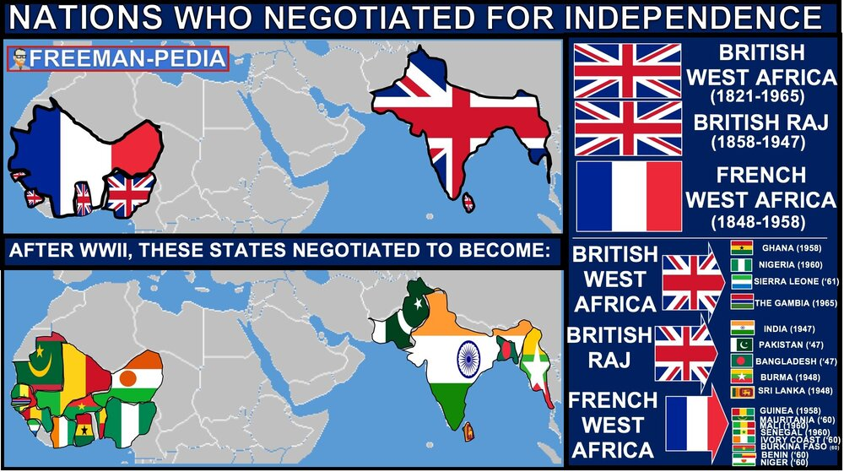

Introduction
The next two sections are all about Decolonization and the New States that emerge onto the World Scene. If you remember how long and gruesome Unit 6 was (Imperialism), you should also know that there are a million examples here too. But, you can break them into a few categories. How was Independence achieved? Was it NON-VIOLENT or NEGOTIATED like India or Ghana? Or, was there an ARMED STRUGGLE like Vietnam, Algeria, or Angola? Nationalist leaders and parties in Asia and Africa sought varying degrees of autonomy within or independence from imperial rule. After the end of World War II, some colonies negotiated their independence, while others achieved independence through armed struggle. Regional, religious, and ethnic movements challenged colonial rule and inherited imperial boundaries. Some of these movements advocated for autonomy

Suggested Skill: Making Connections
5.B Explain how a historical development or process relates to another historical development or process.

See attachment titled “Decolonization Podcast Assignment”.

Learning Outcomes:
Thematic Focus: Governance: A variety of internal and external factors contribute to state formation, expansion, and decline. Governments maintain order through a variety of administrative institutions, policies, and procedures, and governments obtain, retain, and exercise power in different ways and for different purposes.
EQ #1: Compare the processes by which various peoples pursued independence after 1900.
_______________________________________________________________________________________________________________________________________________________________________________________________________________________________________________________________________________________________________________________________________________________________________________________________________________________________________________________________________________________________________________________________________________________________________________________________________________________________________________________________________________________________________________________________________.

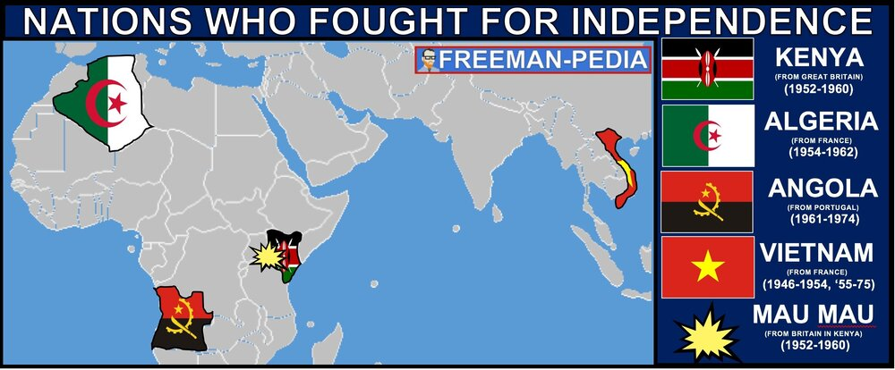
Illustratives Examples to know:
- Nationalist leaders and parties:
  - Indian National Congress
  - Ho Chi Minh in French Indochina (Vietnam)
  - Kwame Nkrumah in British Gold Coast (Ghana)
  - Gamal Abdel Nasser in Egypt
- Negotiated independence:
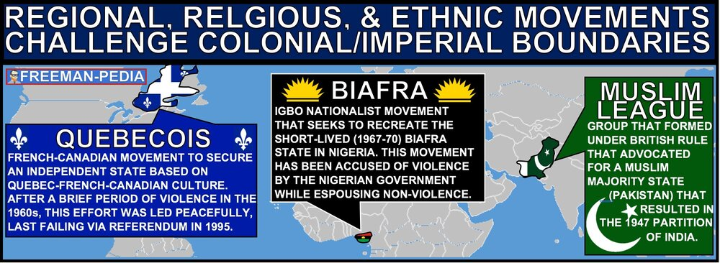
  - India from the British Empire
  - The Gold Coast from the British Empire
  - French West Africa
- Independence through armed struggle:
  - Algeria from the French empire
  - Angola from the Portuguese empire
  - Vietnam from the French empire
- Regional, religious, and ethnic movements:
  - Muslim League in British India
  - Québécois separatist movement in Canada
  - Biafra secessionist movement in Nigeria

AP WORLD 2021-22 - KELLY Name:

Chapter 22: Topic 8.6 Period:
Newly Independent States

Introduction
So, one way or another… we got some New Kids on the Block. These are the newest additions to the Nations of the World. They were all founded as European rule came to an end due to Decolonization. But, it’s what they do AFTER they’ve gained self-rule that the College Board focuses on here. The new boundaries drawn for these states will lead to conflicts for years to come (Israel, Pakistan). Focus here on how these governments intervened in their economies to help their people. Lastly, focus on the concept of a METROPOLE and how it led the people of former colonies to migrate to the country that had once ruled over them.The redrawing of political boundaries after the withdrawal of former colonial authorities led to the creation of new states. The redrawing of political boundaries in some cases led to conflict as well as population displacement and/or resettlements, including those related to the Partition of India and the creation of the state of Israel. In newly independent states after World War II, governments often took on a strong role in guiding economic life to promote development. The migration of former colonial subjects to imperial metropoles (the former colonizing country), usually in the major cities, maintained cultural and economic ties between the colony and the metropole even after the dissolution of empires.

Suggested Skill: Sources and Situations
3.D Explain how claims or evidence support, modify, or refute a source’s argument.
See attachment titled “Partition of India Assignment”.

Learning Outcomes:
Thematic Focus: Governance: A variety of internal and external factors contribute to state formation, expansion, and decline. Governments maintain order through a variety of administrative institutions, policies, and procedures, and governments obtain, retain, and exercise power in different ways and for different purposes.
EQ #1: Explain how political changes in the period from c. 1900 to the present led to territorial, demographic, and nationalist developments.
____________________________________________________________________________________________________________________________________________________________________________________________________________________________________________________________________________________________________________________________________________________________________________________________________________________________________________________________________________________________________________________________________________________________________________________________________________________________________________________________________________________________________________________________________________________________________________________________________________________________________________________________________________________________________________________________________________________________________________________________.

Thematic Focus: Economic Situations: As societies develop, they affect and are affected by the ways that they produce, exchange, and consume goods and services.
EQ #1: Explain the economic changes and continuities resulting from the process of decolonization.
____________________________________________________________________________________________________________________________________________________________________________________________________________________________________________________________________________________________________________________________________________________________________________________________________________________________________________________________________________________________________________________________________________________________________________________________________________________________________________________________________________________________________________________________________________________________________________________________________________________________________________________________________________________________________________________________________________________________________________________________.
ILLUSTRATIVE EXAMPLES
- States created by redrawing of political boundaries:
  - Israel
  - Cambodia
  - Pakistan
- Governments guiding economic life:
  - Gamal Abdel Nasser’s promotion of economic development in Egypt
  - Indira Gandhi's economic policies in India
  - Julius Nyerere’s modernization in Tanzania
  - Sirimavo Bandaranaike’s economic policies in Sri Lanka
- Migrations:
  - South Asians to Britain
  - Algerians to France
  - Filipinos to the United States

AP WORLD 2021-22 - KELLY Name:

Chapter 22: Topic 8.7 Period:
Global Resistance to Established Power Structures After 1900

Introduction
This is one of the tougher sections to give an overview for… Basically, there are two ways to challenge or resist the global established powers: VIOLENT & NON-VIOLENT. But, what is ‘resistance to established powers’? Weird. Anyways, focus on Mandela’s struggle against Apartheid, the rise of dictators who rule with an iron fist, and, finally, terrorism. I told you… it’s a weird section. Although conflict dominated much of the 20th century, many individuals and groups— including states—opposed this trend. Some individuals and groups, however, intensified the conflicts. Groups and individuals challenged the many wars of the century, and some, such as Mohandas Gandhi, Martin Luther King Jr., and Nelson Mandela, promoted the practice of nonviolence as a way to bring about political change. Militaries and militarized states often responded to the proliferation of conflicts in ways that further intensified conflict. Some movements used violence against civilians in an effort to achieve political aims.

Suggested Skill: Claims and Evidence in Sources
2.B Explain the point of view, purpose, historical situation, and/or audience of a source..
See attachment titled “Non-Violent Leaders Literature Circles”.

Learning Outcomes:
Thematic Focus: Cultural Developments and Interactions: The development of ideas, beliefs, and religions illustrates how groups in society view themselves, and the interactions of societies and their beliefs often have political, social, and cultural implications.
EQ #1: Explain various reactions to existing power structures in the period after 1900.
____________________________________________________________________________________________________________________________________________________________________________________________________________________________________________________________________________________________________________________________________________________________________________________________________________________________________________________________________________________________________________________________________________________________________________________________________________________________________________________________________________________________________________________________________________________________________________________________________________________________________________________________________________________________________________________________________________________________________________________________.

Illustratives Examples to know:
- Responses that intensified conflict:
  - Chile under Augusto Pinochet
  - Spain under Francisco Franco
  - Uganda under Idi Amin
  - The buildup of the military–industrial complex and weapons trading
- Movements that used violence:
  - Shining Path
  - Al-Qaeda

AP WORLD 2021-22 - KELLY Name:

Chapter 22: Topic 8.8 Period:
End of the Cold War

Introduction
Well… well… well… Look who just won their THIRD WORLD WAR! (WWI✓, WWII✓, COLD WAR✓). But, it’s too simple to just say we MURKA’d them to death. It was more like a death by 1,000 cuts for the Soviet Union and their allies. The College Board only mentions three things: Soviet Invasion of Afghanistan, Public Discontent and Economic weaknesses. The Soviet Union peaked around 1960. Their planned economy and collective farms could not keep pace with the American capitalist workforce. Their invasion of the Soviet Union turned into the ‘Bear Trap’. Soviet secrecy led to the Chernobyl Disaster in 1986. Star Wars (SDI) forced the Soviets into ruinous spending. And, discontent amongst the satellite states of East Europe mixed with the reforms of 1990 Nobel Peace Prize Winner Mikhail Gorbachev brought the Cold War to a close in 1991. Advances in U.S. military and technological development, the Soviet Union’s costly and ultimately failed invasion of Afghanistan, and public discontent and economic weakness in communist countries led to the end of the Cold War and the collapse of the Soviet Union.

Suggested Skill: Developments and Processes
1.B Explain a historical concept, development, or process.

See attachment titled “Fall of USSR and End of Cold War Political Cartoon or Newspaper Article Activity”.

Learning Outcomes:
Thematic Focus: Governance: A variety of internal and external factors contribute to state formation, expansion, and decline. Governments maintain order through a variety of administrative institutions, policies, and procedures, and governments obtain, retain, and exercise power in different ways and for different purposes
EQ #1: Explain the causes of the end of the Cold War.
____________________________________________________________________________________________________________________________________________________________________________________________________________________________________________________________________________________________________________________________________________________________________________________________________________________________________________________________________________________________________________________________________________________________________________________________________________________________________________________________________________________________________________________________________________________________________________________________________________________________________________________________________________________________________________________________________________________________________________________________.

