AP WORLD 2021-22 - KELLY Name:

Period:

UNIT 7: Global Conflict c. 1900 to Present
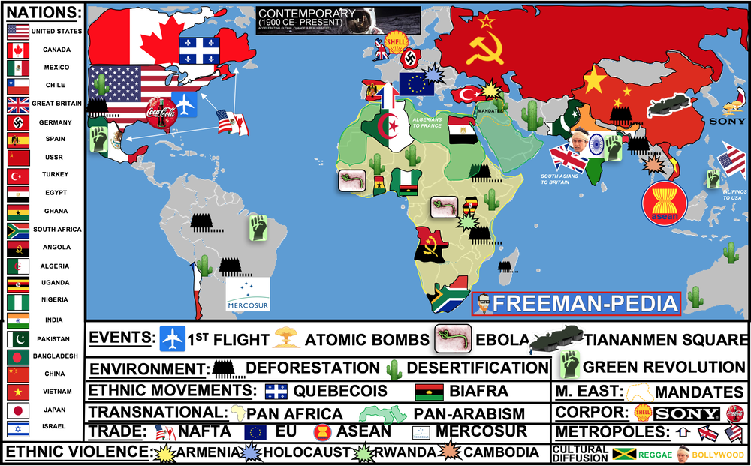

Topics of Study

Topic 7.1 Shifting Power after 1900: Ways of the World Ch.20
Topic 7.2 Causes of WWI: Ways of the World Ch.20
Topic 7.3 Conducting WWI: Ways of the World AMSCO
Topic 7.4 The Economy in the interwar Years: Ways of the World Ch.20
Topic 7.5 Unresolved Tensions after WWI: Ways of the World Ch.20
Topic 7.6 Causes of WWII: AMSCO
Topic 7.7 Conducting WWII: AMSCO
Topic 7.8 Mass Atrocities after 1900: Our World’s Story
Topic 7.9 Causation in Global Conflict: AMSCO

This period has two sections. The first one was all about the major changes in the Political World (Enlightenment/Revolutions) and the Economic World (Industrial Revolution). The second unit of the MODERN PERIOD (1750-1900) is all about the NEW IMPERIALISM. This is NOT your ‘Columbus sailed the Ocean Blue in 1492’. This time around the Europeans are looking for colonies to sell their products (MARKETS) and places to obtain more raw materials for their factories back home (MATERIALS). Using their new technological prowess, the West will dominate the world in search of M&Ms (MARKETS & MATERIALS).In the last unit, Industrialization pushed the West into a position of power; in this unit, they will flex that muscle around the globe. Below, are the many causes and effects of this NEW Imperialism.

AP WORLD 2021-22 - KELLY Name:

Chapter 20: Topic 7.1 Period:
Shifting Power After 1900
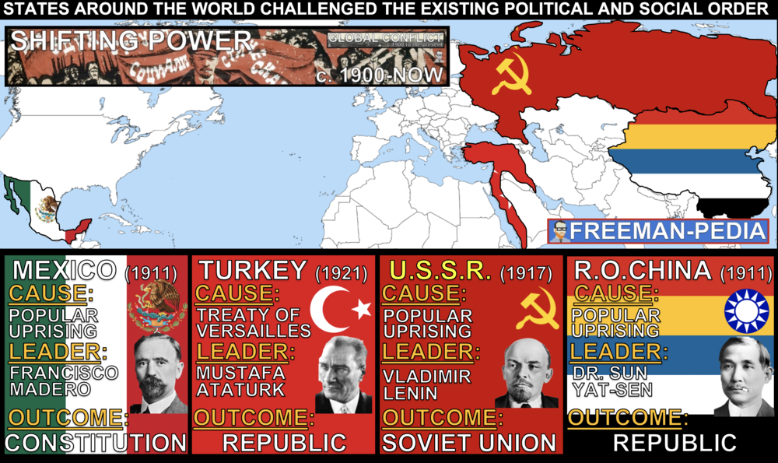

Introduction
Your teacher may have just jumped STRAIGHT into THE GREAT WAR (WWI). But, there were definitely some shifting power dynamics going on prior to 1914. World War I definitely exacerbated the problems being seen around the world (especially in Russia and the Ottoman Empire). But, it’s worth a look at the four hot-spots in the world PRIOR to the GREAT WAR. So, let’s focus on MEXICO, RUSSIA, OTTOMANS, and QING CHINA. The West dominated the global political order at the beginning of the 20th century, but both land-based and maritime empires gave way to new states by the century’s end. The older, land-based Ottoman, Russian, and Qing empires collapsed due to a combination of internal and external factors. These changes in Russia eventually led to communist revolution. States around the world challenged the existing political and social order, including the Mexican Revolution that arose as a result of political crisis.

Suggested Skill: Contextualization
4.B Explain how a specific historical development or process is situated within a broader historical context.
See attachment titled “Comparison - Mexican, Chinese, and Russian Revolutions Graphic Organizer”.

Learning Outcomes:
Thematic Focus: Governance: A variety of internal and external factors contribute to state formation, expansion, and decline. Governments maintain order through a variety of administrative institutions, policies, and procedures, and governments obtain, retain, and exercise power in different ways and for different purposes.
EQ #1: Explain how internal and external factors contributed to change in various states after 1900.
____________________________________________________________________________________________________________________________________________________________________________________________________________________________________________________________________________________________________________________________________________________________________________________________________________________________________________________________________________________________________________________________________________________________________________________________________________________________________________________________________________________________________________________________________________________________________________________________________________________________________________________________________________________________________________________________________________________________________________________________.

1. WHAT IS TO BE DONE?, Vladimir Lenin, 1902

2. THREE PRINCIPLES OF THE PEOPLE, Sun Yat-sen, 1905

3. PLAN OF SAN LUIS POTOSI, Francisco Madero, 1910

4. POLITICAL CONSTITUTION OF THE UNITED MEXICAN STATES, 1917

5. NUTUK, Mustafa Kemal Ataturk, 1927

AP WORLD 2021-22 - KELLY Name:

Chapter 20: Topic 7.2 Period:
Causes of World War I
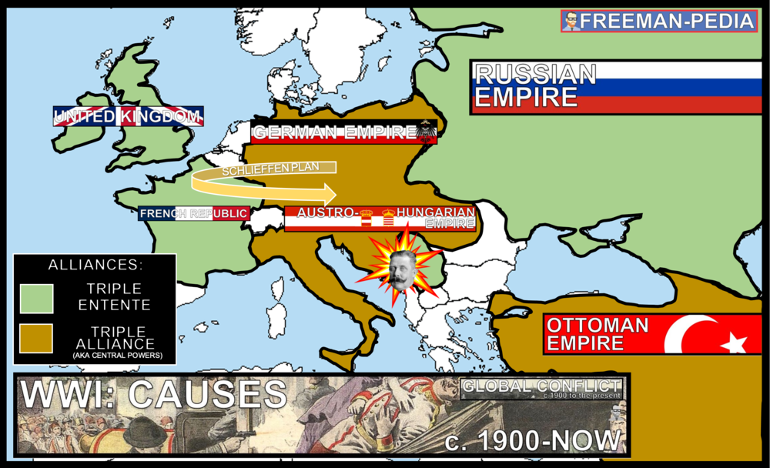

Introduction
Remember how nothing was the same after the Industrial Revolution? The world was truly a different place? Well, that took place over 100+ years. The Great War (WWI) will do all of that in 5 years. This is such a major conflict involving so many moving parts. If you’re a history nerd like, me this one is so much fun. WARNING: This is AP World, not AP World War. Don’t get bogged down here. I know… it’s archdukes and drive-bys and ultimatums and Schileffens….I know… But, don’t linger here. Know the order of how things went down here. Know how the heir to the Austro-Hungarian Empire’s assassination brought the world to war. Then, off to the war itself in the next section. The causes of World War I included imperialist expansion and competition for resources. In addition, territorial and regional conflicts combined with a flawed alliance system and intense nationalism to escalate the tensions into global conflict.

Suggested Skill: Developments and Processes
1.B Explain a historical concept, development, or process.
See attachment titled “Causes of World War I Document Set and Causes of World War I Document Chart”.

Learning Outcomes:
Thematic Focus: Governance: A variety of internal and external factors contribute to state formation, expansion, and decline. Governments maintain order through a variety of administrative institutions, policies, and procedures, and governments obtain, retain, and exercise power in different ways and for different purposes.
EQ #1: Explain the causes and consequences of World War I.
____________________________________________________________________________________________________________________________________________________________________________________________________________________________________________________________________________________________________________________________________________________________________________________________________________________________________________________________________________________________________________________________________________________________________________________________________________________________________________________________________________________________________________________________________________________________________________________________________________________________________________________________________________________________________________________________________________________________________________________________.

AP WORLD 2021-22 - KELLY Name:

Chapter 20: Topic 7.3 Period:
Conducting World War I
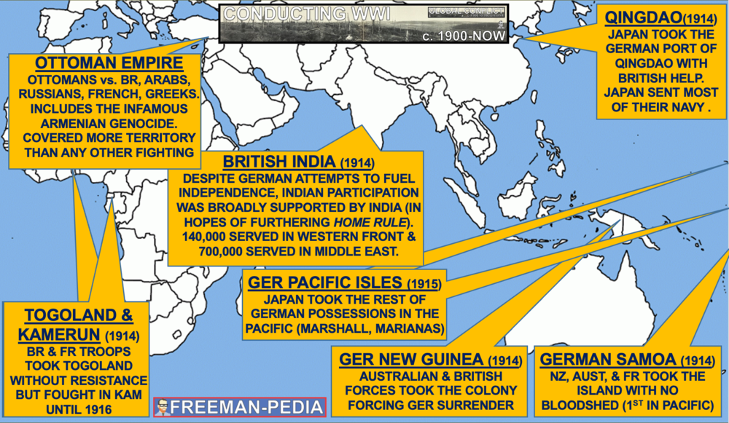

Introduction
THIS… CHANGED… EVERYTHING. The Great War was the first major clash of Industrialized Global powers. It’s been called the “Civil War of the West”. All of those empires that were using their economic and technological advantage to build empires in Unit 6, are now turning that power against one another. I’ll warn you again here. You can get lost in all of this war. It’s massive. You could devote your whole life to these four years and never know it all. So, focus on the generic flow of the war, the new technologies (tanks, gas, machine guns, heavy artillery), and the ways these countries mobilized their people to fight (both from within their countries and from their colonies). World War I was the first total war. Governments used a variety of strategies, including political propaganda, art, media, and intensified forms of nationalism, to mobilize populations (both in the home countries and the colonies) for the purpose of waging war. New military technology led to increased levels of wartime casualties.

Suggested Skill: Claims and Evidence in Sources
3.B Identify the evidence used in a source to support an argument.
See attachment titled “Colonies in the War Document Set”.

Learning Outcomes:
Thematic Focus: Technology and Innovation: Human adaptation and innovation have resulted in increased efficiency, comfort, and security, and technological advances have shaped human development and interactions with both intended and unintended consequences.
EQ #1: Explain how governments used a variety of methods to conduct war.
____________________________________________________________________________________________________________________________________________________________________________________________________________________________________________________________________________________________________________________________________________________________________________________________________________________________________________________________________________________________________________________________________________________________________________________________________________________________________________________________________________________________________________________________________________________________________________________________________________________________________________________________________________________________________________________________________________________________________________________________.

1. TRENCH WARFARE
2. TRENCH RATS
3. MUSTARD GAS
4. WESTERN FRONT
5. DREADNOUGHT
6. U-BOAT
7. LUSITANIA
8. ZIMMERMAN NOTE
9. TREATY OF VERSAILLES
10. MANDATES

AP WORLD 2021-22 - KELLY Name:

Chapter 20: Topic 7.4 Period:
Economy in the Interwar Period
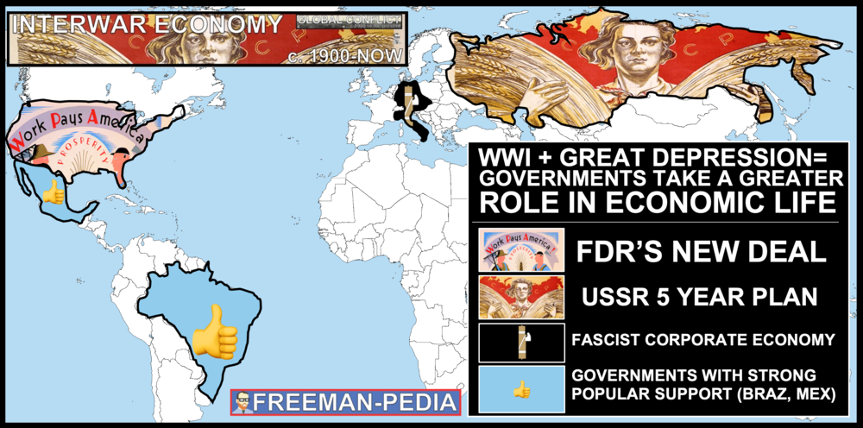

Introduction
The Interwar Economy is dominated by the Great Depression and how different countries responded. This was the largest economic crisis in World History. Different nations responded to this crisis in their own ways. The Soviets turned to their 5 Year Plans of rapid modernization and upgrading of production for the agricultural and industrial sectors. The United States practiced Keynesian Economics as the government pumped money into the economy by putting America back to work with FDR’s New Deal. Meanwhile, the Fascist states of Europe took control of their economies using protectionist policies to manipulate the economy to their own purposes. Following World War I and the onset of the Great Depression, governments began to take a more active role in economic life. In the Soviet Union, the government controlled the national economy through the Five Year Plans, often implementing repressive policies, with negative repercussions for the population.

Suggested Skill: Sourcing and Situation
2.C Explain the significance of a source’s point of view, purpose, historical situation, and/or audience, including how these might limit the use(s) of a source
See attachment titled “LEQ Unit 7 Argument Building Activity - Effects of the Great Depression”.

Learning Outcomes:
Thematic Focus: Economic Situations: As societies develop, they affect and are affected by the ways that they produce, exchange, and consume goods and services.
EQ #1: Explain how different governments responded to the economic crisis after 1900.
____________________________________________________________________________________________________________________________________________________________________________________________________________________________________________________________________________________________________________________________________________________________________________________________________________________________________________________________________________________________________________________________________________________________________________________________________________________________________________________________________________________________________________________________________________________________________________________________________________________________________________________________________________________________________________________________________________________________________________________________.

ILLUSTRATIVE EXAMPLES
- Government intervention in the economy:
  - The New Deal
  - The fascist corporatist economy
  - Governments with strong popular support in Brazil and Mexico

AP WORLD 2021-22 - KELLY Name:

Chapter 20: Topic 7.5 Period:
Unresolved Tensions after World War I
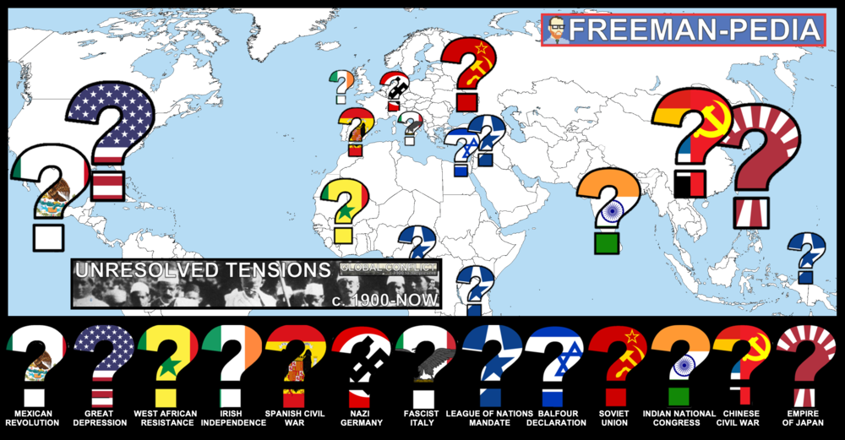

Introduction
The Great War is over! NEVER AGAIN! I’m sure everything will be fine from here on out… Wrong. There are a myriad of UNRESOLVED TENSIONS leftover after the first World War. Conflicts continued to rage after the Great War. And, these are not small localized wars. Conflicts like the Russian and Chinese Civil Wars saw Communism rise as a viable alternative to Capitalism. The Great Depression brought the world to its financial knees, shaking the earth’s finances to its core. Communism wasn’t the only alternative to the status quo as Fascist dictatorships brought the world to the brink of another Global Conflict. Between the two world wars, Western and Japanese imperial states predominantly maintained control over colonial holdings; in some cases, they gained additional territories through conquest or treaty settlement and in other cases faced anti-imperial resistance.

Suggested Skill: Sourcing and Situation
2.C Explain the significance of a source’s point of view, purpose, historical situation, and/or audience, including how these might limit the use(s) of a source.

See attachment titled “Unsolved Tensions After World War I Document Set”.

Learning Outcomes:
Thematic Focus: Governance: A variety of internal and external factors contribute to state formation, expansion, and decline. Governments maintain order through a variety of administrative institutions, policies, and procedures, and governments obtain, retain, and exercise power in different ways and for different purposes.
EQ #1: Explain the continuities and changes in territorial holdings from 1900 to the present.
____________________________________________________________________________________________________________________________________________________________________________________________________________________________________________________________________________________________________________________________________________________________________________________________________________________________________________________________________________________________________________________________________________________________________________________________________________________________________________________________________________________________________________________________________________________________________________________________________________________________________________________________________________________________________________________________________________________________________________________________.

Illustratives Examples to know:
- Territorial gains:
  - Transfer of former German colonies to Great Britain and France under the system of League of Nations mandates
  - Manchukuo/Greater East Asia Co-Prosperity Sphere
- Anti-imperial resistance:
  - Indian National Congress
  - West African resistance (strikes/congresses) to French rule

AP WORLD 2021-22 - KELLY Name:

Chapter 20: Topic 7.6 Period:
Causes of World War II
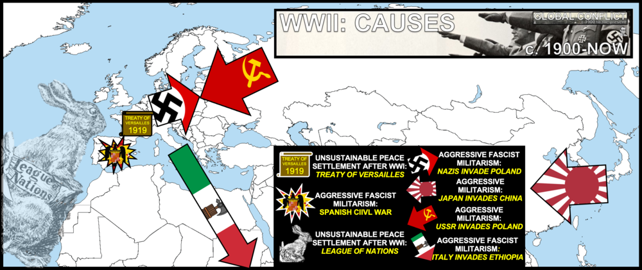

Introduction
You thought the Great War was bad? Well, I’ve got some bad news… There’s a Second World War… WWII. It’s the big one. It’s roughly 3x as large as the First World War (WWI). We’ll get to all the madness that took place in the actual war. But, this section is all about the CAUSES. This is a pretty big topic, but don’t get lost here go with what the College Board says. They break it down like this: Terrible peace treaties and systems (Treaty of Versailles and the League of Nations) that couldn’t keep the peace; the lingering effects of the Great Depression; the continued growth of the Western Empires (from Unit 6); and the rise of Fascist and Totalitarian regimes like Hitler and Stalin. The LITERAL cause here in the ATLANTIC THEATER was Germany’s invasion of Poland in 1939 and in the PACIFIC THEATER, it was Japan’s invasion of China in 1937. The causes of World War II included the unsustainable peace settlement after World War I, the global economic crisis engendered by the Great Depression, continued imperialist aspirations, and especially the rise to power of fascist and totalitarian regimes that resulted in the aggressive militarism of Nazi Germany under Adolf Hitler.

Suggested Skill: Sources and Situations
2.C Explain the significance of a source’s point of view, purpose, historical situation, and/or audience, including how these might limit the use(s) of a source

See attachment titled “Lead up to World War II Political Cartoons/Images Historical Situation Activity”.

Learning Outcomes:
Thematic Focus: Governance: A variety of internal and external factors contribute to state formation, expansion, and decline. Governments maintain order through a variety of administrative institutions, policies, and procedures, and governments obtain, retain, and exercise power in different ways and for different purposes.
EQ #1: Explain the causes and consequences of World War II.
____________________________________________________________________________________________________________________________________________________________________________________________________________________________________________________________________________________________________________________________________________________________________________________________________________________________________________________________________________________________________________________________________________________________________________________________________________________________________________________________________________________________________________________________________________________________________________________________________________________________________________________________________________________________________________________________________________________________________________________________.

AP WORLD 2021-22 - KELLY Name:

Chapter 20: Topic 7.7 Period:
Conducting World War II
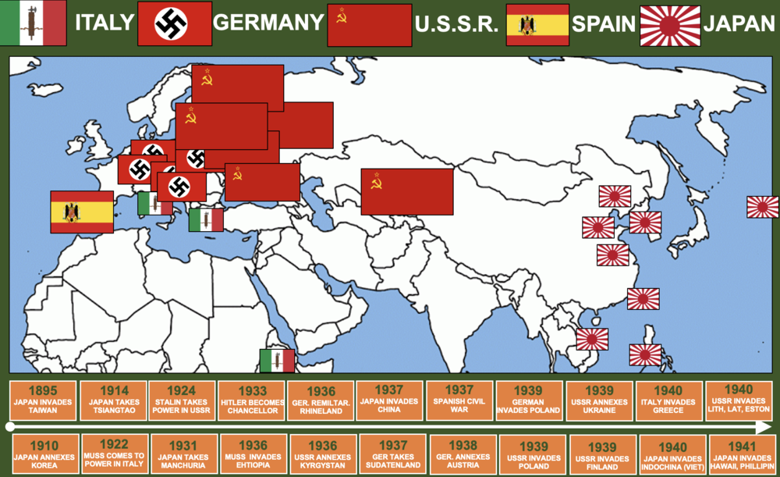

Introduction
This is EASILY the biggest event in the history of the planet. For 8 years, nearly the entire planet fought the deadliest war in human history. Countless books, shows, and movies have been made about WWII. In fact, WWII might be the thing you knew the most about coming into this course… WARNING: The College Board doesn’t expect you to know that much about it. So, DO NOT GET BOGGED DOWN HERE. Don’t worry about battles or people as much. Focus on what got the world into this war… and then what happened after this war. They really only want you to focus on the new weaponry in WWII for the actual fighting of the war: FIREBOMBING and NUCLEAR BOMBS. That’s it. So, watch Band of Brothers and Saving Private Ryan and Dunkirk later. Place WWII into the greater scheme of Unit 7, but don’t get lost here…World War II was a total war. Governments used a variety of strategies, including political propaganda, art, media, and intensified forms of nationalism, to mobilize populations (both in the home countries and the colonies or former colonies) for the purpose of waging war. Governments used ideologies, including fascism and communism to mobilize all of their state’s resources for war and, in the case of totalitarian states, to repress basic freedoms and dominate many aspects of daily life during the course of the conflicts and beyond. New military technology and new tactics, including the atomic bomb, fire-bombing, and the waging of “total war” led to increased levels of wartime casualties.

Suggested Skill: Claims and Evidence in Sources
3.D Explain how claims or evidence support, modify, or refute a source’s argument.
See attachment titled “The Human Cost of Total War”.

Learning Outcomes:
Thematic Focus: Governance: A variety of internal and external factors contribute to state formation, expansion, and decline. Governments maintain order through a variety of administrative institutions, policies, and procedures, and governments obtain, retain, and exercise power in different ways and for different purposes.
EQ #1: Explain similarities and differences in how governments used a variety of methods to conduct war.
____________________________________________________________________________________________________________________________________________________________________________________________________________________________________________________________________________________________________________________________________________________________________________________________________________________________________________________________________________________________________________________________________________________________________________________________________________________________________________________________________________________________________________________________________________________________________________________________________________________________________________________________________________________________________________________________________________________________________________________________.

Illustrative Examples to know:
- Western democracies mobilizing for war:
  - Great Britain under Winston Churchill
  - United States under Franklin Roosevelt
- Totalitarian states mobilizing for war:
  - Germany under Adolf Hitler
  - USSR under Joseph Stalin

AP WORLD 2021-22 - KELLY Name:

Chapter 20: Topic 7.8 Period:
Mass Atrocities after 1900
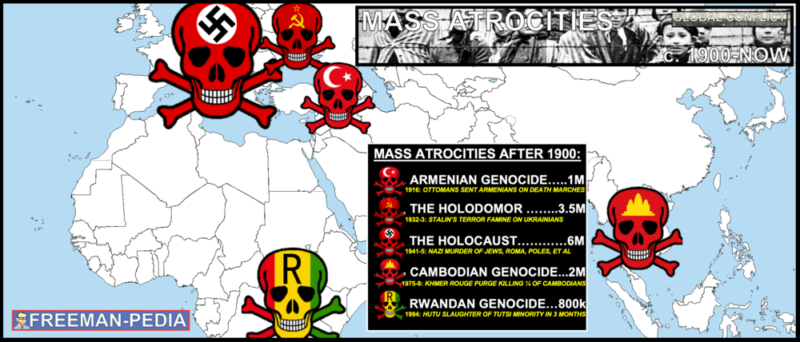

Introduction
The Global Conflicts of Unit 7 provide the appropriate backdrop to introduce the concept of GENOCIDE. We’ve seen mass atrocities before whether it was the Mongol expansion, diseases/Europeans killing the Native Americans, the death of 10 million Congolese under King Leopold II and many others. But, the CONTEMPORARY period is the first to see true genocides. The College Board wants you to focus on these 5: The Armenian Genocide in 1916, The Holodomor in the Ukraine in 1933, the Holocaust during WWII, the Cambodian Genocide in the 1970s, and the Rwandan Genocide in the summer of 1994. The rise of extremist groups in power led to the attempted destruction of specific populations, notably the Nazi killing of the Jews in the Holocaust during World War II, and to other atrocities, acts of genocide, or ethnic violence.

Suggested Skill: Making Connections
5.B Corroborate, qualify, or modify an argument using diverse and alternative evidence in order to develop a complex argument.

See attachment titled “Mass Atrocities in the Early 1900s - Armenia and Ukraine”.

Learning Outcomes:
Thematic Focus: Social Interactions and Organization: The process by which societies group their members and the norms that govern the interactions between these groups and between individuals influence political, economic, and cultural institutions and organization.
EQ #1: Explain the various causes and consequences of mass atrocities in the period from 1900 to the present.
____________________________________________________________________________________________________________________________________________________________________________________________________________________________________________________________________________________________________________________________________________________________________________________________________________________________________________________________________________________________________________________________________________________________________________________________________________________________________________________________________________________________________________________________________________________________________________________________________________________________________________________________________________________________________________________________________________________________________________________________.
ILLUSTRATIVE EXAMPLES
- Genocide, ethnic violence, or attempted destruction of specific populations:
  - Armenians in the Ottoman Empire during and after World War I
  - Cambodia during the late 1970s
  - Tutsi in Rwanda in the 1990s
  - Ukraine in the Soviet Union in the 1920s and 1930s

AP WORLD 2021-22 - KELLY Name:

Chapter AMSCO: Topic 7.9 Period:
Causation in Global Conflict

Introduction
Rapid advances in science and technology altered the understanding of the universe and the natural world and led to advances in communication, transportation, industry, agriculture, and medicine. Peoples and states around the world challenged the existing political and social order in varying ways, leading to unprecedented worldwide conflicts. The West dominated the global political order at the beginning of the 20th century, but both land-based and maritime empires gave way to new states by the century’s end. The older, land-based Ottoman, Russian, and Qing empires collapsed due to a combination of internal and external factors. These changes in Russia eventually led to communist revolution. States around the world challenged the existing political and social order, including the Mexican Revolution that arose as a result of political crisis..

Suggested Skill: Argumentation
6.D Corroborate, qualify, or modify an argument using diverse and alternative evidence in order to develop a complex argument. This argument might:
- Explain the nuance of an issue by analyzing multiple variables.
- Explain relevant and insightful connections within and across periods.
- Explain the relative historical significance of a source’s credibility and limitations.
- Explain how or why a historical claim or argument is or is not effective.
See attachment titled “Sources of World War I and World War II”.

Learning Outcomes:
EQ #1: Explain the relative significance of the causes of global conflict in the period 1900 to the present.
____________________________________________________________________________________________________________________________________________________________________________________________________________________________________________________________________________________________________________________________________________________________________________________________________________________________________________________________________________________________________________________________________________________________________________________________________________________________________________________________________________________________________________________________________________________________________________________________________________________________________________________________________________________________________________________________________________________________________________________________.

