AP WORLD 2021-22 - KELLY Name:

Period:

UNIT 6: Consequences of Industrialization c. 1750 to c. 1900
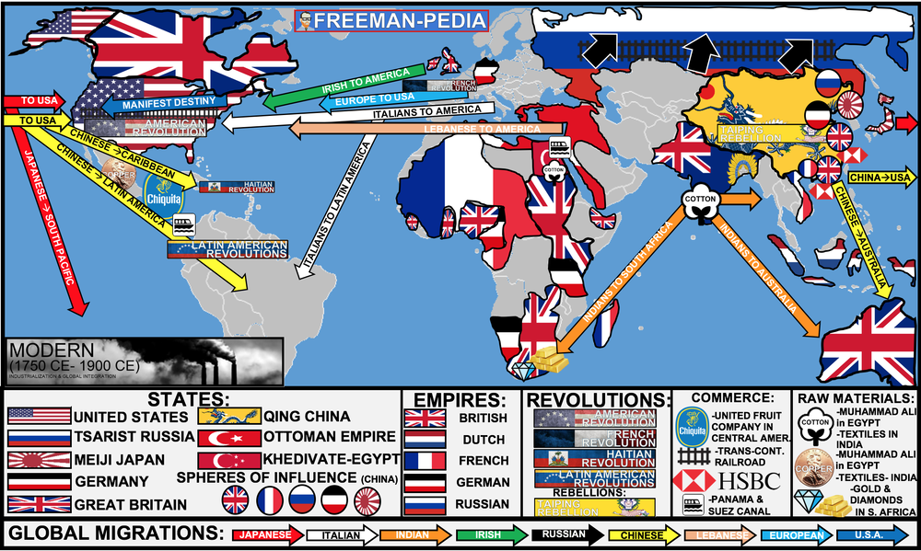

Topics of Study

Topic 6.1 Rationales for Imperialism: Ways of the World Ch.18
Topic 6.2 State Expansion from 1750: Ways of the World Ch.18
Topic 6.3 Indigenous Responses to State Expansion: Ways of the World AMSCO
Topic 6.4 Global Economic Development: Ways of the World Ch.18
Topic 6.5 Economic Imperialism: Ways of the World Ch.18
Topic 6.6 Causes of Migration in an Interconnected World: AMSCO
Topic 6.7 Effects of Migration: AMSCO
Topic 6.8 Causation in the Imperial Age: AMSCO

This period has two sections. The first one was all about the major changes in the Political World (Enlightenment/Revolutions) and the Economic World (Industrial Revolution). The second unit of the MODERN PERIOD (1750-1900) is all about the NEW IMPERIALISM. This is NOT your ‘Columbus sailed the Ocean Blue in 1492’. This time around the Europeans are looking for colonies to sell their products (MARKETS) and places to obtain more raw materials for their factories back home (MATERIALS). Using their new technological prowess, the West will dominate the world in search of M&Ms (MARKETS & MATERIALS).In the last unit, Industrialization pushed the West into a position of power; in this unit, they will flex that muscle around the globe. Below, are the many causes and effects of this NEW Imperialism.
AP WORLD 2021-22 - KELLY Name:

Chapter 18: Topic 6.1 Period:
Rationales for Imperialism 1750 - 1900
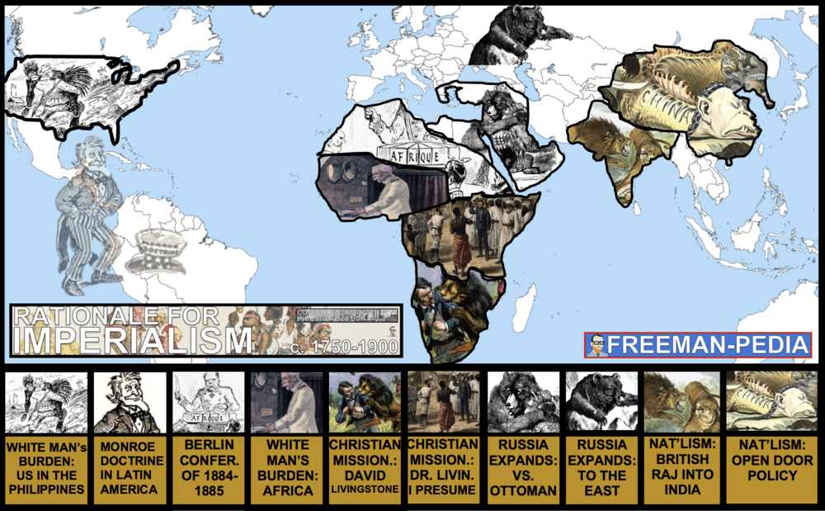

Introduction
Gotta love the College Board here… “Rationale”… That’s cute. These are the excuses, both real and imagined, as to why the Europeans are setting out around the world to conquer. This ain’t 1492. The Europeans aren’t dependent on Smallpox and a few garbage muskets to save them. This time, they have the backing of the Industrial Revolution (UNIT 5). The Europeans are set to go out and take over a HUGE chunk of the world. Why? These are are the RATIONALES for IMPERIALISM. A range of cultural, religious, and racial ideologies were used to justify imperialism, including Social Darwinism, nationalism, the concept of the civilizing mission, and the desire to religiously convert indigenous populations.

Suggested Skill: Contextualization
4.B Explain how a specific historical development or process is situated within a broader historical context.
See attachment titled “Motives for Imperialism DBQ”.

Learning Outcomes:
Thematic Focus: Cultural Developments and Interactions: The development of ideas, beliefs, and religions illustrates how groups in society view themselves, and the interactions of societies and their beliefs often have political, social, and cultural implications.
EQ #1: Explain how ideologies contributed to the development of imperialism from 1750 to 1900.
____________________________________________________________________________________________________________________________________________________________________________________________________________________________________________________________________________________________________________________________________________________________________________________________________________________________________________________________________________________________________________________________________________________________________________________________________________________________________________________________________________________________________________________________________________________________________________________________________________________________________________________________________________________________________________________________________________________________________________________________.

1. The Europeans are coming.

2. They are industrialized and are even more advanced than the last wave.

3. They will use their industrial might to take over your lands for the Raw Materials and to provide Markets to sell their industrially produced stuff.

4. They have a million excuses. Religion (missionaries), Science (Social Darwinism), Economics (Competition), Helping (White Man’s Burden)

5. But, the ONLY REAL rationale is to exploit your resources and dominate your markets.

AP WORLD 2021-22 - KELLY Name:

Chapter 18: Topic 6.2 Period:
State Expansion from 1750 to 1900
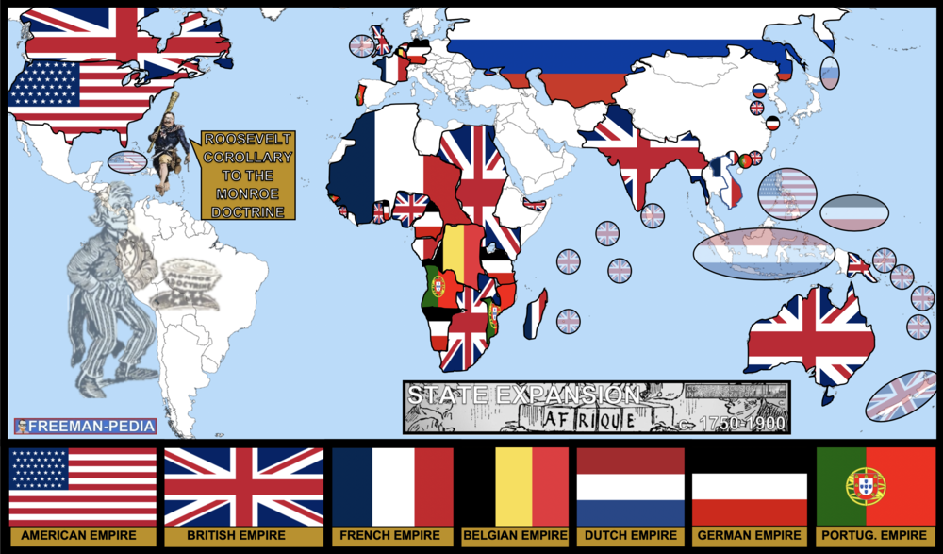

Introduction
Enough dancing around the issue… Imperialism is literally the EXPANSION of STATES. You’ve seen the reasoning (both real and imagined) for the Industrial West’s expansion. Now, we focus on where they went. You’ll see outcomes, economics, and other effects of this expansion. But, for now: Treat this like 4.2 CAUSES and EVENTS of the MARITIME EMPIRES. Using your knowledge of the ‘rationales’, now see where they go with their Industrial might and how their empires progress. These expansions have HUGE repercussions for the rest of the course, so don’t just glance at the map and move on. Double down on this one: It’s important. Some states with existing colonies strengthened their control over those colonies and in some cases assumed direct control over colonies previously held by non-state entities. European states as well as the United States and Japan acquired territories throughout Asia and the Pacific, while Spanish and Portuguese influence declined. Many European states used both warfare and diplomacy to expand their empires in Africa. Europeans established settler colonies in some parts of their empires. The United States, Russia, and Japan expanded their land holdings by conquering and settling neighboring territories.

Suggested Skill: Claims and Evidence in Sources
4.B Explain how a specific historical development or process is situated within a broader historical context.
See attachment titled “Atrocities in the Belgian Congo”.

Learning Outcomes:
Thematic Focus: Governance: A variety of internal and external factors contribute to state formation, expansion, and decline. Governments maintain order through a variety of administrative institutions, policies, and procedures, and governments obtain, retain, and exercise power in different ways and for different purposes.
EQ #1: Compare processes by which state power shifted in various parts of the world from 1750 to 1900.
____________________________________________________________________________________________________________________________________________________________________________________________________________________________________________________________________________________________________________________________________________________________________________________________________________________________________________________________________________________________________________________________________________________________________________________________________________________________________________________________________________________________________________________________________________________________________________________________________________________________________________________________________________________________________________________________________________________________________________________________.

Illustratives Examples to know:
- Non-state to state colonial control:
  - Shift from the private ownership of the Congo by King Leopold II to the Belgium government
  - Shift from the Dutch East India Company to Dutch government control in Indonesia and Southeast Asia
- European states that expanded empires in Africa:
  - Britain in West Africa
  - Belgium in the Congo
  - French in West Africa
- Settler colonies established in empires:
  - New Zealand

AP WORLD 2021-22 - KELLY Name:

Chapter AMSCO: Topic 6.3 Period:
Indigenous Responses to State Expansion from 1750 to 1900
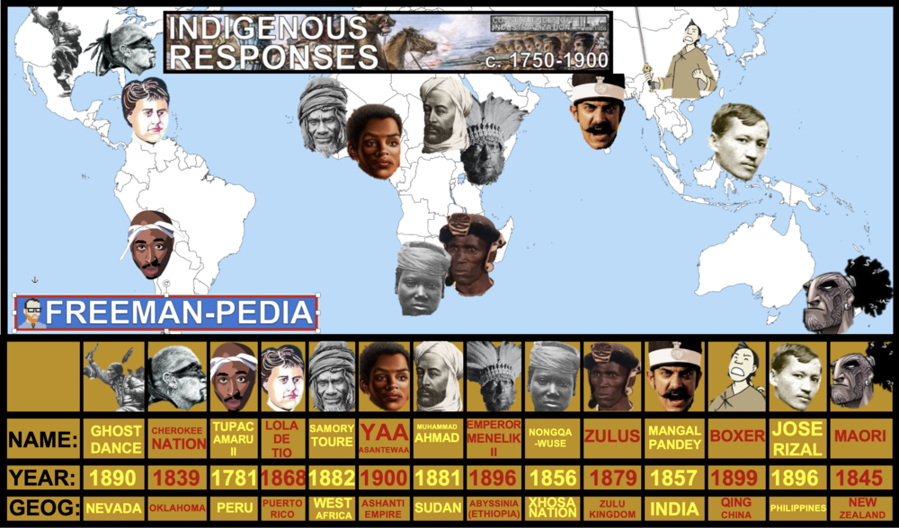

Introduction
Once the Europeans set out to take over… it’s pretty difficult to stop them. Why? See UNIT 5. Their Industrial strength is just too powerful. This does NOT mean that the indigenous people simply let it happen. There are a myriad of examples all over the world where the people fight back. Check the map below but these are just a few of the more famous examples. The problem that all of these peoples face is: HOW DO YOU FIGHT AN ARMY OF TECHNOLOGICALLY ADVANCED WESTERNERS WHO HAVE RAIL LINES, TELEGRAPHS, MACHINE GUNS, etc. etc. etc… Most people will lose. Most people will not be able to match the military prowess and technology of the new conquerors. Check out the map from 5.2: Most of the planet will be taken over by these guys. BUT, there are a select few who end up succeeding. Increasing questions about political authority and growing nationalism contributed to anticolonial movements. Anti-imperial resistance took various forms, including direct resistance within empires and the creation of new states on the peripheries. Increasing discontent with imperial rule led to rebellions, some of which were influenced by religious ideas.

Suggested Skill: Sourcing and Situation
2.C Explain the significance of a source’s point of view, purpose, historical situation, and/or audience, including how these might limit the use(s) of a source.
See attachment titled “Resistance to Imperialism Document Set”.

Learning Outcomes:
Thematic Focus: Governance: A variety of internal and external factors contribute to state formation, expansion, and decline. Governments maintain order through a variety of administrative institutions, policies, and procedures, and governments obtain, retain, and exercise power in different ways and for different purposes.
EQ #1: Explain how and why internal and external factors have influenced the process of state building from 1750 to 1900.
____________________________________________________________________________________________________________________________________________________________________________________________________________________________________________________________________________________________________________________________________________________________________________________________________________________________________________________________________________________________________________________________________________________________________________________________________________________________________________________________________________________________________________________________________________________________________________________________________________________________________________________________________________________________________________________________________________________________________________________________.

Illustratives Examples to know:
- Direct resistance:
  - Túpac Amaru II rebellion in Peru
  - Samory Touré’s military battles in West Africa
  - Yaa Asantewaa War in West Africa § 1857 rebellion in India
- New states:
  - Establishment of independent states in the Balkans
  - Sokoto Caliphate in modern-day Nigeria
  - Cherokee Nation § Zulu Kingdom
- Rebellions:
  - Ghost Dance in the U.S.
  - Xhosa Cattle-Killing Movement in Southern Africa
  - Mahdist wars in Sudan

AP WORLD 2021-22 - KELLY Name:

Chapter 18: Topic 6.4 Period:
Global Economic Development from 1750 to 1900
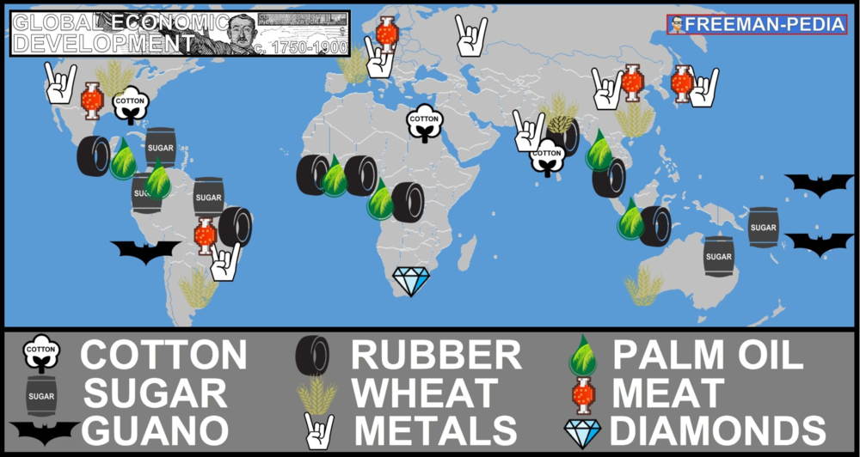

Introduction
The Europeans (and Japan) are Industrialized (or Industrializing). They need those Raw Materials to feed their industrial machines back home. Check out the map. Notice this is NOT the days of God, Gold and Glory. This is the age of Materials and Markets. Start to associate these raw materials with their ultimate uses whether it’s metals to machinery or guano to fertilizer or meat to eat. 6.2 was all about the expansion of these Empires… but, if you compare the map below to the 6.2 map, you can see what raw materials each nation was looking for/finding when building their empires. The need for raw materials for factories and increased food supplies for the growing population in urban centers led to the growth of export economies around the world that specialized in commercial extraction of natural resources and the production of food and industrial crops. The profits from these raw materials were used to purchase finished goods. The need for raw materials for factories and increased food supplies for the growing population in urban centers led to the growth of export economies around the world that specialized in commercial extraction of natural resources and the production of food and industrial crops. The profits from these raw materials were used to purchase finished goods.

Suggested Skill: Sourcing and Situation
2.B Explain the point of view, purpose, historical situation, and/or audience of a source.
See attachment titled “Making Connections: Global Exchange”.

Learning Outcomes:
Thematic Focus: Humans and the Environment: The environment shapes human societies, and as populations grow and change, these populations in turn shape their environments.
EQ #1: Explain how various environmental factors contributed to the development of the global economy from 1750 to 1900.
____________________________________________________________________________________________________________________________________________________________________________________________________________________________________________________________________________________________________________________________________________________________________________________________________________________________________________________________________________________________________________________________________________________________________________________________________________________________________________________________________________________________________________________________________________________________________________________________________________________________________________________________________________________________________________________________________________________________________________________________.

Illustratives Examples to know:
- Resource export economies:
  - Cotton production in Egypt
  - Rubber extraction in the Amazon and the Congo basin
  - The palm oil trade in West Africa
  - The guano industries in Peru and Chile
  - Meat from Argentina and Uruguay
  - Diamonds from Africa

AP WORLD 2021-22 - KELLY Name:

Chapter 18: Topic 6.5 Period:
Economic Imperialism from 1750 to 1900
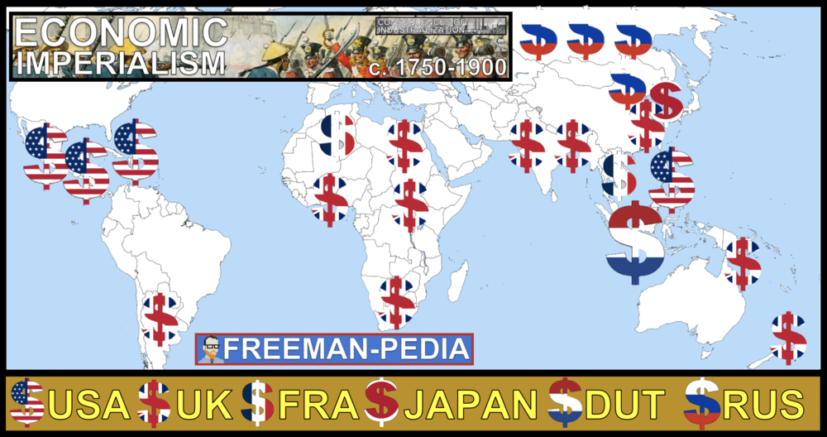

Introduction
Often, when you think of IMPERIALISM, images of Viceroys and Colonization come to mind. BUT, it’s not always that way. Sometimes, one country can rule over another without having to invade and sign treaties with existing rulers. This is the newest field of Imperialism studies in Social Sciences. The best way to think of Economic Imperialism is that the country doing the Imperializing (Mother Country) does not take over the government or try to rule them. Instead, they try to dominate their economies by exploiting them via their government or companies to get the cash crops, minerals, or whatever they want from their economic colony. Sometimes this is done almost entirely by businesses. The best example of this are the BANANA REPUBLICS of Central America. Industrialized states and businesses within those states practiced economic imperialism primarily in Asia and Latin America. Trade in some commodities was organized in a way that gave merchants and companies based in Europe and the U.S. a distinct economic advantage.

Suggested Skill: Sourcing and Situation
4.B Explain the point of view, purpose, historical situation, and/or audience of a source.
See attachment titled “Economic Imperialism Causation Activity”.

Learning Outcomes:
Thematic Focus: Economic Systems: As societies develop, they affect and are affected by the ways that they produce, exchange, and consume goods and services.
EQ #1: Explain how various economic factors contributed to the development of the global economy from 1750 to 1900
____________________________________________________________________________________________________________________________________________________________________________________________________________________________________________________________________________________________________________________________________________________________________________________________________________________________________________________________________________________________________________________________________________________________________________________________________________________________________________________________________________________________________________________________________________________________________________________________________________________________________________________________________________________________________________________________________________________________________________________________.

Illustratives Examples to know:
- Industrialized states practicing economic imperialism:
  - Britain and France expanding their influence in China through the Opium Wars
  - The construction of the Port of Buenos Aires with the support of British firms
- Commodities that contributed to European and American economic advantage:
  - Opium produced in the Middle East or South Asia and exported to China
  - Cotton grown in South Asia and Egypt and exported to Great Britain and other European countries
  - Palm oil produced in sub-Saharan Africa and exported to European countries
  - Copper extracted in Chile

AP WORLD 2021-22 - KELLY Name:

Chapter AMSCO: Topic 6.6 Period:
Causes of Migration in an Interconnected World
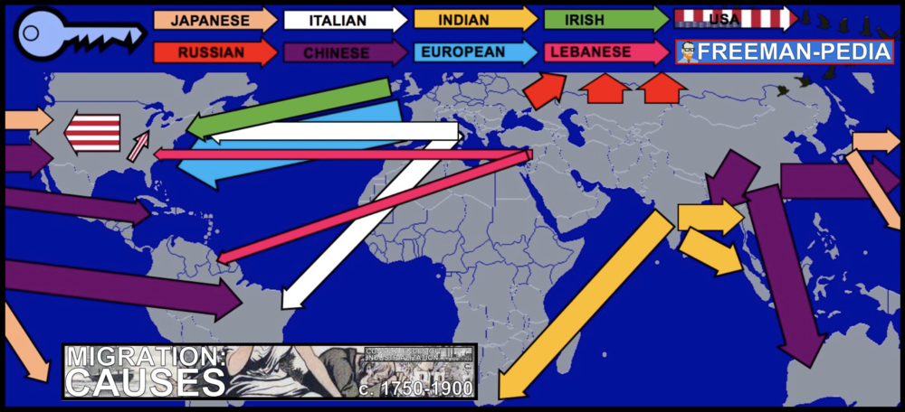

Introduction
The last two sections of this unit are focused on Migration. Due to all of the technological innovations seen in UNIT 5, it was now possible for millions of people to emigrate from their country of origin to new places. There are a number of reasons why and how people left and moved. Some were PUSH factors: Famine, war, strife, conflict… Some were PULL factors: jobs, space, opportunity… Below are the causes of the mass migrations of the 1800s. Migration in many cases was influenced by changes in demographics in both industrialized and unindustrialized societies that presented challenges to existing patterns of living. Because of the nature of new modes of transportation, both internal and external migrants increasingly relocated to cities. This pattern contributed to the significant global urbanization of the 19th century. The new methods of transportation also allowed for many migrants to return, periodically or permanently, to their home societies. Many individuals chose freely to relocate, often in search of work. The new global capitalist economy continued to rely on coerced and semi-coerced labor migration, including enslavement of Chinese and Indian indentured servitude, and convict labor.

Suggested Skill: Making Connections
5.B Explain how a historical development or process relates to another historical development or process.
See attachment titled “Global Migration Google Slides Presentation w/6.7”.

Learning Outcomes:
Thematic Focus: Humans and the Environments: The environment shapes human societies, and as populations grow and change, these populations in turn shape their environments.
EQ #1: Explain how various environmental factors contributed to the development of varied patterns of migration from 1750 to 1900.
____________________________________________________________________________________________________________________________________________________________________________________________________________________________________________________________________________________________________________________________________________________________________________________________________________________________________________________________________________________________________________________________________________________________________________________________________________________________________________________________________________________________________________________________________________________________________________________________________________________________________________________________________________________________________________________________________________________________________________________________.
Thematic Focus: Economic Systems: As societies develop, they affect and are affected by the ways that they produce, exchange, and consume goods and services.
EQ #1: Explain how various economic factors contributed to the development of varied patterns of migration from 1750 to 1900.
____________________________________________________________________________________________________________________________________________________________________________________________________________________________________________________________________________________________________________________________________________________________________________________________________________________________________________________________________________________________________________________________________________________________________________________________________________________________________________________________________________________________________________________________________________________________________________________________________________________________________________________________________________________________________________________________________________________________________________________________.

Illustratives Examples to know:
- Return of migrants:
  - Japanese agricultural workers in the Pacific
  - Lebanese merchants in the Americas
  - Italian industrial workers in Argentina
  - Irish to the United States
  - British engineers and geologists to South Asia and Africa

AP WORLD 2021-22 - KELLY Name:

Chapter AMSCO: Topic 6.7 Period:
Effects of Migration

Introduction
OK. People are on the move for a myriad of reasons. But, there are just as many effects when they arrive. 6.6 was all about why these people were on the move. 6.6 is about the effects. Most of what’s covered here is about the types of labor the immigrants are doing or the discrimination they face. The labor was manual. It was hard work on cash crops, mines, railroads, etc. These are jobs the immigrants would do for a cheaper cost. Arrival in large numbers, working tough jobs, and moving into cities is no way to make friends with the locals. These groups (seen in the arrows on the map) tended to stick together in Enclaves that can still be seen today in Chinatowns et al. Many countries (most notably South Africa, USA, and Australia) tried to pass laws and quotas on how many people could arrive from certain places in the world (most notably China). Without these migrations, the world would look very different (and, in fact, you would probably live in a different place than you do right now… maybe). Migrants tended to be male, leaving women to take on new roles in the home society that had been formerly occupied by men. Migrants often created ethnic enclaves in different parts of the world that helped transplant their culture into new environments. Receiving societies did not always embrace immigrants, as seen in the various degrees of ethnic and racial prejudice and the ways states attempted to regulate the increased flow of people across their borders.

Suggested Skill: Making Connections
5.B Explain how a historical development or process relates to another historical development or process.
See attachment titled “Global Migration Google Slides Presentation w/6.7”.

Learning Outcomes:
Thematic Focus: Social Interactions and Organization: The process by which societies group their members and the norms that govern the interactions between these groups and between individuals influence political, economic, and cultural institutions and organization.
EQ #1: Explain how and why new patterns of migration affected society from 1750 to 1900.
____________________________________________________________________________________________________________________________________________________________________________________________________________________________________________________________________________________________________________________________________________________________________________________________________________________________________________________________________________________________________________________________________________________________________________________________________________________________________________________________________________________________________________________________________________________________________________________________________________________________________________________________________________________________________________________________________________________________________________________________.

Illustratives Examples to know:
- Migrant ethnic enclaves:
  - Chinese in Southeast Asia, the Caribbean, South America, and North America
  - Indians in East and Southern Africa, the Caribbean, and Southeast Asia
  - Irish in North America
  - Italians in North and South America
- Regulation of immigrants:
  - Chinese Exclusion Act
  - White Australia policy

AP WORLD 2021-22 - KELLY Name:

Chapter AMSCO: Topic 6.8 Period:
Causation in the Imperial Age

Introduction
OK. People are on the move for a myriad of reasons. But, there are just as many effects when they arrive. 6.6 was all about why these people were on the move. 6.6 is about the effects. Most of what’s covered here is about the types of labor the immigrants are doing or the discrimination they face. The labor was manual. It was hard work on cash crops, mines, railroads, etc. These are jobs the immigrants would do for a cheaper cost. Arrival in large numbers, working tough jobs, and moving into cities is no way to make friends with the locals. These groups (seen in the arrows on the map) tended to stick together in Enclaves that can still be seen today in Chinatowns et al. Many countries (most notably South Africa, USA, and Australia) tried to pass laws and quotas on how many people could arrive from certain places in the world (most notably China). Without these migrations, the world would look very different (and, in fact, you would probably live in a different place than you do right now… maybe). Migrants tended to be male, leaving women to take on new roles in the home society that had been formerly occupied by men. Migrants often created ethnic enclaves in different parts of the world that helped transplant their culture into new environments. Receiving societies did not always embrace immigrants, as seen in the various degrees of ethnic and racial prejudice and the ways states attempted to regulate the increased flow of people across their borders. The development of industrial capitalism led to increased standards of living for some, and to continued improvement in manufacturing methods that increased the availability, affordability, and variety of consumer goods. As states industrialized, they also expanded existing overseas empires and established new colonies and transoceanic relationships. The 18th century marked the beginning of an intense period of revolution and rebellion against existing governments, leading to the establishment of new nation-states around the world. As a result of the emergence of transoceanic empires and a global capitalist economy, migration patterns changed dramatically, and the numbers of migrants increased significantly

Suggested Skill: Making Connections
5.D Corroborate, qualify, or modify an argument using diverse and alternative evidence in order to develop a complex argument.
See attachment titled “Imperialism - Causation Chalk Talk”.

Learning Outcomes:
EQ #1: Explain the relative significance of the effects of imperialism from 1750 to 1900.
____________________________________________________________________________________________________________________________________________________________________________________________________________________________________________________________________________________________________________________________________________________________________________________________________________________________________________________________________________________________________________________________________________________________________________________________________________________________________________________________________________________________________________________________________________________________________________________________________________________________________________________________________________________________________________________________________________________________________________________________.
1. Immigration has always happened in history.
2. But, in the 19th Century (1800s) it took off (see 6.6).
3. SPOILER: Not everyone was happy to see the new arrivals.
4. Immigrants, much like today, were met with harassment and discrimination.
5. The cultures they brought mixed and melded wherever they went helping to create the global world as we know it today.

