AP WORLD 2021-22 - KELLY Name:

UNIT 5: Revolutions c. 1750 to c. 1900 Period:
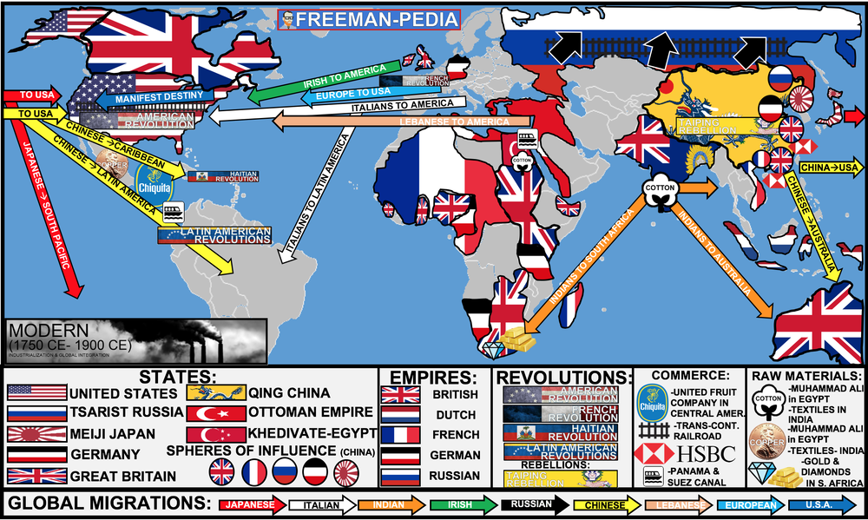

Topics of Study

Topic 5.1 The Enlightenment: Ways of the World Ch. 15
Topic 5.2 Nationalism and Revolutions in the world: Ways of the World Ch. 16
Topic 5.3 Industrial Revolution Begins: Ways of the World Ch. 17
Topic 5.4 Industrialization Spreads: Ways of the World AMSCO
Topic 5.5 Technology of the Industrial Age: Ways of the World AMSCO
Topic 5.6 Industrialization: Government’s Role: Ch.19
Topic 5.7 Economic Developments and Innovations: Ch.19
Topic 5.8 Reactions to the Industrial Economy: Ch.19
Topic 5.9 Society and the Industrial Age: Ch.17
Topic 5.10 Continuity and Change in the Industrial Age: AMSCO

Our first steps into the MODERN PERIOD (1750-1900) are revolutionary. The last period saw its fair share of change; but this period is ALL ABOUT CHANGE. We begin with the Political Revolutions (USA!, France, Haiti, Latin America). But, the majority of this unit deals with a revolution of a different kind… THE INDUSTRIAL REVOLUTION. There is no greater change in humanity than the Industrial Revolution. It’s on par with the Agricultural Revolution in changing the way humanity functions as a whole. Look around you right now… pretty much everything near you is a product of the Industrial Revolution (including the school you’re in!). These are the Revolutions of the Modern Period (1750-1900).
AP WORLD 2021-22 - KELLY Name:

Chapter 15: Topic 5.1 Period:
The Enlightenment 1750 - 1900
Topic 5.1: How revolutions begin
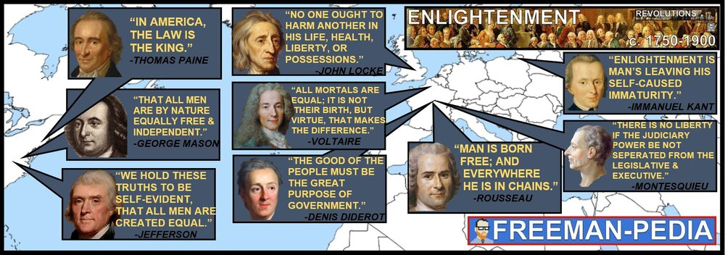

Introduction
The last period laid the foundations for the changes you are about to see in this period. The people in the image/banner above don’t look very modern. They’re not. The Enlightenment was a movement in the 18th Century (1700s) that led to the changes in government that brought you such governments as The United States, the French Republic, Haiti, and the 5+ countries that Bolivar freed. Most of the influential writings in the Enlightenment happened in the last period or at the VERY beginning of this period (c. 1750). But, if you don’t understand the Enlightenment, you can’t understand the Revolutions. Think of the Scientific Revolution; but instead of blood circulation or astronomy; apply that logic and reasoning to the government… Why do we have a King again? Because God said so? Nah… that can’t be right… This is the Enlightenment. Enlightenment philosophies applied new ways of understanding and empiricist approaches to both the natural world and human relationships; they also reexamined the role that religion played in public life and emphasized the importance of reason. Philosophers developed new political ideas about the individual, natural rights, and the social contract. The rise and diffusion of Enlightenment thought that questioned established traditions in all areas of life often preceded revolutions and rebellions against existing governments. Nationalism also became a major force shaping the historical development of states and empires. Enlightenment ideas and religious ideals influenced various reform movements. These reform movements contributed to the expansion of rights, as seen in expanded suffrage, the abolition of slavery, and the end of serfdom. Demands for women’s suffrage and an emergent feminism challenged political and gender hierarchies.

Suggested Skill: Claims and Evidence in Sources
3.A Identify and describe a claim and/or argument in a text-based or non text-based source.
See attachment titled “Enlightenment Document Excerpts”.

Learning Outcomes:
Thematic Focus: Cultural Developments and Interactions: The development of ideas, beliefs, and religions illustrates how groups in society view themselves, and the interactions of societies and their beliefs often have political, social, and cultural implications.
EQ #1: Explain the intellectual and ideological context in which revolutions swept the Atlantic world from 1750 to 1900.
____________________________________________________________________________________________________________________________________________________________________________________________________________________________________________________________________________________________________________________________________________________________________________________________________________________________________________________________________________________________________________________________________________________________________________________________________________________________________________________________________________________________________________________________________________________________________________________________________________________________________________________________________________________________________________________________________________________________________________________________.
Thematic Focus: Social Interactions and Organization: The process by which societies group their members and the norms that govern the interactions between these groups and between individuals influence political, economic, and cultural institutions and organization.
EQ #2: Explain how the Enlightenment affected societies over time.
____________________________________________________________________________________________________________________________________________________________________________________________________________________________________________________________________________________________________________________________________________________________________________________________________________________________________________________________________________________________________________________________________________________________________________________________________________________________________________________________________________________________________________________________________________________________________________________________________________________________________________________________________________________________________________________________________________________________________________________________.

Illustratives Examples to know:
- Demands:
  - Mary Wollstonecraft’s A Vindication of the Rights of Woman
  - Olympe de Gouges’s Declaration of the Rights of Woman and of the Female Citizen
  - Seneca Falls Conference (1848) organized by Elizabeth Cady Stanton and Lucretia Mott

AP WORLD 2021-22 - KELLY Name:

Chapter 16: Topic 5.2 Period:
Nationalism and Revolutions
Topic 5.2: Call to Arms
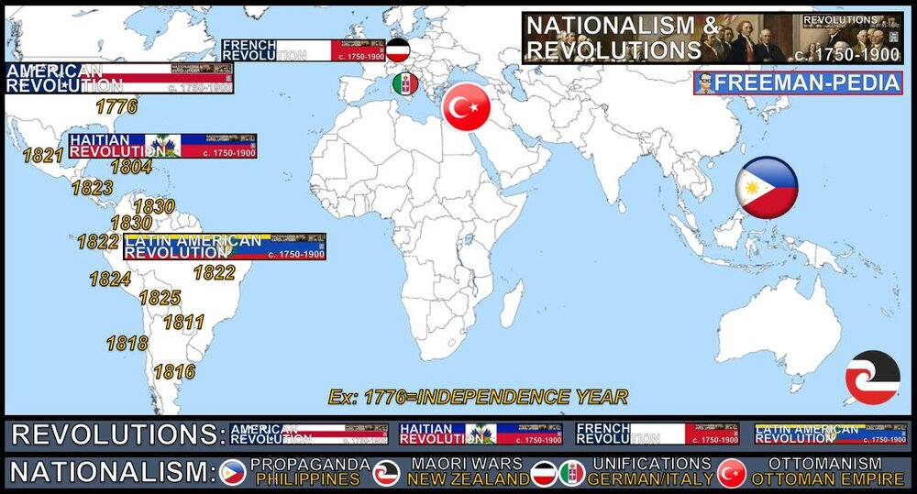

Introduction
All of those philosophes and writings about the purpose of government and how society should function did not happen in a vacuum. Around the world, people started to put the Philosophe’s arguments into play. Starting in America, revolutions swept the colonies as former mercantile dependents severed the bonds that tied them to the mother country. But, this was not all about revolution. A new idea took root on the heels of the American and French Revolution. People of the same culture, language, history, laws, etc. began to push to have their own nations. These nationalist ideas took hold from the Philippines to the Ottoman Empire to Germany & Italy, and even New Zealand and Puerto Rico. People around the world developed a new sense of commonality based on language, religion, social customs, and territory. This was sometimes harnessed by governments to foster a sense of unity. The 18th century marked the beginning of an intense period of revolution and rebellion against existing governments, leading to the establishment of new nation-states around the world. Discontent with monarchist and imperial rule encouraged the development of systems of government and various ideologies, including democracy and 19th-century liberalism.
Colonial subjects in the Americas led a series of rebellions inspired by democratic ideals. The American Revolution, and its successful establishment of a republic, the United States of America, was a model and inspiration for a number of the revolutions that followed. The American Revolution, the Haitian Revolution, and the Latin American independence movements facilitated the emergence of independent states in the Americas. The ideas of Enlightenment philosophers, as reflected in revolutionary documents— including the American Declaration of Independence during the American Revolution, the French “Declaration of the Rights of Man and of the Citizen” during the French Revolution, and Bolívar’s “Letter from Jamaica” on the eve of the Latin American revolutions— influenced resistance to existing political authority, often in pursuit of independence and democratic ideals. Newly imagined national communities often linked this new national identity with borders of the state, and in some cases, nationalists challenged boundaries or sought unification of fragmented regions.

Suggested Skill: Claims and Evidence in Sources
3.C Compare the arguments or main ideas of two sources.
See attachment titled “Documents of the Atlantic Revolutions”.

Learning Outcomes:
Thematic Focus: Governance: A variety of internal and external factors contribute to state formation, expansion, and decline. Governments maintain order through a variety of administrative institutions, policies, and procedures, and governments obtain, retain, and exercise power in different ways and for different purposes.
EQ #1: Explain causes and effects of the various revolutions in the period from 1750 to 1900.
____________________________________________________________________________________________________________________________________________________________________________________________________________________________________________________________________________________________________________________________________________________________________________________________________________________________________________________________________________________________________________________________________________________________________________________________________________________________________________________________________________________________________________________________________________________________________________________________________________________________________________________________________________________________________________________________________________________________________________________________.

Illustratives Examples to know:
- Call for national unification or liberation:
  - Propaganda Movement in the Philippines
  - Maori nationalism and the New Zealand wars in New Zealand
  - Puerto Rico—writings of Lola Rodríguez de Tió
  - German and Italian unifications
  - Balkan nationalisms
  - Ottomanism

1. The Industrial Revolution began in Great Britain.

2. Great Britain had rivers, canals, coal, iron, capital and an empire.

3. Each invention led to another that continually improved production.

4. People stopped working in the home, and worked in factories around complex machinery.

5. Britain will have a huuuuge head start in the Industrial Revolution, but will be copied by others.

AP WORLD 2021-22 - KELLY Name:

Chapter 17: Topic 5.3 Period:
Industrial Revolution Begins
Topic 5.3: The World meets its future
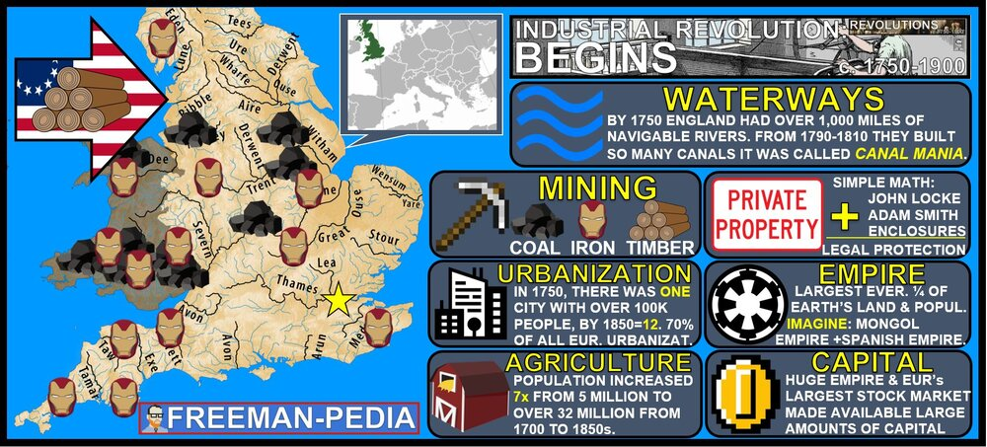

Introduction
The Industrial Revolution is one of the most important “events” to ever occur on this planet. It changed everything. But, it had to start somewhere. And, for the Industrial Revolution, that means Great Britain. British people aren’t better than you (see 1776), but they had the perfect ingredients for this movement to begin. They had a perfect storm of CAPITAL (wealth), NATURAL RESOURCES (waterways, coal, iron), and INGENUITY (a huge chunk of the inventors your teacher probably yelled at you are from Great Britain. So, it begins here. It also begins in and around the TEXTILE industry. Don’t think that the Industrial Revolution started with Oil and Skyscrapers… It was more like steam and better ways to make clothing. A variety of factors contributed to the growth of industrial production and eventually resulted in the Industrial Revolution, including:
- Proximity to waterway
- Access to rivers and canals
- Geographical distribution of coal, iron, and timber
- Urbanization
- Improved agricultural productivity
- Legal protection of private property
- Access to foreign resources
- Accumulation of capital
The development of the factory system concentrated production in a single location and led to an increasing degree of specialization of labor.
Suggested Skill: Developments and Processes
1.B Explain a historical concept, development, or process
See attachment titled “Causes of the IR Debate Activity”.

Learning Outcomes:
Thematic Focus: Humans and the Environments: The environment shapes human societies, and as populations grow and change, these populations in turn shape their environments.
EQ #1: Explain how environmental factors contributed to industrialization from 1750 to 1900.
____________________________________________________________________________________________________________________________________________________________________________________________________________________________________________________________________________________________________________________________________________________________________________________________________________________________________________________________________________________________________________________________________________________________________________________________________________________________________________________________________________________________________________________________________________________________________________________________________________________________________________________________________________________________________________________________________________________________________________________________.

Illustratives Examples to know:
- Call for national unification or liberation:
  - Propaganda Movement in the Philippines
  - Maori nationalism and the New Zealand wars in New Zealand
  - Puerto Rico—writings of Lola Rodríguez de Tió
  - German and Italian unifications
  - Balkan nationalisms
  - Ottomanism
AP WORLD 2021-22 - KELLY Name:

Chapter AMSCO: Topic 5.4 Period:
Industrialization Spreads
Topic 5.4: Technology is contagious!
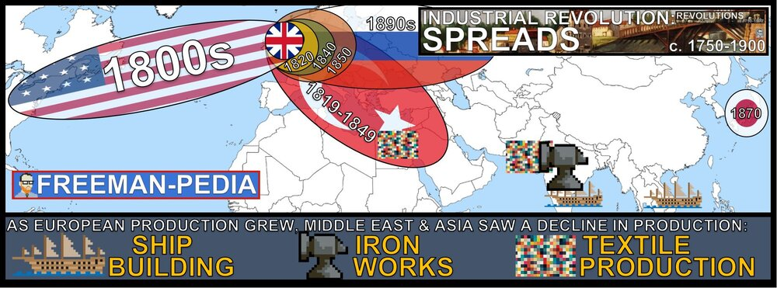

Introduction
Good ideas spread. The Industrial Revolution will change the world. And that idea spread pretty quickly once it was out. Where does it spread? Initially, just to Europe and the USA. But, there will be attempts to copy this all over the world. Sometimes governments will get directly involved (but that’s a later section of this unit). For now, focus on the places that immediately start trying to copy Great Britain first. The rapid development of steam-powered industrial production in European countries and the U.S. contributed to the increase in these regions’ share of global manufacturing during the first Industrial Revolution. While Middle Eastern and Asian countries continued to produce manufactured goods, these regions’ share in global manufacturing declined. As new methods of industrial production became more common in parts of northwestern Europe, they spread to other parts of Europe and the United States, Russia, and Japan.
Suggested Skill: Making Connections
5.A Identify patterns among or connections between historical developments and processes.
See attachment titled “The DBQ Argument Building Activity”.

Learning Outcomes:
Thematic Focus: Technology and Innovation: Human adaptation and innovation have resulted in increased efficiency, comfort, and security, and technological advances have shaped human development and interactions with both intended and unintended consequences.
EQ #1: Explain how different modes and locations of production have developed and changed over time.
____________________________________________________________________________________________________________________________________________________________________________________________________________________________________________________________________________________________________________________________________________________________________________________________________________________________________________________________________________________________________________________________________________________________________________________________________________________________________________________________________________________________________________________________________________________________________________________________________________________________________________________________________________________________________________________________________________________________________________________________.

Illustratives Examples to know:
- Decline of Middle Eastern and Asian share in global manufacturing:
  - Shipbuilding in India and Southeast Asia
  - Iron works in India
  - Textile production in India and Egypt

AP WORLD 2021-22 - KELLY Name:

Chapter AMSCO: Topic 5.5 Period:
Technology of the Industrial Age
Topic 5.5: New forms of Tech!
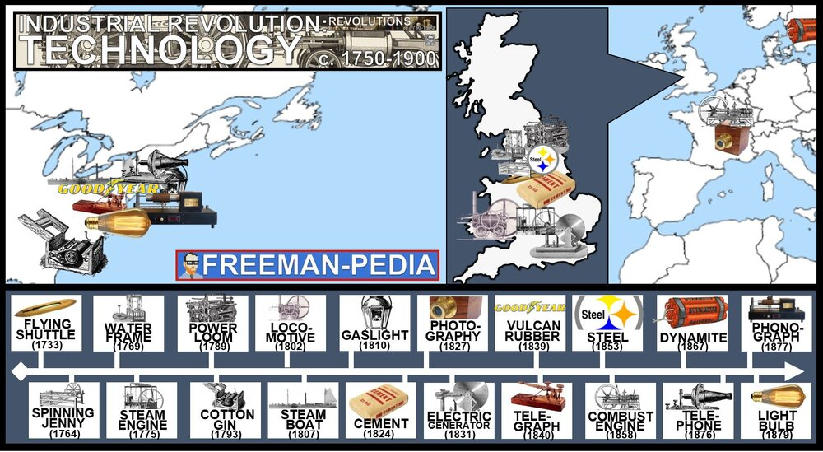

Introduction
Finally… All of this talk about “progress”, “advancements”, “improvements”, “production”… But, HOW? Let’s focus for a second on the actual means of production. How are they sewing so fast? How did they get that yarn spun so quickly? How does boiling water make energy? How does dead dinosaur oil explosions make a car run? Why are the buildings so tall now? Why is everyone rushing to live all cramped in a city? THESE are the technologies that reshaped the historical world to something that looks more modern. The development of machines, including steam engines and the internal combustion engine, made it possible to take advantage of both existing and vast newly discovered resources of energy stored in fossil fuels, specifically coal and oil. The fossil fuels revolution greatly increased the energy available to human societies. The “second industrial revolution” led to new methods in the production of steel, chemicals, electricity, and precision machinery during the second half of the 19th century. Railroads, steamships, and the telegraph made exploration, development, and communication possible in interior regions globally, which led to increased trade and migration.
Suggested Skill: Developments and Processes
1.B Explain a historical concept, development, or process.
See attachment titled “Four Corners: Industrial Revolution Inventions/Developments Activity”.

Learning Outcomes:
Thematic Focus: Technology and Innovation: Human adaptation and innovation have resulted in increased efficiency, comfort, and security, and technological advances have shaped human development and interactions with both intended and unintended consequences.
EQ #1: Explain how technology shaped economic production over time.
____________________________________________________________________________________________________________________________________________________________________________________________________________________________________________________________________________________________________________________________________________________________________________________________________________________________________________________________________________________________________________________________________________________________________________________________________________________________________________________________________________________________________________________________________________________________________________________________________________________________________________________________________________________________________________________________________________________________________________________________.

AP WORLD 2021-22 - KELLY Name:

Chapter 19: Topic 5.6 Period:
Industrialization: Government’s Role
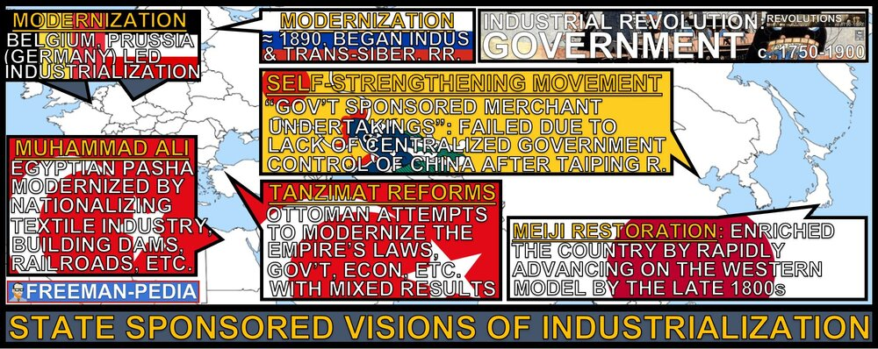
Topic 5.6: Role of the Government during the IR

Introduction
This Industrial Revolution thing is a hit. Everyone is doing it. But, if your nation is not modernizing/industrializing enough to keep up with the “Big Boys” (Britain, US, Germany); sometimes the government will step in with an Industrialization plan of their own. There are really three to know: Japan (Meiji), Ottomans (Tanzimat) and China (Self Strengthening). But, there are others like Muhammad Ali in Egypt and the Russians beginning to modernize in the 1890s. As the influence of the Industrial Revolution grew, a small number of states and governments promoted their own state sponsored visions of industrialization. The expansion of U.S. and European influence in Asia led to internal reform in Japan that supported industrialization and led to the growing regional power of Japan in the Meiji Era.
Suggested Skill: Making Connections
5.A Identify patterns among or connections between historical developments and processes.
See attachment titled “Meiji Restoration through Art”.

Learning Outcomes:
Thematic Focus: Governance: A variety of internal and external factors contribute to state formation, expansion, and decline. Governments maintain order through a variety of administrative institutions, policies, and procedures, and governments obtain, retain, and exercise power in different ways and for different purposes.
EQ #1: Explain the causes and effects of economic strategies of different states and empires.
____________________________________________________________________________________________________________________________________________________________________________________________________________________________________________________________________________________________________________________________________________________________________________________________________________________________________________________________________________________________________________________________________________________________________________________________________________________________________________________________________________________________________________________________________________________________________________________________________________________________________________________________________________________________________________________________________________________________________________________________.

Illustratives Examples to know:
- State-sponsored visions of industrialization:
  - Muhammad Ali’s development of a cotton textile industry in Egypt

AP WORLD 2021-22 - KELLY Name:

Chapter 19: Topic 5.7 Period:
Economic Developments and Innovations
Topic 5.7: Birth of Consumerism

Introduction
This Industrial Revolution thing is a hit. Everyone is doing it. But, if your nation is not modernizing/industrializing enough to keep up with the “Big Boys” (Britain, US, Germany); sometimes the government will step in with an Industrialization plan of their own. There are really three to know: Japan (Meiji), Ottomans (Tanzimat) and China (Self Strengthening). But, there are others like Muhammad Ali in Egypt and the Russians beginning to modernize in the 1890s. As the influence of the Industrial Revolution grew, a small number of states and governments promoted their own state sponsored visions of industrialization. The expansion of U.S. and European influence in Asia led to internal reform in Japan that supported industrialization and led to the growing regional power of Japan in the Meiji Era. Western European countries began abandoning mercantilism and adopting free trade policies, partly in response to the growing acceptance of Adam Smith’s theories of laissez-faire capitalism and free markets. The global nature of trade and production contributed to the proliferation of large-scale transnational businesses that relied on new practices in banking and finance. The development of industrial capitalism led to increased standards of living for some, and to continued improvement in manufacturing methods that increased the availability, affordability, and variety of consumer goods.
Suggested Skill: Making Connections
5.B Explain how a historical development or process relates to another historical development or process.

See attachment titled “Qing China and Ottoman Empire Comparison Activity”.

Learning Outcomes:
Thematic Focus: Economic Systems: As societies develop, they affect and are affected by the ways that they produce, exchange, and consume goods and services.
EQ #1: Explain the development of economic systems, ideologies, and institutions and how they contributed to change in the period from 1750 to 1900.
____________________________________________________________________________________________________________________________________________________________________________________________________________________________________________________________________________________________________________________________________________________________________________________________________________________________________________________________________________________________________________________________________________________________________________________________________________________________________________________________________________________________________________________________________________________________________________________________________________________________________________________________________________________________________________________________________________________________________________________________.

Illustratives Examples to know:
- Transnational businesses:
  - Hong Kong and Shanghai Banking Corporation (HSBC)
  - Unilever based in England and the Netherlands and operating in British West Africa and the Belgian Congo
- Financial instruments:
  - Stock markets
  - Limited-liability corporations

AP WORLD 2021-22 - KELLY Name:

Chapter 19: Topic 5.8 Period:
Reactions to the Industrial Economy
Topic 5.8: Birth of Consumerism
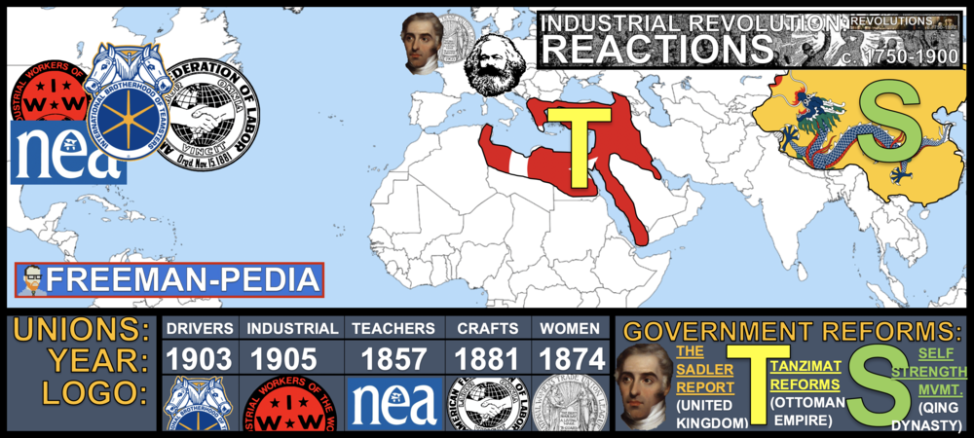

Introduction
OK, the world is a different place now that the Industrial Revolution has spread around the globe. But, not everyone is happy with what is happening. Workers (men, women, and children) were being exploited as Laissez-faire policies let the Controllers of the Means of Production free to conduct their factories in any way they chose. However, many philosophers came up with new ideas to challenge the status quo. The most famous was Karl Marx. His theories called up for the workers to rise up and seize the means of production. Workers began to form unions to push for rights for all workers. Meanwhile, older empires tried to play catch up. The Ottomans and the Qing both tried to catch up with state sponsored Industrial programs, which usually failed to meet their overall goals. In response to the social and economic changes brought about by industrial capitalism, some governments, organizations, and individuals promoted various types of political, social, educational, and urban reforms. In industrialized states, many workers organized themselves, often in labor unions, to improve working conditions, limit hours, and gain higher wages. Workers’ movements and political parties emerged in different areas, promoting alternative visions of society. Discontent with established power structures encouraged the development of various ideologies, including those espoused by Karl Marx, and the ideas of socialism and communism. In response to the expansion of industrializing states, some governments in Asia and Africa, including the Ottoman Empire and Qing China, sought to reform and modernize their economies and militaries. Reform efforts were often resisted by some members of government or established elite groups.

Suggested Skill: Making Connections
2.B Explain the point of view, purpose, historical situation, and/or audience of a source.

See attachment titled “Qing China and Ottoman Empire Comparison Activity”.

Learning Outcomes:
Thematic Focus: Social Interactions and Organization: The process by which societies group their members and the norms that govern the interactions between these groups and between individuals influence political, economic, and cultural institutions and organization
EQ #1: Explain the causes and effects of calls for changes in industrial societies from 1750 to 1900.
_____________________________________________________________________________________________________________________________________________________________________________________________________________________________________________________________________________________________________________________________________________________________________________________________________________________________________________________________________________________________________________________________________________________________________________________________________________________________________________________________________________________________________________________________________________________________________________________________________________________________________________________________________________________________________.

1. The Industrial Revolution spread around the world at varying levels of success.
2. Unchecked, the Industrialists went to extremes.
3. People worked for better conditions for workers, women, children, et al.
4. One way the workers got better conditions/pay etc. was by forming Labor Unions.
5. Older empires (Ottoman, Qing) tried to modernize with varying levels of success.

AP WORLD 2021-22 - KELLY Name:

Chapter 17: Topic 5.9 Period:
Society and the Industrial Age
Topic 5.9: Birth of Consumerism

Introduction
You think all these massive changes are going down and society would not be affected? Nah. Society gets flipped upside down. You couldn’t relate to someone from the 1700s. But. You could relate to someone from 1900. You had a childhood. You had leisure. You went to school. Your family works a job with 9-5-ish type hours. What are you doing this for? Oh. You’re in school. Why are you there? You seem pretty able bodied. Shouldn’t you be doing soul-crushing labor in a factory? Wait… there’s a MIDDLE class?!? So, yeah. There’s a ton of changes to society. Women can vote? What? People live in urban areas? I could go on all day. These are the societal changes stemming from the Industrial Revolution. New social classes, including the middle class and the industrial working class, developed. While women and often children in working class families typically held wage-earning jobs to supplement their families’ income, middle-class women who did not have the same economic demands to satisfy were increasingly limited to roles in the household or roles focused on child development. The rapid urbanization that accompanied global capitalism at times led to a variety of challenges, including pollution, poverty, increased crime, public health crises, housing shortages, and insufficient infrastructure to accommodate urban growth.
Suggested Skill: Contextualization
4.B Explain how a specific historical development or process is situated within a broader historical context.

See attachment titled “Industrial Revolution Document Set and Industrial Revolution Document Analysis Chart”.

Learning Outcomes:
Thematic Focus: Social Interactions and Organization: The process by which societies group their members and the norms that govern the interactions between these groups and between individuals influence political, economic, and cultural institutions and organization
EQ #1: Explain how industrialization caused change in existing social hierarchies and standards of living.
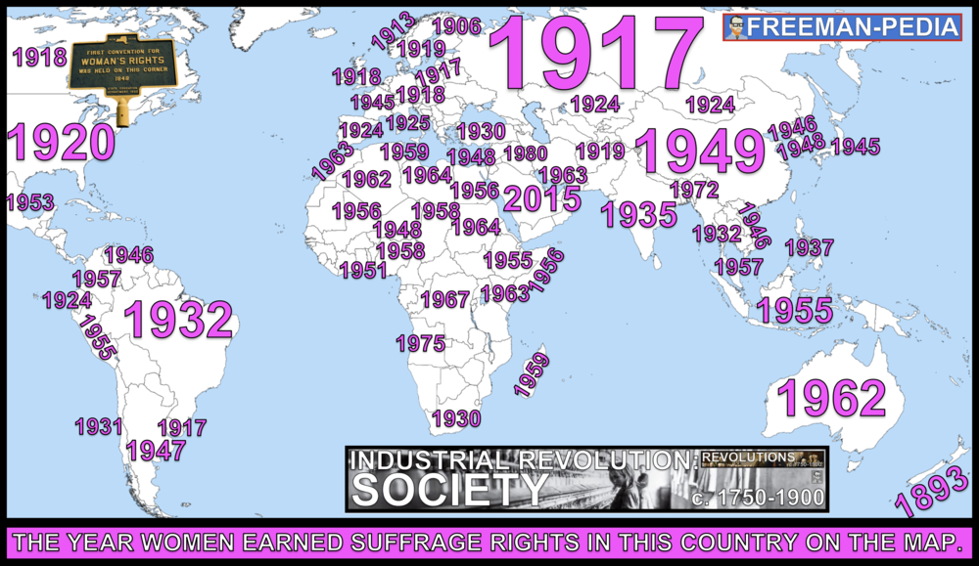
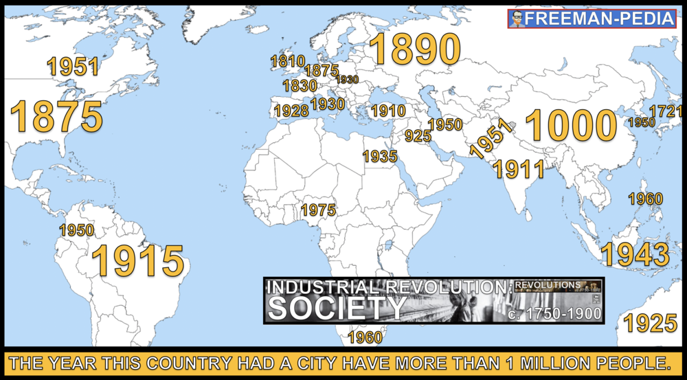
_____________________________________________________________________________________________________________________________________________________________________________________________________________________________________________________________________________________________________________________________________________________________________________________________________________________________________________________________________________________________________________________________________________________________________________________________________________________________________________________________________________________________________________________________________________________________________________________________________________________________________________________________________________________________________.

AP WORLD 2021-22 - KELLY Name:

Chapter AMSCO: Topic 5.10 Period:
Continuity and Change in the Industrial Age
Topic 5.10: What changed, and what stayed the same.

Introduction
The development of industrial capitalism led to increased standards of living for some, and to continued improvement in manufacturing methods that increased the availability, affordability, and variety of consumer goods. Railroads, steamships, and the telegraph made exploration, development, and communication possible in interior regions globally, which led to increased trade and migration.
Suggested Skill: Argumentation
6.C Use historical reasoning to explain relationships among pieces of historical evidence

Learning Outcomes:
Thematic Focus: CCOT
EQ #1: Explain the extent to which industrialization brought change from 1750 to 1900.
_____________________________________________________________________________________________________________________________________________________________________________________________________________________________________________________________________________________________________________________________________________________________________________________________________________________________________________________________________________________________________________________________________________________________________________________________________________________________________________________________________________________________________________________________________________________________________________________________________________________________________________________________________________________________________.

