AP WORLD 2021-22 - KELLY Name:

UNIT 4: Transoceanic Interconnections Period:
c. 1450 to c. 1750
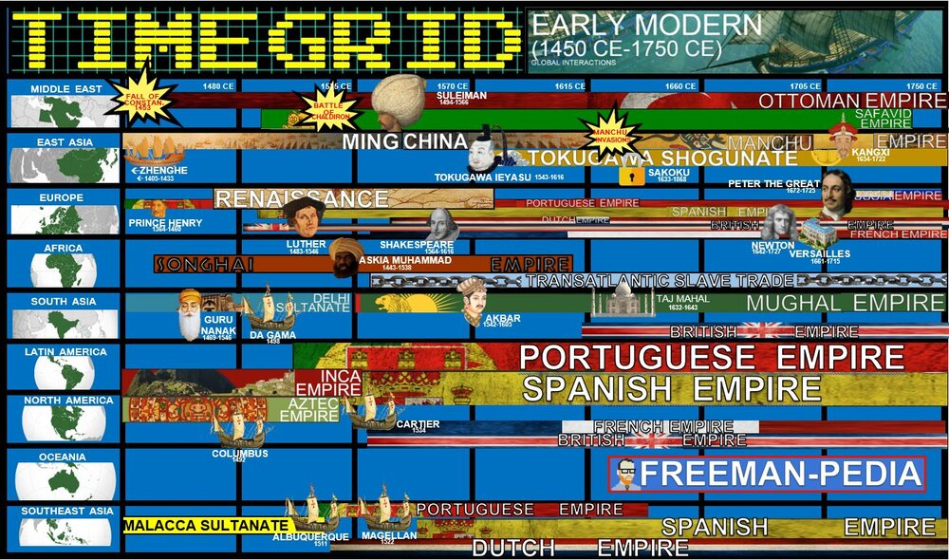

Topics of Study

Topic 4.1 Technological Innovations: Ways of the World Ch.13
Topic 4.2 Exploration: Causes and Events: Ways of the World Ch. 13
Topic 4.3 Columbian Exchange: Ways of the World Ch. 13 -15
Topic 4.4 Maritime Empires Established: Ways of the World Ch. 14
Topic 4.5 Maritime Empires Maintained and Developed: Ways of the World Ch. 14
Topic 4.6 Internal and External Challenges to State Power: AMSCO
Topic 4.7 Changing Social Hierarchies; AMSCO
Topic 4.8 Continuity and Change: AMSCO

The history of the world sees one of its most drastic changes as the Europeans take to the seas and spread out around the world. There is waaay more to this than ‘Columbus sailed the ocean blue in fourteen hundred ninety-two’. This half of the Early Modern period (1450-1750) focuses on the causes, implications, and outcomes of Europeans arriving in the Americas, Africas, and Asia. Good thing you just mastered the Land Empires in the last unit, because the Europeans are about to start knocking on their doors… These are the Transoceanic Interactions of the Early Modern Period.

AP WORLD 2021-22 - KELLY Name:

Chapter 13: Topic 4.1 Period:
Technological Innovations from 1450 - 1750
Topic 4.1: How Explorers conquered the world
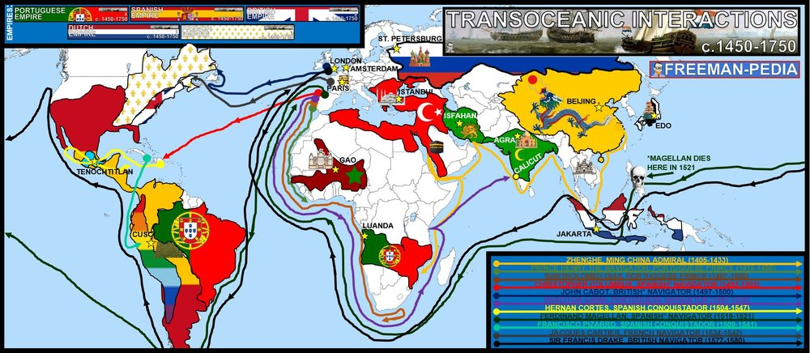

Introduction
Europe didn’t wake up one day and decide to go sailing. The technology and science behind the instruments/techniques used by the Europeans during the transoceanic maritime reconnaissance was the result of centuries of Greek, Arab, Persian, Indian and Chinese advances. This new amalgamation of innovation allowed the Europeans to leave their little continent and go global. The effects of these voyages will play out over the next few eras, but for now; these are the new technological innovations of the Early Modern Period. Knowledge, scientific learning, and technology from the Classical, Islamic, and Asian worlds spread, facilitating European technological developments and innovation. The developments included the production of new tools, innovations in ship designs, and an improved understanding of regional wind and currents patterns—all of which made transoceanic travel and trade possible.

Suggested Skill: Contextualization
4.A Identify and describe a historical context for a specific historical development or process.
See attachment titled “Causation in European Exploration Activity”.

Learning Outcomes:
Thematic Focus: Technology and Innovation- Human adaptation and innovation have resulted in increased efficiency, comfort, and security, and technological advances have shaped human development and interactions with both intended and unintended consequences.
EQ #1: Explain how cross-cultural interactions resulted in the diffusion of technology and facilitated changes in patterns of trade and travel from 1450 to 1750.
____________________________________________________________________________________________________________________________________________________________________________________________________________________________________________________________________________________________________________________________________________________________________________________________________________________________________________________________________________________________________________________________________________________________________________________________________________________________________________________________________________________________________________________________________________________________________________________________________________________________________________________________________________________________________________________________________________________________________________________________.

Illustratives Examples to know:
- Innovations in ship design:
  - Caravel
  - Carrack
  - Fluyt
- European technological developments influenced by cross-cultural interactions with the Classical, Islamic, and Asian worlds.
  - Lateen sail
  - Compass
  - Astronomical charts

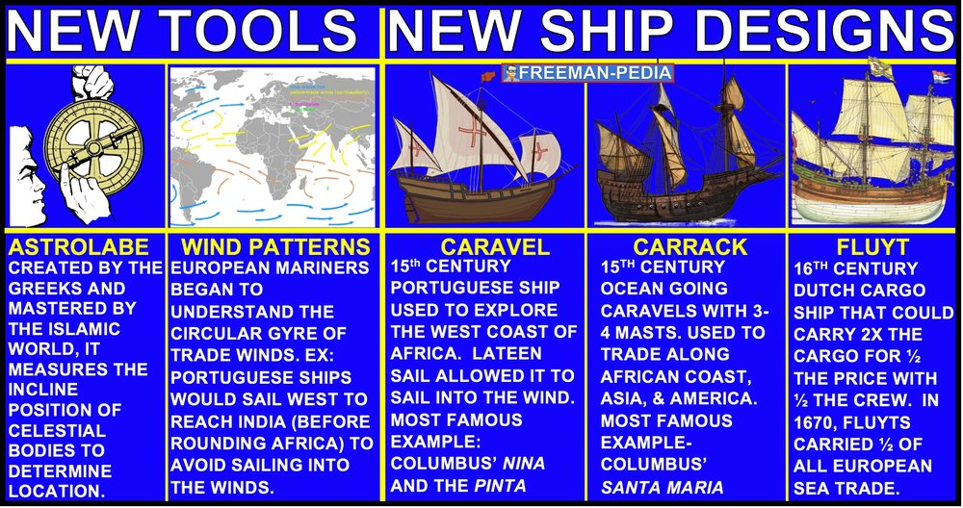

AP WORLD 2021-22 - KELLY Name:

Chapter 13: Topic 4.2 Period:
Exploration: Causes and Events from 1450 - 1750
Topic 4.2: WHY Explorers conquered the world
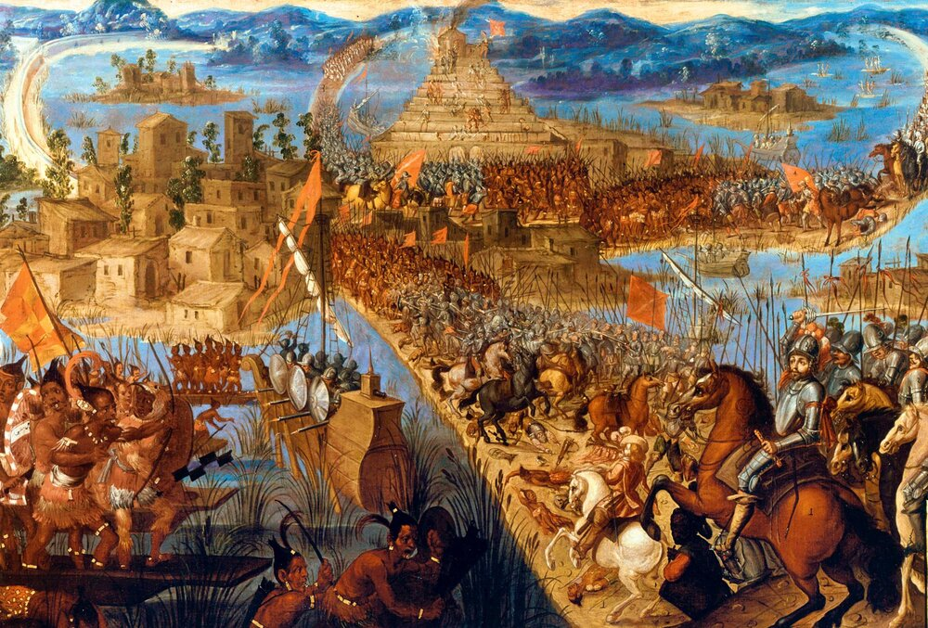
Cortez conquerors the Aztecs

Introduction
The background to 4.2 is everything that happened in Units 1, 2, & 3. The key exception: It’s Europe’s turn to join the Networks of Exchange. Using all of those cross-cultural transfers from one region to another, the Europeans had accumulated the know-how, experience, and technology to make these long distance overseas voyages a reality. The College Board calls this “Causes and Events” but don’t list any specific ones… So, focus on the European Maritime Empires and how and why they went where they did. New state-supported transoceanic maritime exploration occurred in this period. Portuguese development of maritime technology and navigational skills led to increased travel to and trade with Africa and Asia and resulted in the construction of a global trading-post empire. Spanish sponsorship of the voyages of Columbus and subsequent voyages across the Atlantic and Pacific dramatically increased European interest in transoceanic travel and trade. KC-4.1.III.C Northern Atlantic crossings were undertaken under English, French, and Dutch sponsorship, often with the goal of finding alternative sailing routes to Asia

Suggested Skill: Making Connections
5.B Explain how a historical development or process relates to another historical development or process.
See attachment titled “Bartolome de la Casas Activity”.

Learning Outcomes:
Thematic Focus: Governance- A variety of internal and external factors contribute to state formation, expansion, and decline. Governments maintain order through a variety of administrative institutions, policies, and procedures, and governments obtain, retain, and exercise power in different ways and for different purposes.
EQ #1: Describe the role of states in the expansion of maritime exploration from 1450 to 1750.
____________________________________________________________________________________________________________________________________________________________________________________________________________________________________________________________________________________________________________________________________________________________________________________________________________________________________________________________________________________________________________________________________________________________________________________________________________________________________________________________________________________________________________________________________________________________________________________________________________________________________________________________________________________________________________________________________________________________________________________________.
Thematic Focus: Economic Systems As societies develop, they affect and are affected by the ways that they produce, exchange, and consume goods and services.

EQ #2: Explain the economic causes and effects of maritime exploration by the various European states.
____________________________________________________________________________________________________________________________________________________________________________________________________________________________________________________________________________________________________________________________________________________________________________________________________________________________________________________________________________________________________________________________________________________________________________________________________________________________________________________________________________________________________________________________________________________________________________________________________________________________________________________________________________________________________________________________________________________________________________________________.
1. The Europeans have all that new navigational technology from 4.1.
2. Spain and Portugal go out first. They split the world in the Treaty of Tordesillas (think of Brazil vs. the rest of the Americas).
3. The New Kids are the British, Dutch and the French.
4. These are Trading Post Empires (not the massive empires you will see in the next period). Just along the coast.
5. These aren’t just arrivals. The European arrivals were often accompanied by death, disease, and genocide.

AP WORLD 2021-22 - KELLY Name:

Chapter 13-15: Topic 4.3 Period:
Exploration: Columbian Exchange
Topic 4.3: Atlantic Trade Routes
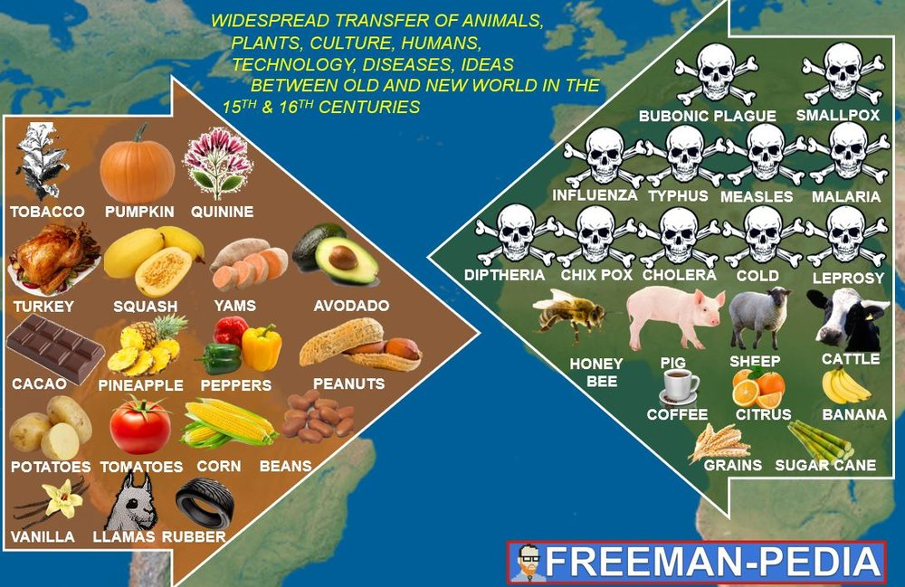
“Unexpected exchanges that altered the world forever”

Introduction
You’re trucking along in AP World History and learn one historical thing after another. History blah bla blah. But, every so often; you come upon something that is super important. Like, Top-5-most-important-things-that-ever-happened-important. Having said that, THE COLUMBIAN EXCHANGE WAS NOT AN EVENT! Columbus didn’t show up in the Caribbean with a box labelled “OLD WORLD”. And, the natives did not have a box labelled “NEW WORLD”. But, over the course of time and stemming from Columbus (hence the name) the two parts of the globe that had been separated for millenia finally became connected. Big Picture: Diseases and livestock go to the Americas and tons of awesome foods and medicines go to Afro-Eurasia. This is the Columbian Exchange. The new connections between the Eastern and Western Hemispheres resulted in the exchange of new plants, animals, and diseases, known as the Columbian Exchange. European colonization of the Americas led to the unintentional transfer of disease vectors, including mosquitoes and rats, and the spread of diseases that were endemic in the Eastern Hemisphere, including smallpox, measles, and malaria. Some of these diseases substantially reduced the indigenous populations, with catastrophic effects in many areas. American foods became staple crops in various parts of Europe, Asia, and Africa. Cash crops were grown primarily on plantations with coerced labor and were exported mostly to Europe and the Middle East. Afro-Eurasian fruit trees, grains, sugar, and domesticated animals were brought by Europeans to the Americas, while other foods were brought by African enslaved persons. Populations in Afro-Eurasia benefitted nutritionally from the increased diversity of American food crops.

Suggested Skill: Claims and Evidence
3.B Identify the evidence used in a source to support an argument.
See attachment titled “Columbian Exchange Article for Discussion”.

Learning Outcomes:
Thematic Focus: Humans and the Environments: The environment shapes human societies, and as populations grow and change, these populations in turn shape their environments.
EQ #1: Explain the causes of the Columbian Exchange and its effects on the Eastern and Western Hemispheres.
____________________________________________________________________________________________________________________________________________________________________________________________________________________________________________________________________________________________________________________________________________________________________________________________________________________________________________________________________________________________________________________________________________________________________________________________________________________________________________________________________________________________________________________________________________________________________________________________________________________________________________________________________________________________________________________________________________________________________________________________.

Illustratives Examples to know:
- Domesticated Animals:
  - Horses
  - Pigs
  - Cattle
- Foods brought by African enslaved persons:
  - Okra
  - Rice

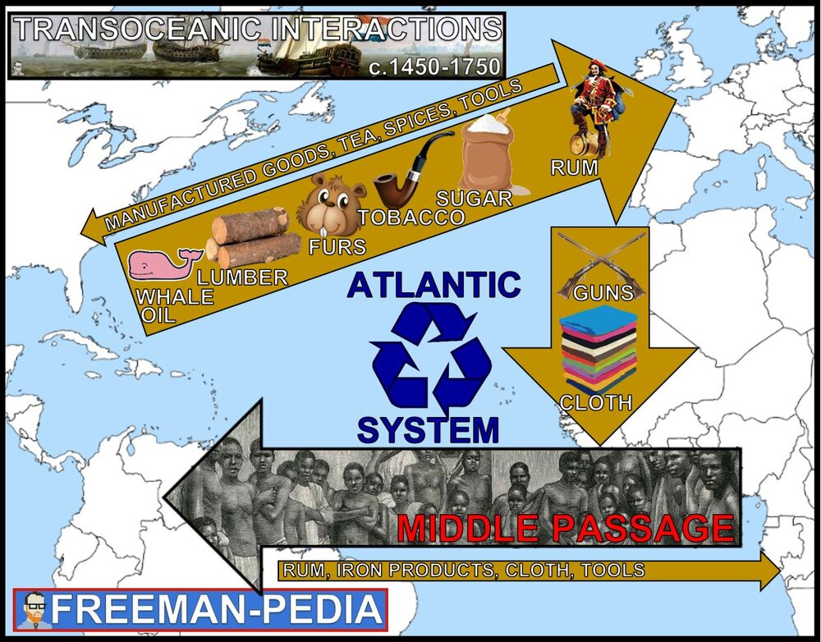

AP WORLD 2021-22 - KELLY Name:

Chapter 14: Topic 4.4 Period:
Exploration: Maritime Empires Established
Topic 4.4: Ocean Based Trade Empires - & the NKOTB!
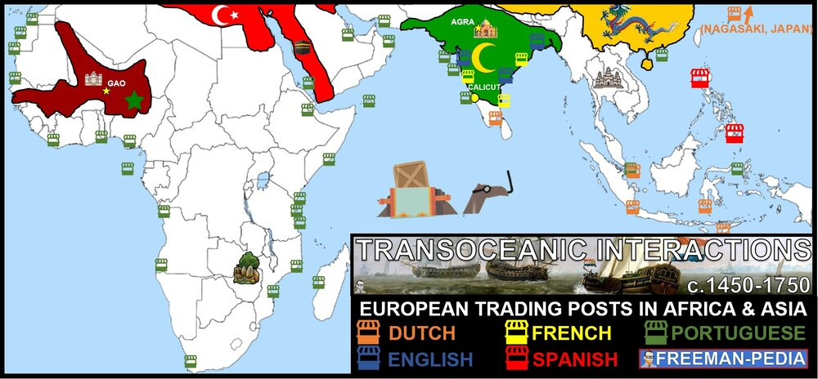

Introduction
The Europeans are here to stay. In some cases, these colonies will last into the late 20th Century. So, how do they set up these empires? You already know who goes where and the initial interactions. But, for this section: focus on how they set up their empires. Below, I’ve made A PAGE FOR EACH EMPIRE so you can see the key people, terms, art, etc. for each of the BIG 5 EMPIRES. These empires were built on global trading networks. Some Asian states (Japan, and China) saw the writing on the wall and started to limit contacts with the West. Along with all of this trade, brought new labor systems like Chattel slavery and the Encomienda system. Europeans established new trading posts in Africa and Asia, which proved profitable for the rulers and merchants involved in new global trade networks. Some Asian states sought to limit the disruptive economic and cultural effects of European-dominated long-distance trade by adopting restrictive or isolationist trade policies.
Driven largely by political, religious, and economic rivalries, European states established new maritime empires, including the Portuguese, Spanish, Dutch, French, and British. The expansion of maritime trading networks fostered the growth of states in Africa, including the Asante and the Kingdom of the Kongo, whose participation in trading networks led to an increase in their influence. Despite some disruption and restructuring due to the arrival of Portuguese, Spanish, and Dutch merchants, existing trade networks in the Indian Ocean continued to flourish and included intra-Asian trade and Asian merchants. Newly developed colonial economies in the Americas largely depended on agriculture, utilized existing labor systems, including the Incan mit’a, and introduced new labor systems including chattel slavery, indentured servitude, and encomienda and hacienda systems. Enslavement in Africa continued in its traditional forms, including incorporation of enslaved persons into households and the export of enslaved persons to the Mediterranean and the Indian Ocean regions. The growth of the plantation economy increased the demand for enslaved labor in the Americas, leading to significant demographic, social, and cultural changes.

Suggested Skill: Sourcing and Situation
2.A Identify a source’s point of view, purpose, historical situation, and/or audience.
See attachment titled “Transatlantic Slave Trade Activity”.

Learning Outcomes:
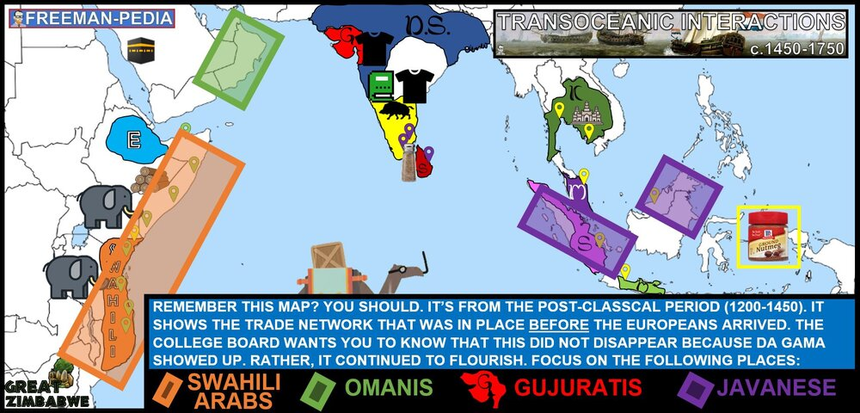
Thematic Focus: Governance: A variety of internal and external factors contribute to state formation, expansion, and decline. Governments maintain order through a variety of administrative institutions, policies, and procedures, and governments obtain, retain, and exercise power in different ways and for different purposes.
EQ #1: Explain the process of state building and expansion among various empires and states in the period from 1450 to 1750.
____________________________________________________________________________________________________________________________________________________________________________________________________________________________________________________________________________________________________________________________________________________________________________________________________________________________________________________________________________________________________________________________________________________________________________________________________________________________________________________________________________________________________________________________________________________________________________________________________________________________________________________________________________________________________________________________________________________________________________________________.
Thematic Focus: Economic Systems: As societies develop, they affect and are affected by the ways that they produce, exchange, and consume goods and services.
EQ #2: Explain the continuities and changes in economic systems and labor systems from 1450 to 1750.
____________________________________________________________________________________________________________________________________________________________________________________________________________________________________________________________________________________________________________________________________________________________________________________________________________________________________________________________________________________________________________________________________________________________________________________________________________________________________________________________________________________________________________________________________________________________________________________________________________________________________________________________________________________________________________________________________________________________________________________________.
Thematic Focus: Social Interactions and Organization: The process by which societies group their members and the norms that govern the interactions between these groups and between individuals influence political, economic, and cultural institutions and organization.
EQ #3: Explain changes and continuities in systems of slavery in the period from 1450 to 1750.
____________________________________________________________________________________________________________________________________________________________________________________________________________________________________________________________________________________________________________________________________________________________________________________________________________________________________________________________________________________________________________________________________________________________________________________________________________________________________________________________________________________________________________________________________________________________________________________________________________________________________________________________________________________________________________________________________________________________________________________________.

Illustratives Examples to know:
- Asian states that adopted restrictive or isolationist trade policies:
  - Ming China
  - Tokugawa Japan
- Indian Ocean Asian merchants:
  - Swahili Arabs
  - Omanis
  - Gujaratis
  - Javanese

AP WORLD 2021-22 - KELLY Name:

Chapter 14: Topic 4.5 Period:
Exploration: Maritime Empires Maintained and Developed
Topic 4.5: Ocean Based Trade Empires - & the NKOTB!
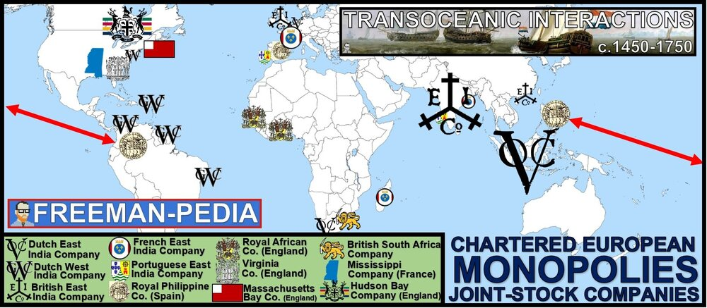

Introduction
Mercantilist policies and practices were used by European rulers to expand and control their economies and claim overseas territories. Joint-stock companies, influenced by these mercantilist principles, were used by rulers and merchants to finance exploration and were used by rulers to compete against one another in global trade. Economic disputes led to rivalries and conflict between states. The Atlantic trading system involved the movement of goods, wealth, and labor, including enslaved persons. The new global circulation of goods was facilitated by chartered European monopoly companies and the global flow of silver, especially from Spanish colonies in the Americas, which was used to purchase Asian goods for the Atlantic markets and satisfy Chinese demand for silver. Regional markets continued to flourish in Afro-Eurasia by using established commercial practices and new transoceanic and regional shipping services developed by European merchants. Peasant and artisan labor continued and intensified in many regions as the demand for food and consumer goods increased. Some notable gender and family restructuring occurred, including demographic changes in Africa that resulted from the trade of enslaved persons. The Atlantic trading system involved the movement of labor—including enslaved persons and the mixing of African, American, and European cultures and peoples, with all parties contributing to this cultural synthesis. In some cases, the increase and intensification of interactions between newly connected hemispheres expanded the reach and furthered development of existing religions, and contributed to religious conflicts and the development of syncretic belief systems and practices.
WARNING: This section is THREE PAGES in the course curriculum. That’s more than any other. For reference, World War II is two full sections and only two pages. This one is three pages. So, buckle down. Know. These. Empires.
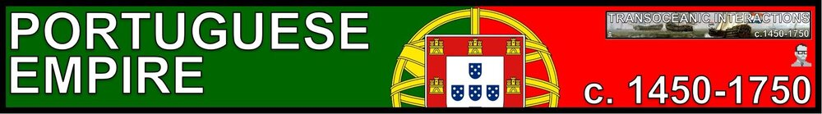
As Europe sets off to expand across the oceans, the first contestant=PORTUGAL. Check out a map. They are super far away from any trade route. Not isolated, but but out there. So, it makes sense that they would lead the way in seeking out new trade routes and peoples to convert to Catholicism. Portugal has a decent head start as well. King John the Good (Henry’s dad) first took territory in Africa (Ceuta) in 1415! Columbus was 77 years later. That’s a massive lead in terms of exploration. Everyone else took their cues from Portugal on the sea route to Asia. Having said that… Portugal’s empire will not be the largest (Britain) or the longest lasting (Ottomans). . They have their crown jewel: BRAZIL; but otherwise, they are pretty much a Trading Post Empire without significant land holdings outside of Brazil (The Portuguese are the 21st largest empire ever, just behind the Achaemenid Persians). So, when studying the Portuguese; remember them for their explorers, and being the first Europeans to reach a lot of places by sea… This is the Portuguese Empire:

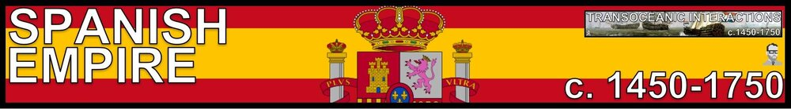
Portugal set it off. But, Spain hit the jackpot. Portugal may have lead the way around Africa, but Spain essentially takes the New World. Portugal was the 21st largest empire… Spain? 4th. The story of the Spanish Empire is dominated by the Americas, and that means Conquistadors. Focus on the interactions between the Native Americans (specifically, the Aztecs and Incas) and the Spanish Empire. There is a good bit to know here and (IMO) Spain and the Dutch are the most important of these Maritime Empires. Why? Well, this is the only real time both of them will be brought up (unless its in regards to them losing empire). Plus, the Spanish v. Americans storyline is one of the most important interactions in World History. The British Empire is a larger empire… but not in this period. So, invest some time here with the Spanish Empire:
Finally, let’s go. The biggest empire of all time. The big show. The champ is here… Wait. That’s in the next period. Think of this as the prequel. By 1763, the British Empire was still small time. It was a Trading Post Empire (see the map below). Notice their biggest colony?? It’s us (USA). So, they are about to lose that as well at the beginning of the next period. But, don’t feel bad for the measly British Empire. The British East India Trading Company is one of the biggest entities in the world during this period (and the next one too). It’s no VOC (Dutch), but it’s a big deal. So, get to know the British Empire… they’ll be here for awhile:

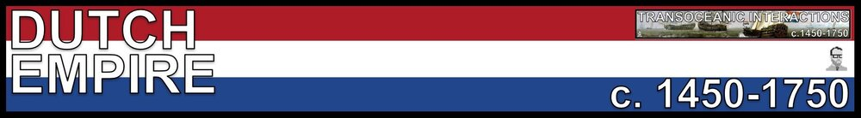
The Dutch Empire is one of the most successful stories in history. Think of them as the Mongols of this period. They arise from an obscure location on the map to dominate a huge chunk of the globe. Their empire size itself is not massive. But, the Dutch aren’t here to take over the world. They have one thing on the mind: TRADE. They will have some long term colonizational tendencies in some places (coughINDONESIAcough). But, think of them as the shiny, sleek, new empire with the greatest Trading Company in history (VOC) and exclusive access to the Japanese markets. Don’t think of the Dutch as Conquistadors carrying bibles to convert the heathens; rather, see them as business men on a mission for profits and trade throughout the Indian Ocean Trade Network… These are the Dutch:

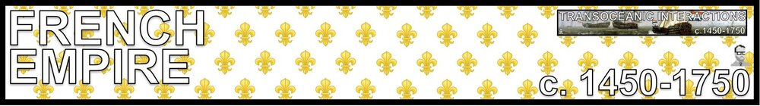
Last but not least… The French. So, Maritime is not exactly their strong suit. Kings? Absolutely. Louis XIV is THE absolute ruler. Revolutions? Of course, bring on the guillotines. Land Empires? Obvi. Do I even have to bring up Napoleon? But, Maritime Empire is not what their known for. Focus on a couple of spots: Canada and the coast of India. That’s it. Next period, like Britain, will bring them a larger global presence in Africa and Asia. But, for now, glance at France… But, spend most of your time on the other empires. This is the French Maritime Empire.

Suggested Skill: Claims and Evidence in Sources
3.A Identify and describe a claim and/or argument in a text-based or non-text-based source.
See attachment titled “Transatlantic Slave Trade Activity”.

Learning Outcomes:
Thematic Focus: Governance: A variety of internal and external factors contribute to state formation, expansion, and decline. Governments maintain order through a variety of administrative institutions, policies, and procedures, and governments obtain, retain, and exercise power in different ways and for different purposes.
EQ #1: Explain how rulers employed economic strategies to consolidate and maintain power throughout the period from 1450 to 1750.
____________________________________________________________________________________________________________________________________________________________________________________________________________________________________________________________________________________________________________________________________________________________________________________________________________________________________________________________________________________________________________________________________________________________________________________________________________________________________________________________________________________________________________________________________________________________________________________________________________________________________________________________________________________________________________________________________________________________________________________________.
Thematic Focus: Economic Systems: As societies develop, they affect and are affected by the ways that they produce, exchange, and consume goods and services.
EQ #2: Explain the continuities and changes in networks of exchange from 1450 to 1750.
____________________________________________________________________________________________________________________________________________________________________________________________________________________________________________________________________________________________________________________________________________________________________________________________________________________________________________________________________________________________________________________________________________________________________________________________________________________________________________________________________________________________________________________________________________________________________________________________________________________________________________________________________________________________________________________________________________________________________________________________.
Thematic Focus: Social Interactions and Organization: The process by which societies group their members and the norms that govern the interactions between these groups and between individuals influence political, economic, and cultural institutions and organization.
EQ #3: Explain how political, economic, and cultural factors affected society from 1450 to 1750.
____________________________________________________________________________________________________________________________________________________________________________________________________________________________________________________________________________________________________________________________________________________________________________________________________________________________________________________________________________________________________________________________________________________________________________________________________________________________________________________________________________________________________________________________________________________________________________________________________________________________________________________________________________________________________________________________________________________________________________________________.
Thematic Focus: Cultural Developments and Interactions: The development of ideas, beliefs, and religions illustrates how groups in society view themselves, and the interactions of societies and their beliefs often have political, social, and cultural implications.
EQ #4: Explain the similarities and differences in how various belief systems affected societies from 1450 to 1750.
____________________________________________________________________________________________________________________________________________________________________________________________________________________________________________________________________________________________________________________________________________________________________________________________________________________________________________________________________________________________________________________________________________________________________________________________________________________________________________________________________________________________________________________________________________________________________________________________________________________________________________________________________________________________________________________________________________________________________________________________.

Illustratives Examples to know:
- Competition over trade routes:
  - Muslim–European rivalry in the Indian Ocean
  - Moroccan conflict with the Songhai Empire
- Increased peasant and artisan labor:
  - Western Europe— wool and linen
  - India—cotton
  - China—silk

AP WORLD 2021-22 - KELLY Name:

Chapter AMSCO: Topic 4.6 Period:
Exploration: Internal and External Challenges to State Power from 1450 - 1750
Topic 4.6: What, you don’t want to be ruled by a big empire?
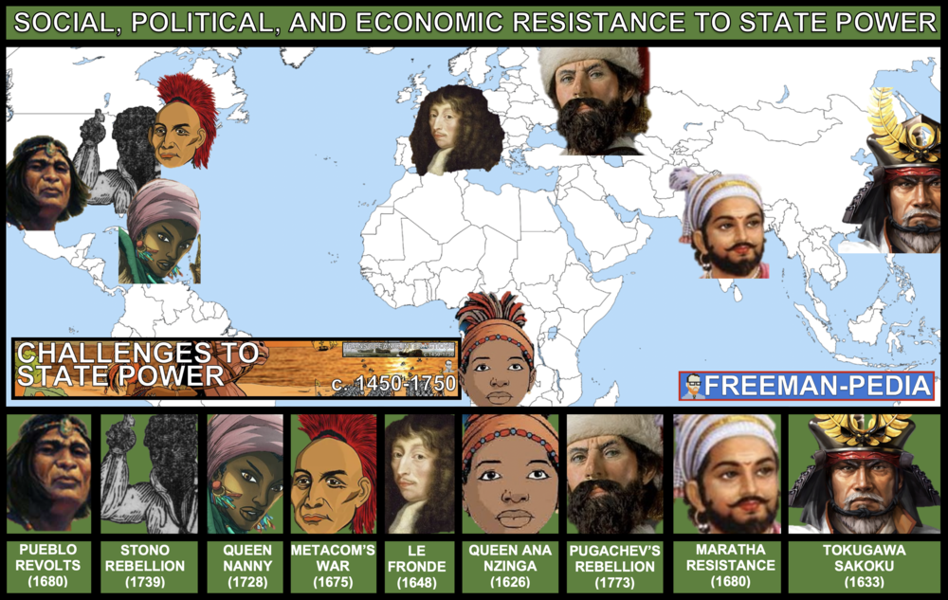

Introduction

Not everyone loves these new large empires. In fact, some people are even going to CHALLENGE these empires. They will do it socially, politically, and economically. I love a good rebellion. The College Board gives you a nice mix of challenges from slave revolts, native american revolts, religious revolts… Louis XIV’s kid’s even tried to overthrow him. Ben Freeman included all of the “illustrative examples” on the map and people to know below. You really need to focus on a couple of these movements and keep them in your back pocket in case you need to use them in an essay. THESE are the CHALLENGERS! State expansion and centralization led to resistance from an array of social, political, and economic groups on a local level. Enslaved persons challenged existing authorities in the Americas through organized resistance.

Suggested Skill: Contextualization
4.B Explain how a specific historical development or process is situated within a broader historical context
See attachment titled “Resistance to European Colonization”.

Learning Outcomes:
Thematic Focus: Governance: A variety of internal and external factors contribute to state formation, expansion, and decline. Governments maintain order through a variety of administrative institutions, policies, and procedures, and governments obtain, retain, and exercise power in different ways and for different purposes.
EQ #1: Explain the effects of the development of state power from 1450 to 1750.
_______________________________________________________________________________________________________________________________________________________________________________________________________________________________________________________________________________________________________________________________________________________________________________________________________________________________________________________________________________________________________________________________________________________________________________________________________________________________________________________________________________________________________________________.

Illustratives Examples to know:
- Local resistance:
  - Pueblo Revolts
  - Fronde
  - Cossack revolts
  - Maratha conflict with Mughals
  - Ana Nzinga’s resistance (as ruler of Ndongo and Matamba)
  - Metacom’s War (King Philip’s War)
- Resistance of enslaved persons:
  - The establishment of Maroon societies in the Caribbean and Brazil
  - Resistance of enslaved persons in North America
AP WORLD 2021-22 - KELLY Name:

Chapter AMSCO: Topic 4.7 Period:
Exploration: Changing Social Hierarchies
Topic 4.7: Colonizations effect on mankind, and the social order
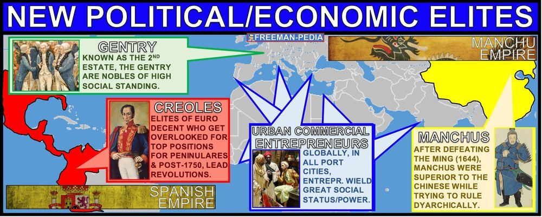

Introduction

With the arrival of the Europeans to your region, the social order is thrown all out of whack. So, there are bound to be changes to who is in charge. Now, I know this is supposed to be “Maritime Empires” time. But, this section also includes the social hierarchies of the Land Empires (Mughal Akbar’s Toleration and the Manchus treatment of the Han in China, and the treatment of the Jews in the Ottoman Empire). The most visually obvious social hierarchy here are the Castas of Latin America. But, it’s not just the organization: There are entirely new groups of elites that emerge. Needless to say, the order of society is changing everywhere in this period (1450-1750). Many states, such as the Mughal and Ottoman empires, adopted practices to accommodate the ethnic and religious diversity of their subjects or to utilize the economic, political, and military contributions of different ethnic or religious groups. In other cases, states suppressed diversity or limited certain groups’ roles in society, politics, or the economy. Imperial conquests and widening global economic opportunities contributed to the formation of new political and economic elites, including in China with the transition to the Qing Dynasty and in the Americas with the rise of the Casta system. The power of existing political and economic elites fluctuated as the elites confronted new challenges to their ability to affect the policies of the increasingly powerful monarchs and leaders.

Suggested Skill: Claims and Evidence in Sources
3.D Explain how claims or evidence support, modify, or refute a source’s argument.
See attachment titled “CastaLessonActivity”.

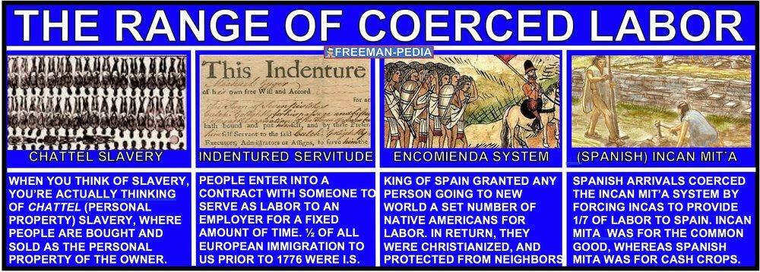

Learning Outcomes:
Thematic Focus: Social Interactions and Organization: The process by which societies group their members and the norms that govern the interactions between these groups and between individuals influence political, economic, and cultural institutions and organization.
EQ #1: Explain how social categories, roles, and practices have been maintained or have changed over time.
______________________________________________________________________________________________________________________________________________________________________________________________________________________________________________________________________________________________________________________________________________________________________________________________________________________________________________________________________________________________________________________________________________________________________________________________________________________________________________________________________________________________________________________________________________________________________________________________________________.

Illustratives Examples to know:
- Differential treatment of groups in society, politics, and the economy:
  - Expulsion of Jews from Spain and Portugal; the acceptance of Jews in the Ottoman Empire
  - Restrictive policies against Han Chinese in Qing China
  - Varying status of different classes of women within the Ottoman Empire
- Existing elites:
  - Ottoman timars
  - Russian boyars
  - European nobility

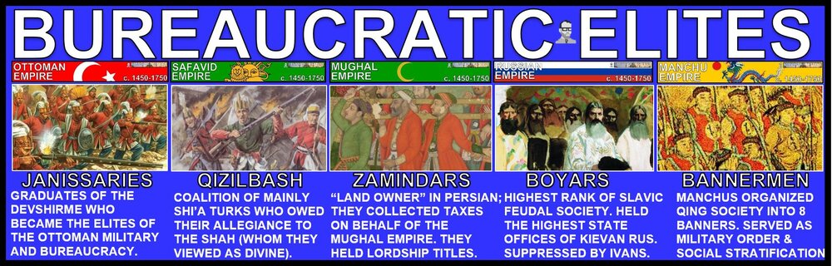

AP WORLD 2021-22 - KELLY Name:

Chapter AMSCO: Topic 4.8 Period:
Exploration: Continuity and Change
Topic 4.8: What stayed the same, and what changed in the age of European conquest
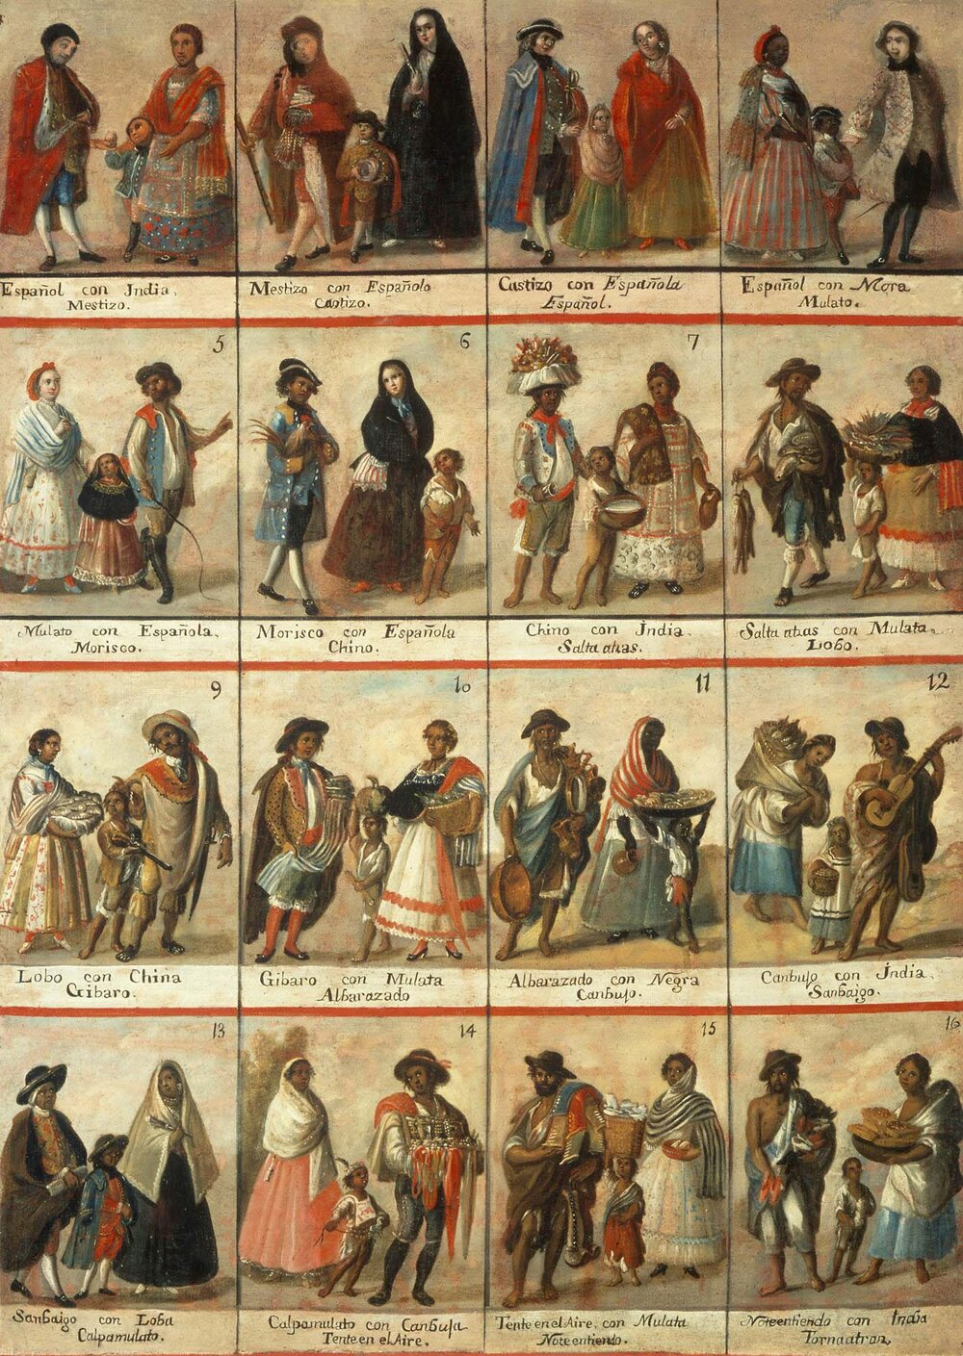

Introduction

The interconnection of the Eastern and Western Hemispheres, made possible by transoceanic voyaging, transformed trade and had a significant social impact on the world. Knowledge, scientific learning, and technology from the Classical, Islamic, and Asian worlds spread, facilitating European technological developments and innovation. The developments included the production of new tools, innovations in ship designs, and an improved understanding of regional wind and currents patterns—all of which made transoceanic travel and trade possible. Although the world’s productive systems continued to be heavily centered on agriculture, major changes occurred in agricultural labor, the systems and locations of manufacturing, gender and social structures, and environmental processes. The demand for labor intensified as a result of the growing global demand for raw materials and finished products. Traditional peasant agriculture increased and changed in nature, plantations expanded, and the Atlantic slave trade developed and intensified. Empires achieved increased scope and influence around the world, shaping and being shaped by the diverse populations they incorporated. Economic disputes led to rivalries and conflict between states.

Suggested Skill: Claims and Evidence in Sources
6.C Use historical reasoning to explain relationships among pieces of historical evidence.
See attachment titled “ ”.

Learning Outcomes:
Thematic Focus: Economic Systems: As societies develop, they affect and are affected by the ways that they produce, exchange, and consume goods and services.
EQ #1: Explain how economic developments from 1450 to 1750 affected social structures over time.
______________________________________________________________________________________________________________________________________________________________________________________________________________________________________________________________________________________________________________________________________________________________________________________________________________________________________________________________________________________________________________________________________________________________________________________________________________________________________________________________________________________________________________________________________________________________________________________________________________.

