AP WORLD 2021-22 - KELLY Name:

UNIT 3: Land-Based Empires Period:
c. 1450 to c. 1750
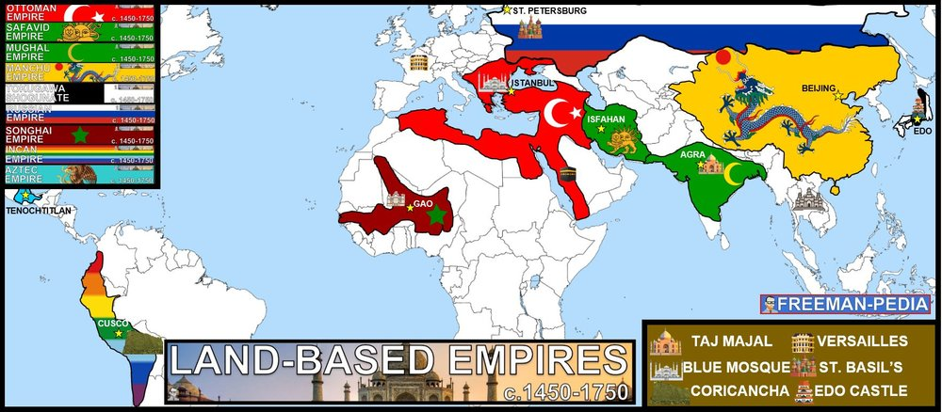

Topics of Study

Topic 3.1 Empires Expand
Topic 3.2 Empires: Administration
Topic 3.3 Empires: Belief Systems
Topic 3.4 Comparison in Land-based Empires

The Land Based Empires are the major players in this period. It’s easy to jump to Columbus et al and assume the Europeans are taking over. They’re not. They are moving into the outer reaches that are not already dominated by major Land Based Empires. Look at the map below. Now compare that to the Maritime Empires. There is virtually no overlap (outside of the Americas). Another knock against the Europeans in this period (1450-1750), is to look at when the Land Based Empires finally fell. Mughals, 1857. Tokugawa, 1868. Manchu Empire, 1911. Ottoman Empire, 1919. So, pump your brakes on the European Empires. They are still in the back seat to the Land Based empires.

AP WORLD 2021-22 - KELLY Name:

Chapter AMSCO: Topic 3.1 Period:
Empires Expand
Topic 3.1: Land-based Empires Expand (via GUNPOWDER)

Introduction
Welcome to the Early Modern Period (1450-1750). You are about to meet some brand new empires. They will help branch the world of 1450 to the Modern world. Invest in these Empires because they will last (sorry, Safavids, Aztecs, and Incas…) for 80% of the course. Double down here. It will pay off for the rest of the course to have a good grip on these specifically (also, if you’re coming from a more Euro-centric historical background like I did; these will seem to be mostly new material/things you haven’t heard before. It’s OK. That’s a good thing. You’re learning the REAL history of the planet…). Let’s see how these Empires grew to some of the largest, longest lasting empires in all of earth’s history. Imperial expansion relied on the increased use of gunpowder, cannons, and armed trade to establish large empires in both hemispheres. Land empires included the Manchu in Central and East Asia; the Mughal in South and Central Asia; the Ottoman in Southern Europe, the Middle East, and North Africa; and the Safavids in the Middle East. Political and religious disputes led to rivalries and conflict between states.

Suggested Skill: Developments and Processes
1.B Explain a historical concept, development, or process.
See attachment titled “Empires Thesis Statement Activity”.

Learning Outcomes:
Thematic Focus: Governance - A variety of internal and external factors contribute to state formation, expansion, and decline. Governments maintain order through a variety of administrative institutions, policies, and procedures, and governments obtain, retain, and exercise power in different ways and for different purposes.
EQ #1: Explain how and why various land-based empires developed and expanded from 1450 to 1750.
____________________________________________________________________________________________________________________________________________________________________________________________________________________________________________________________________________________________________________________________________________________________________________________________________________________________________________________________________________________________________________________________________________________________________________________________________________________________________________________________________________________________________________________________________________________________________________________________________________________________________________________________________________________________________________________________________________________________________________________________.

Illustratives Examples to know:
- State Rivalries:
  - Safavid Mughal Conflict
  - Songhai Empire’s conflict with Morocco

AP WORLD 2021-22 - KELLY Name:

Chapter AMSCO: Topic 3.2 Period:
Empires: Administration
Topic 3.2: Land-based Empires legitimizing/consolidating

Introduction
The Land Empires are now established. So. How do you rule these massive, united chunks of land? Each one has its own unique way of functioning on a daily basis. Below are the people, means, systems, etc. that these Empires maintained power. Recruitment and use of bureaucratic elites, as well as the development of military professionals, became more common among rulers who wanted to maintain centralized control over their populations and resources. Rulers continued to use religious ideas, art, and monumental architecture to legitimize their rule. Rulers used tribute collection, tax farming, and innovative tax-collection systems to generate revenue in order to forward state power and expansion.

Suggested Skill: Contextualization
4.A Identify and describe a historical context for a specific historical development or process
See attachment titled “Ming, Qing, and Joseon Dynasty Documents”.

Learning Outcomes:
Thematic Focus: Governance - A variety of internal and external factors contribute to state formation, expansion, and decline. Governments maintain order through a variety of administrative institutions, policies, and procedures, and governments obtain, retain, and exercise power in different ways and for different purposes.
EQ #1: Explain how rulers used a variety of methods to legitimize and consolidate their power in land-based empires from 1450 to 1750
____________________________________________________________________________________________________________________________________________________________________________________________________________________________________________________________________________________________________________________________________________________________________________________________________________________________________________________________________________________________________________________________________________________________________________________________________________________________________________________________________________________________________________________________________________________________________________________________________________________________________________________________________________________________________________________________________________________________________________________________.

Illustratives Examples to know:
- Bureaucratic elites or military professionals:
  - Ottoman devshirme
  - Salaried samurai
- Religious ideas:
  - Mexica practice of human sacrifice
  - European notions of divine right
  - Songhai promotion of Islam
- Art and monumental architecture:
  - Qing imperial portraits
  - Incan sun temple of Cuzco
  - Mughal mausolea and mosques
  - European palaces, such as Versailles
- Tax-collection systems:
  - Mughal zamindar tax collection
  - Ottoman tax farming
  - Mexica tribute lists
  - Ming practice of collecting taxes in hard currency

AP WORLD 2021-22 - KELLY Name:

Chapter AMSCO: Topic 3.3 Period:
Empires: Belief Systems
Topic 3.3: Land-based Empires diffusion of belief
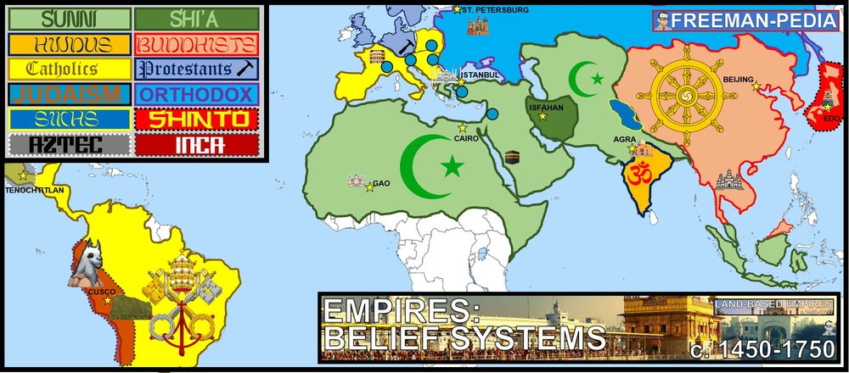

Introduction
You need to start thinking of religion a bit differently from here on. Yes, you need to know the tenets of each religion and a little of the history behind it. BUT, from here on: we need to look at religion in terms of GEOPOLITICS (how places interact with one another). Look at the map below, you can see the conflicts happening just from the Belief Systems. Without any political borders, you can see the Ottomans vs. Safavids or Spanish vs. Native Americans or the Northern Europeans vs. Southern Europeans. Notice that several of the religions from earlier in history have now fractured… There are 3 MAJOR BRANCHES OF CHRISTIANITY NOW! There are even more divisions than this, but the College Board seems content with keeping Buddhism and Hinduism as monolithic belief systems. ABOVE, are the belief systems of the Early Modern Period. The Protestant Reformation marked a break with existing Christian traditions and both the Protestant and Catholic reformations contributed to the growth of Christianity. Political rivalries between the Ottoman and Safavid empires intensified the split within Islam between Sunni and Shi’a. Sikhism developed in South Asia in a context of interactions between Hinduism and Islam.

Suggested Skill: Sourcing and Situation
2.B Explain the point of view, purpose, historical situation, and/or audience of a source.
See attachment titled “Sikhism-Hinduism-Islam Comparative Activity”.

Learning Outcomes:
Thematic Focus: Cultural Developments and Interactions - The development of ideas, beliefs, and religions illustrates how groups in society view themselves, and the interactions of societies and their beliefs often have political, social, and cultural implications.
EQ #1: Explain continuity and change within the various belief systems during the period from 1450 to 1750.
____________________________________________________________________________________________________________________________________________________________________________________________________________________________________________________________________________________________________________________________________________________________________________________________________________________________________________________________________________________________________________________________________________________________________________________________________________________________________________________________________________________________________________________________________________________________________________________________________________________________________________________________________________________________________________________________________________________________________________________________.

AP WORLD 2021-22 - KELLY Name:

Chapter AMSCO: Topic 3.4 Period:
COMPARISON in Land-Based Empires
Topic 3.4: Comparison time again!

Introduction
The interconnection of the Eastern and Western Hemispheres made possible by transoceanic voyaging, transformed trade and had a significant social impact on the world. In some cases, the increase and intensification of interactions between newly connected hemispheres expanded the reach and furthered development of existing religions, and contributed to religious conflicts and the development of syncretic belief systems and practices. Empires achieved increased scope and influence around the world, shaping and being shaped by the diverse populations they incorporated. Imperial expansion relied on the increased use of gunpowder, cannons, and armed trade to establish large empires in both hemispheres. Land empires included the Manchu in Central and East Asia; Mughal in South and Central Asia; Ottoman in Southern Europe, the Middle East, and North Africa; and the Safavids in the Middle East. Political and religious disputes led to rivalries and conflict between states.

Suggested Skill: Argumentation
4.A Support an argument using specific and relevant evidence. Describe specific examples of historically relevant evidence. Explain how specific examples of historically relevant evidence support an argument
See attachment titled “Four Corners Land-Based Empires Comparison Activity”.

Learning Outcomes:
EQ #1: Compare the methods by which various empires increased their influence from 1450 to 1750.
____________________________________________________________________________________________________________________________________________________________________________________________________________________________________________________________________________________________________________________________________________________________________________________________________________________________________________________________________________________________________________________________________________________________________________________________________________________________________________________________________________________________________________________________________________________________________________________________________________________________________________________________________________________________________________________________________________________________________________________________.

