AP WORLD 2021-22 - KELLY Name:

UNIT 2: Networks of Exchange Period:
1200 - 1450
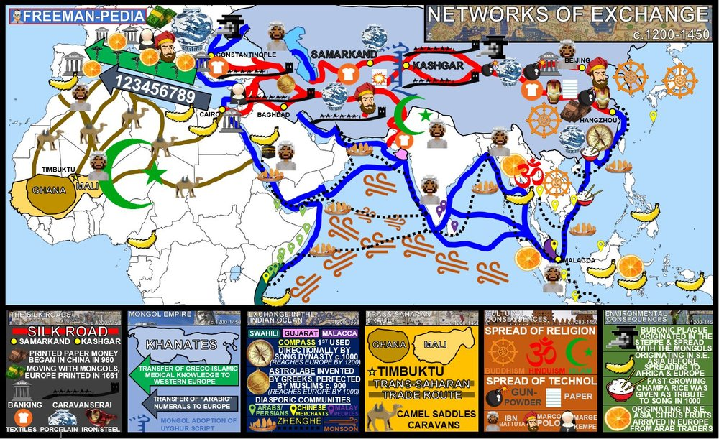

Topics of Study

Topic 2.1 The Silk Roads: Ways of the World Ch. 7
Topic 2.2 The Mongol Empire and the Making of the Modern World: Ways of the World Ch. 11
Topic 2.3 Exchange in the Indian Ocean: Ch. 7
Topic 2.4 Trans-Saharan Trade Routes: Ways of the World Ch. 7
Topic 2.5 Cultural Consequences of Connectivity: Ways of the World AMSCO
Topic 2.6 Environmental Consequences of Connectivity: Ways of the World AMSCO
Topic 2.7 Comparison of Economic Exchange - 1450: AMSCO

AP WORLD 2021-22 - KELLY Name:

Chapter 7: Topic 2.1 Period:
The Silk Roads pre-1200-1450
Topic 2.1: The Silk Roads: SEA/SAND/LAND ROUTES

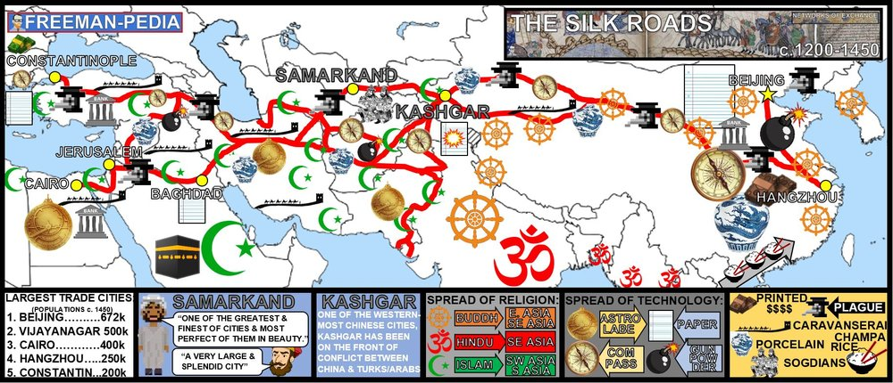

Introduction
The Silk Road is the grand-daddy of them all. This is the big one. This is THE land-based trade network. You know it as a Trade Network, but the Silk Road began as the Han Dynasty was seeking allies to the West to help fight against the dreaded Xiongnu (basically, the bad guys in Mulan). What began as a cry for help developed into a network of trade alliances that eventually spanned Afro-Eurasia. Improved commercial practices led to an increased volume of trade and expanded the geographical range of existing trade routes— including the Silk Roads—promoting the growth of powerful new trading cities. The growth of interregional trade in luxury goods was encouraged by innovations in previously existing transportation and commercial technologies, including the caravanserai, forms of credit, and the development of money economies. Demand for luxury goods increased in AfroEurasia. Chinese, Persian, and Indian artisans and merchants expanded their production of textiles and porcelains for export; manufacture of iron and steel expanded in China

Suggested Skill: Contextualization
4.A Identify and describe a historical context for a specific historical development or process.
See attachment titled “Mapping the Silk Roads Activity”.

Learning Outcomes:
Thematic Focus: Economic Systems - As societies develop, they affect and are affected by the ways that they produce, exchange, and consume goods and services.
EQ #1: EXPLAIN the causes and effects of growth of networks of exchange after 1200.
_______________________________________________________________________________________________________________________________________________________________________________________________________________________________________________________________________________________________________________________________________________________________________________________________________________________________________________________________________________________________________________________________________________________________________________________________________________________________________________________________________________________________________________________________________.

Illustratives Examples to know:
- Trading Cities:
  - Kashgar
  - Samarkand
- New forms of credit and money economies:
  - Bills of exchange
  - Banking Houses
  - Use of paper money

AP WORLD 2021-22 - KELLY Name:

Chapter 11: Topic 2.2 Period: The Mongol Empire and the making of the Modern World 1200 - 1450
Topic 2.2: The Mongols
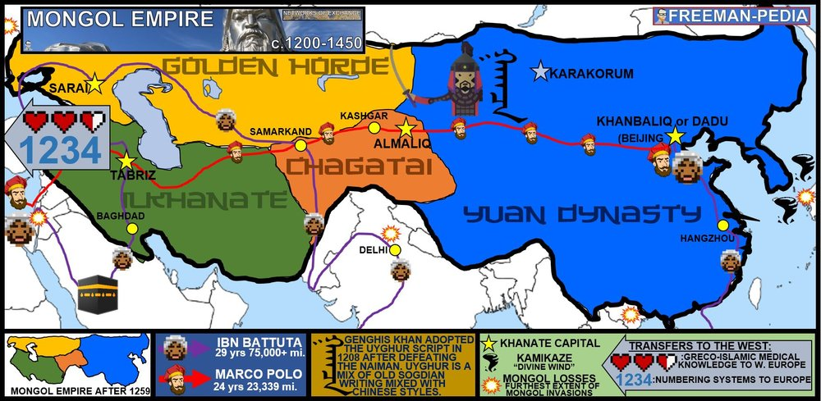

Introduction
Arguably the most important historical thing to happen in the Global Tapestry (1200-1450) is the rise and fall of the Mongols. This group came from the middle of nowhere and rose to be the largest contiguous empire in the history of the planet. The Mongols affect nearly everything that happens historically in this period. Below, is the story of the most unlikely conquerors in history: THE MONGOLS. Empires collapsed in different regions of the world and in some areas were replaced by new imperial states, including the Mongol khanates. The expansion of empires—including the Mongols—facilitated Afro-Eurasian trade and communication as new people were drawn into their conquerors’ economies and trade networks. Interregional contacts and conflicts between states and empires, including the Mongols, encouraged significant technological and cultural transfers.

Suggested Skill: Making Connections
5.A Identify patterns among or connections between historical developments and processes.
See attachment titled “The Brutal Brilliance of Genghis Khan”.

Learning Outcomes:
Thematic Focus: Economic Systems - As societies develop, they affect and are affected by the ways that they produce, exchange, and consume goods and services.
EQ #1: EXPLAIN how the expansion of empires influenced trade and communication over time.
____________________________________________________________________________________________________________________________________________________________________________________________________________________________________________________________________________________________________________________________________________________________________________________________________________________________________________________________________________________________________________________________________________________________________________________________________________________________________________________________________________________________________________________________________________________________________________________________________________________________________________________________________________________________________________________________________________________________________________________________.
Thematic Focus: Governance - A variety of internal and external factors contribute to state formation, expansion, and decline. Governments maintain order through a variety of administrative institutions, policies, and procedures, and governments obtain, retain, and exercise power in different ways and for different purposes.

EQ #2: EXPLAIN the process of state building and decline in Eurasia over time.
____________________________________________________________________________________________________________________________________________________________________________________________________________________________________________________________________________________________________________________________________________________________________________________________________________________________________________________________________________________________________________________________________________________________________________________________________________________________________________________________________________________________________________________________________________________________________________________________________________________________________________________________________________________________________________________________________________________________________________________________.
Thematic Focus: Cultural Developments and Interactions - The development of ideas, beliefs, and religions illustrates how groups in society view themselves, and the interactions of societies and their beliefs often have political, social, and cultural implications.
EQ #3: EXPLAIN the significance of the Mongol Empire in larger patterns of continuity and change.
_______________________________________________________________________________________________________________________________________________________________________________________________________________________________________________________________________________________________________________________________________________________________________________________________________________________________________________________________________________________________________________________________________________________________________________________________________________________________________________________________________________________________________________________________________________________________________________________________________________

Illustratives Examples to know:
- Technological and cultural transfers:
  - Transfer of Greco-Islamic medical knowledge to western society
  - Transfer of numbering systems to Europe
  - Adoption of Uyghur script
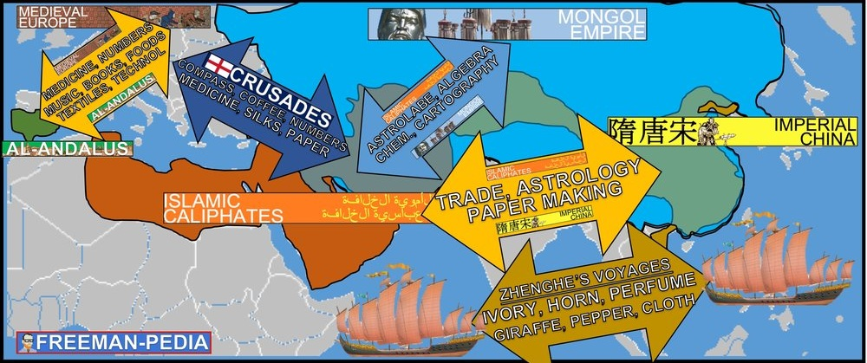

AP WORLD 2021-22 - KELLY Name:

Chapter 7: Topic 2.3 Period: Exchange in the Indian Ocean 1200 - 1450

Topic 2.3: SEA ROUTES
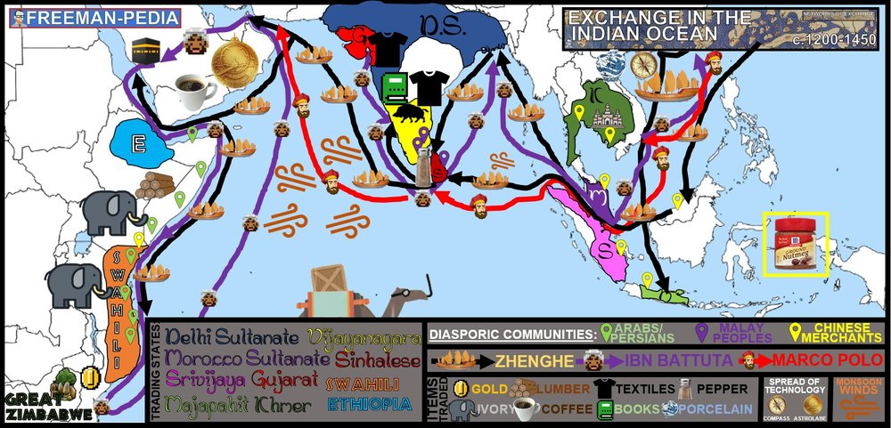

Introduction
The second unit is called “NETWORKS OF EXCHANGE”. You may immediately think, “Oh, like the Silk Road.” Yeah. But, most of the volume being traded around the world at this point was being done here, in the Indian Ocean. Think silks and porcelains for the Silk Road. REAL trade went down in the Indian Ocean. The people’s trade. Stuff the average person might use… textiles, coffee, lumber, etc. So, the Silk Road is nice. But, unless you had a lot of luxury items in your hut… you were way more likely to get textiles from India than silk from China. Improved transportation technologies and commercial practices led to an increased volume of trade and expanded the geographical range of existing trade routes, including the Indian Ocean, promoting the growth of powerful new trading cities. The growth of interregional trade in luxury goods was encouraged by significant innovations in previously existing transportation and commercial technologies, including the use of the compass, the astrolabe, and larger ship designs. The Indian Ocean trading network fostered the growth of states. In key places along important trade routes, merchants set up diasporic communities where they introduced their own cultural traditions into the indigenous cultures and, in turn, indigenous cultures influenced merchant cultures. Interregional contacts and conflicts between states and empires encouraged significant technological and cultural transfers, including during Chinese maritime activity led by Ming Admiral Zheng He. The expansion and intensification of long distance trade routes often depended on environmental knowledge, including advanced knowledge of the monsoon winds.

Suggested Skill: Making Connections
5.A Identify patterns among or connections between historical developments and processes.
See attachment titled “Indian Ocean Basin Trade”.

Learning Outcomes:
Thematic Focus: Economic Systems - As societies develop, they affect and are affected by the ways that they produce, exchange, and consume goods and services.
EQ #1: EXPLAIN the causes of the growth of networks of exchange after 1200.
____________________________________________________________________________________________________________________________________________________________________________________________________________________________________________________________________________________________________________________________________________________________________________________________________________________________________________________________________________________________________________________________________________________________________________________________________________________________________________________________________________________________________________________________________________________________________________________________________________________________________________________________________________________________________________________________________________________________________________________________.
Thematic Focus: Humans and the Environments- The environment shapes human societies, and as populations grow and change, these populations in turn shape their environments.
EQ #2: EXPLAIN the role of environmental factors in the development of networks of exchange in the period from c. 1200 - c. 1450.
____________________________________________________________________________________________________________________________________________________________________________________________________________________________________________________________________________________________________________________________________________________________________________________________________________________________________________________________________________________________________________________________________________________________________________________________________________________________________________________________________________________________________________________________________________________________________________________________________________________________________________________________________________________________________________________________________________________________________________________________.
Thematic Focus: Cultural Developments and Interactions - The development of ideas, beliefs, and religions illustrates how groups in society view themselves, and the interactions of societies and their beliefs often have political, social, and cultural implications.
EQ #3: EXPLAIN the effects of the growth of networks of exchange after 1200.
____________________________________________________________________________________________________________________________________________________________________________________________________________________________________________________________________________________________________________________________________________________________________________________________________________________________________________________________________________________________________________________________________________________________________________________________________________________________________________________________________________________________________________________________________________________________________________________________________________________________________________________________________________________________________________________________________________________________________________________________.

Illustratives Examples to know:
- Growth of states:
  - City-states of the Swahili Coast
  - Gujarat
  - Sultanate of Malacca
- Diasporic Communities:
  - Arab and Persian communities in East Africa
  - Chinese merchant communities in Southeast Asia
  - Malay communities in the Indian Ocean basin

AP WORLD 2021-22 - KELLY Name:

Chapter 7: Topic 2.4 Period: Trans-Saharan Trade Routes 1200 - 1450

Topic 2.4: SAND ROUTES
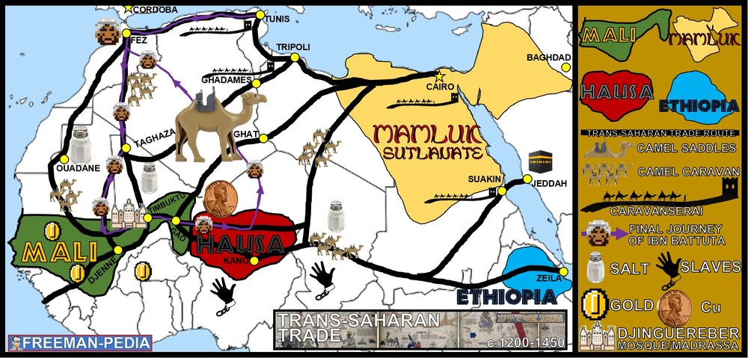

Introduction
The Trans-Saharan Trade route is the THIRD major one of the Global Tapestry Period (1200-1450). It is the most overlooked and underrated. HOWEVER, you get so much from this trade route. Diasporic communities? Check. Camels with freaking saddles? Check. Astrolabes and other devices to navigate the stars in the biggest desert on the planet? Check. Ibn Battuta? Obvious check… Dude is everywhere. Mansa Musa and Lion Kings? Check. Defeaters of Mongols? (Mamluks) Check. Spread and syncretism of Islam? Check. It’s got everything. Unfortunately, it will be COMPLETELY overshadowed in the next period with ATLANTIC SYSTEM and the Europeans heading over into the Indian Ocean. So… Enjoy it while it lasts. THIS is the Trans-Atlantic Trade Route. The growth of interregional trade was encouraged by innovations in existing transportation technologies. Improved transportation technologies and commercial practices led to an increased volume of trade and expanded the geographical range of existing trade routes, including the trans-Saharan trade network. The expansion of empires—including Mali in West Africa–facilitated Afro-Eurasian trade and communication as new people were drawn into the economies and trade networks

Suggested Skill: Developments and Processes
1.B Explain a historical concept, development, or process.
See attachment titled “Trans-Saharan Trade Networks: Document Analysis Activity”.

Learning Outcomes:
Thematic Focus: Technology and Innovation - Human adaptation and innovation have resulted in increased efficiency, comfort, and security, and technological advances have shaped human development and interactions with both intended and unintended consequences.
EQ #1: EXPLAIN the causes and effects of the growth of trans-Saharan trade.
____________________________________________________________________________________________________________________________________________________________________________________________________________________________________________________________________________________________________________________________________________________________________________________________________________________________________________________________________________________________________________________________________________________________________________________________________________________________________________________________________________________________________________________________________________________________________________________________________________________________________________________________________________________________________________________________________________________________________________________________.
Thematic Focus: Governance - A variety of internal and external factors contribute to state formation, expansion, and decline. Governments maintain order through a variety of administrative institutions, policies, and procedures, and governments obtain, retain, and exercise power in different ways and for different purposes.
EQ #2: EXPLAIN how the expansion of empires influenced trade and communication over time.
____________________________________________________________________________________________________________________________________________________________________________________________________________________________________________________________________________________________________________________________________________________________________________________________________________________________________________________________________________________________________________________________________________________________________________________________________________________________________________________________________________________________________________________________________________________________________________________________________________________________________________________________________________________________________________________________________________________________________________________________.

Illustratives Examples to know:
- Technologies encouraging interregional trade:
  - Camel Saddle
  - Caravans

AP WORLD 2021-22 - KELLY Name:

AMSCO: Topic 2.5 Period: Cultural Consequences of Connectivity
Topic 2.5: Silk Roads and Cultural Diffusion
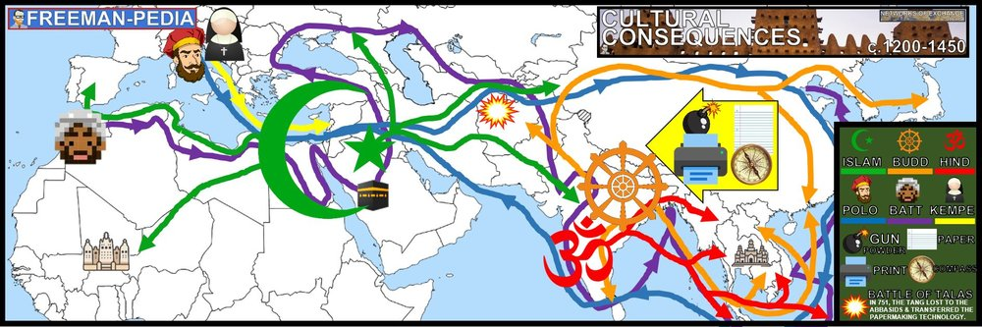

Introduction
With all of this trade going around during the NETWORKS OF EXCHANGE period (1200-1450), there were bound to be MASSIVE cultural consequences. The College Board only mentions a couple, but I’m sure your teacher will come up with more. Religions, languages, sciences, math, technology, etc etc etc. This is the section where they mention the world travelers by name: Ibn Battuta, Marco Polo and Margery Kempe. The Network of Exchange was not just political; below you can see the Cultural Consequences…Increased cross-cultural interactions resulted in the diffusion of literary, artistic, and cultural traditions, as well as scientific and technological innovations. The fate of cities varied greatly, with periods of significant decline and periods of increased urbanization, buoyed by rising productivity and expanding trade networks. As exchange networks intensified, an increasing number of travelers within AfroEurasia wrote about their travels.

Suggested Skill: Sourcing and Situation
2.A Identify a source’s point of view, purpose, historical situation, and/or audience.
See attachment titled “13th and 14th Century Travelers Document Analysis”.

Learning Outcomes:
Thematic Focus: Cultural Developments and Interactions - The development of ideas, beliefs, and religions illustrates how groups in society view themselves, and the interactions of societies and their beliefs often have political, social, and cultural implications.
EQ #1: EXPLAIN the intellectual and cultural effects of the various networks of exchange in Afro-Eurasia from c. 1200 - 1450.
____________________________________________________________________________________________________________________________________________________________________________________________________________________________________________________________________________________________________________________________________________________________________________________________________________________________________________________________________________________________________________________________________________________________________________________________________________________________________________________________________________________________________________________________________________________________________________________________________________________________________________________________________________________________________________________________________________________________________________________________.

Illustratives Examples to know:
- DIFFUSION of cultural traditions:
  - The influence of Buddhism in East Asia
  - The spread of Hinduism and Buddhism into Southeast Asia
  - The spread of Islam in sub-Saharan Africa and Asia
- DiIFFUSION of scientific or technological innovations:
  - Gunpowder from China
  - Paper from China
- Travelers:
  - Ibn Battuta
  - Margery Kempe
  - Marco Polo
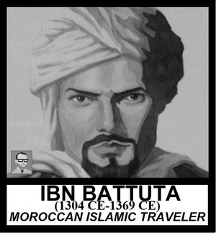
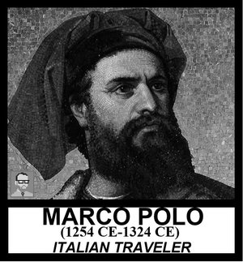

AP WORLD 2021-22 - KELLY Name:

AMSCO: Topic 2.6 Period: Environmental Consequences of Connectivity
Topic 2.6: Silk Roads and Human/Enviro. Impact
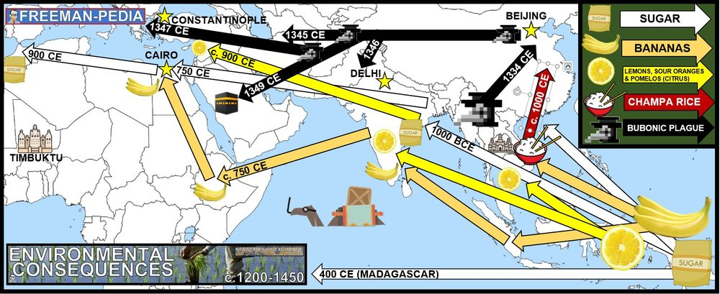

Introduction
Along with all of those goods and technologies, there are serious ENVIRONMENTAL CONSEQUENCES that accompany the NETWORKS OF EXCHANGE (1200-1450). For the College Board, This means foods and diseases. They specifically site Bananas, Champa Rice (a fast growing rice that can grow two full crops per season, which was a tribute from Vietnam to Song China), and citrus fruits (which means lemons, sour oranges, and pomelos (since the Mediterranean already had other citrus fruits as evidenced by seeds at Pompeii and other sources). Another environmental consequence is disease. When the world connects, it creates highways for trade and the spreading of disease. Below are the ENVIRONMENTAL CONSEQUENCES of the NETWORKS OF EXCHANGE. There was continued diffusion of crops and pathogens, with epidemic diseases, including the bubonic plague, along trade routes.

Suggested Skill: Making Connections
5.A Identify patterns among or connections between historical developments and processes.
See attachment titled “European International Trade and Bubonic Plague Activity”.

Learning Outcomes:
Thematic Focus: Humans and the Environments- The environment shapes human societies, and as populations grow and change, these populations in turn shape their environments.
EQ #1: EXPLAIN the environmental effects of the various networks of exchange in Afro-Eurasia from c. 1200 - 1450.
_____________________________________________________________________________________________________________________________________________________________________________________________________________________________________________________________________________________________________________________________________________________________________________________________________________________________________________________________________________________________________________________________________________________________________________________________________________________________________________________________________________________________________________________________________________________________________________________________________________________________________________________________________________________________________.

Illustratives Examples to know:
- DIFFUSION of crops:
  - Bananas in Africa
  - New rice varieties in East Asia
  - Spread of citrus in the Mediterranean
AP WORLD 2021-22 - KELLY Name:

AMSCO: Topic 2.7 Period: Comparison of Economic Exchange

Topic 2.7: Comparison time!

Introduction
A deepening and widening of networks of human interaction within and across regions contributed to cultural, technological, and biological diffusion within and between various societies. Improved commercial practices led to an increased volume of trade and expanded the geographical range of existing trade routes—including the Silk Roads—promoting the growth of powerful new trading cities. The growth of interregional trade in luxury goods was encouraged by innovations in previously existing transportation and commercial technologies, including the caravanserai, forms of credit, and the development of money economies. Changes in trade networks resulted from and stimulated increasing productive capacity, with important implications for social and gender structures and environmental processes. Demand for luxury goods increased in Afro-Eurasia. Chinese, Persian, and Indian artisans and merchants expanded their production of textiles and porcelains for export; manufacture of iron and steel expanded in China.

Suggested Skill: Argumentation
6.B Support an argument using specific and relevant evidence. Describe specific examples of historically relevant evidence. Explain how specific examples of historically relevant evidence support an argument.
See attachment titled “LEQ Argument Building Activity”.

Learning Outcomes:
Thematic Focus: Humans and the Environments- The environment shapes human societies, and as populations grow and change, these populations in turn shape their environments.
EQ #1: Explain the similarities and differences among the various networks of exchange in the period from c. 1200 to c. 1450.
____________________________________________________________________________________________________________________________________________________________________________________________________________________________________________________________________________________________________________________________________________________________________________________________________________________________________________________________________________________________________________________________________________________________________________________________________________________________________________________________________________________________________________________________________________________________________________________________________________________________________________________________________________________________________________________________________________________________________________________________.

