AP WORLD 2021-22 - KELLY Name:

UNIT 1: Global Tapestry Period:
1200 - 1450
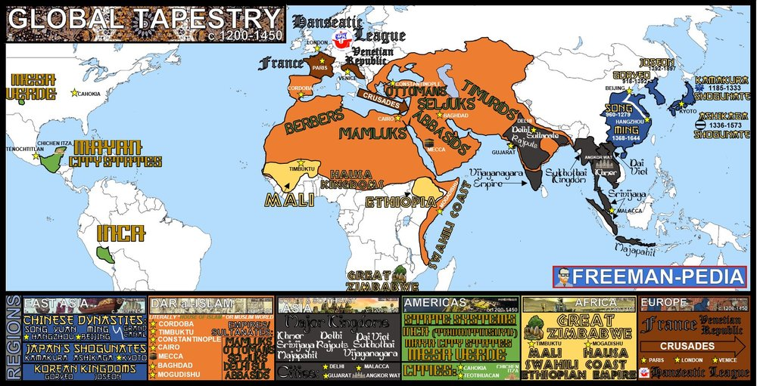

Topics of Study

Topic 1.1 Developments in East Asia 1200 - 1450: Ways of the World Ch. 8
Topic 1.2 Developments in Dar-al Islam 1200 - 1450: Ways of the World Ch. 9
Topic 1.3 Developments in South and Southeast Asia 1200 - 1450: AMSCO
Topic 1.4 State Building in the Americas 1200 - 1450: Ways of the World Ch. 6
Topic 1.5 State Building in Africa 1200 - 1450: Ways of the World Ch. 6
Topic 1.6 Developments in Europe 1200 - 1450: Ways of the World Ch. 10
Topic 1.7 Comparison in the Period from 1200 - 1450: AMSCO

AP WORLD 2021-22 - KELLY Name:

Chapter 8: Topic 1.1 Period:
Developments in East Asia from 1200-1450
Topic 1.1: Developments in East Asia from 1200-1450

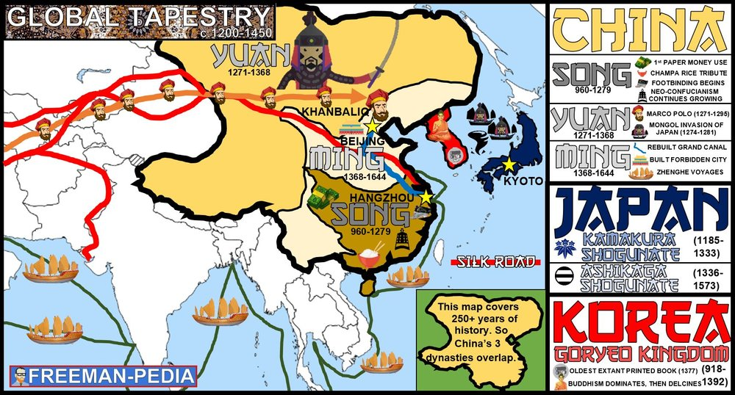

Introduction
Empires and states in Afro-Eurasia and the Americas demonstrated continuity, innovation, and diversity in the 13th century. This included the Song Dynasty of China, which utilized traditional methods of Confucianism, and an imperial bureaucracy to maintain and justify its rule. Chinese traditions continued, and they influenced neighboring regions. Buddhism and its core beliefs continued to shape societies in Asia and included a variety of branches, schools, and practices. The economy of Song China became increasingly commercialized while continuing to depend on free peasant and artisanal labor. The Song economy also flourished as a result of increased productive capacity, expanding trade networks, and innovations in agriculture and manufacturing.

Suggested Skill: Contextualization
4.A Identify and describe a historical context for a specific historical development or process.
See attachment titled “Ballad of Mulan and Analects Discussion”.

Learning Outcomes:
Thematic Focus: Governance - A variety of internal and external factors contribute to state formation, expansion, and decline. Governments maintain order through a variety of administrative institutions, policies, and procedures, and governments obtain, retain, and exercise power in different ways and for different purposes.
EQ #1: EXPLAIN the systems of government employed by Chinese dynasties and how they developed over time.
____________________________________________________________________________________________________________________________________________________________________________________________________________________________________________________________________________________________________________________________________________________________________________________________________________________________________________________________________________________________________________________________________________________________________________________________________________________________________________________________________________________________________________________________________________________________________________________________________________________________________________________________________________________________________________________________________________________________________________________________.
Thematic Focus: Cultural Developments and Interactions- The development of ideas, beliefs, and religions illustrates how groups in society view themselves, and the interactions of societies and their beliefs often have political, social, and cultural implications.
EQ #2: EXPLAIN the effects of Chinese cultural traditions on East Asia over time.
____________________________________________________________________________________________________________________________________________________________________________________________________________________________________________________________________________________________________________________________________________________________________________________________________________________________________________________________________________________________________________________________________________________________________________________________________________________________________________________________________________________________________________________________________________________________________________________________________________________________________________________________________________________________________________________________________________________________________________________________.
Thematic Focus: Economic Systems- As societies develop, they affect and are affected by the ways that they produce, exchange, and consume goods and services.
EQ #1: EXPLAIN the effects of innovation on the Chinese economy over time.
____________________________________________________________________________________________________________________________________________________________________________________________________________________________________________________________________________________________________________________________________________________________________________________________________________________________________________________________________________________________________________________________________________________________________________________________________________________________________________________________________________________________________________________________________________________________________________________________________________________________________________________________________________________________________________________________________________________________________________________________.

Illustratives Examples to know:
- Cultural traditions:
  - Filial Piety in East Asia
  - Influence of Neo-Confucianism and Buddhism in East Asia
  - Confucian traditions of both respect for and expected deference from women.
  - Chinese literary and scholarly tradition, and their spread to Heian Japan and Korea.
- Branches of Buddhism:
  - Theravada
  - Mahayana
  - Tibetan
- Technological innovations
  - Champa RIce
  - Transportation innovations, like the Grand canal Expansion
  - Steel and Iron production
  - Textiles and porcelains for export.

AP WORLD 2021-22 - KELLY Name:

Chapter 9: Topic 1.2 Period:
Developments in Dar al-Islam from 1200-1450
Topic 1.2: Developments Dar al-Islam

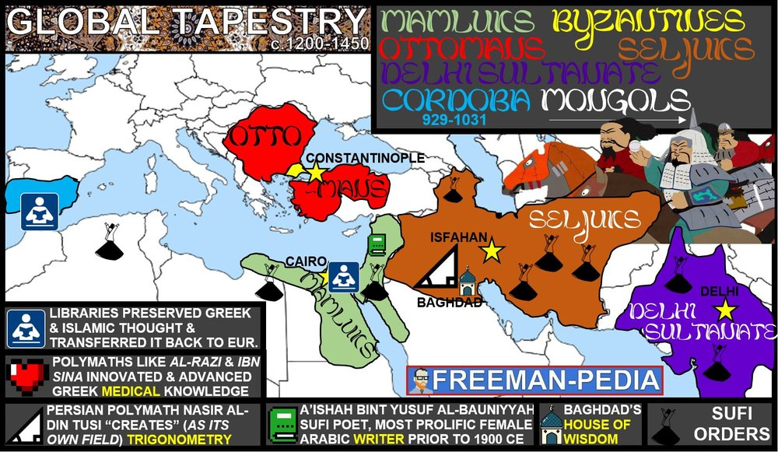

Introduction
Islam, Judaism, Christianity, and the core beliefs and practices of these religions continued to shape societies in Africa and Asia. As the Abbasid Caliphate fragmented, new Islamic political entities emerged, most of which were dominated by Turkic peoples. These states demonstrated continuity, innovation, and diversity. Muslim rule continues to expand to many parts of Afro-Eurasia due to military expansion, and Islam subsequently expanded through the activities of merchants, missionaries, and Sufis. Muslim states and empires encouraged significant intellectual innovations and transfers.

Suggested Skill: Claims and evidence in Sources
3.A Identify and describe a claim and/or argument in a text-based or non-text -based source.
See attachment titled “Muslim Thinkers and Innovators”

Learning Outcomes:
Thematic Focus: Cultural Developments and Interactions- The development of ideas, beliefs, and religions illustrates how groups in society view themselves, and the interactions of societies and their beliefs often have political, social, and cultural implications.
EQ #1: EXPLAIN how systems of belief and their practices affected society in the period from 1200 - 1450.
____________________________________________________________________________________________________________________________________________________________________________________________________________________________________________________________________________________________________________________________________________________________________________________________________________________________________________________________________________________________________________________________________________________________________________________________________________________________________________________________________________________________________________________________________________________________________________________________________________________________________________________________________________________________________________________________________________________________________________________________.
Thematic Focus: Governance - A variety of internal and external factors contribute to state formation, expansion, and decline. Governments maintain order through a variety of administrative institutions, policies, and procedures, and governments obtain, retain, and exercise power in different ways and for different purposes.
EQ #1: EXPLAIN the causes and effects of the rise of Islamic states over time.
____________________________________________________________________________________________________________________________________________________________________________________________________________________________________________________________________________________________________________________________________________________________________________________________________________________________________________________________________________________________________________________________________________________________________________________________________________________________________________________________________________________________________________________________________________________________________________________________________________________________________________________________________________________________________________________________________________________________________________________________.
Thematic Focus: Technology and Innovation - Human adaptation and innovation have resulted in increased efficiency, comfort, and security, and technological advances have shaped human development and interactions with both intended and unintended consequences.
EQ #1: EXPLAIN the effects of intellectual innovations in Dar al-Islam.
____________________________________________________________________________________________________________________________________________________________________________________________________________________________________________________________________________________________________________________________________________________________________________________________________________________________________________________________________________________________________________________________________________________________________________________________________________________________________________________________________________________________________________________________________________________________________________________________________________________________________________________________________________________________________________________________________________________________________________________________.

Illustratives Examples to know:
- New Islamic political entities:
  - Seljuk Empire
  - Mamluk Sultanate
  - Delhi Sultanate
- Innovations:
  - Advances in Mathematics (Nasir al-Din al-Tusi)
  - Advances in Literature (‘A’ishah al-Ba’uniyyah)
  - Advances in Medicine
- Transfers:
  - Preservation and commentaries on Greek moral and natural philosophy
  - House of Wisdom in Abbasid Baghdad
  - Scholarly and cultural transfers in Muslim and Christian Spain

AP WORLD 2021-22 - KELLY Name:

AMSCO: Topic 1.3 Period:
Developments in South and Southeast Asia from 1200-1450
Topic 1.3: Developments in South and Southeast Asia

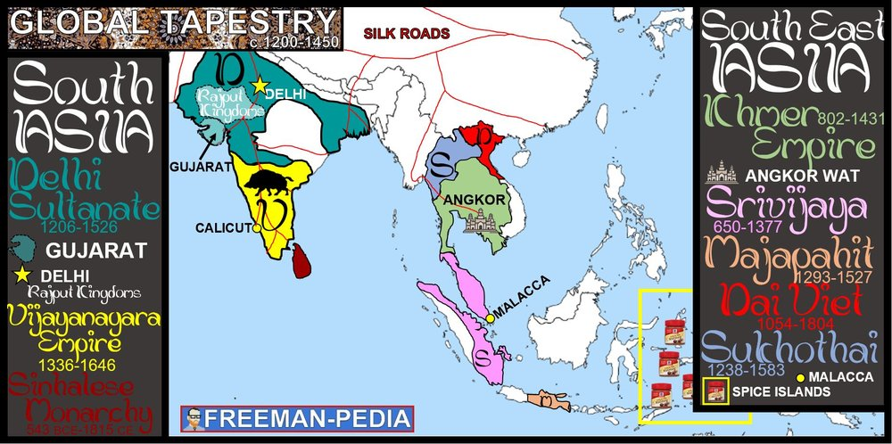

Introduction
Hinduism, Islam, and Buddhism, and their core beliefs and practices, continued to shape societies in South and Southeast Asia. State formation and development demonstrated continuity, innovation, and diversity, including the new Hindu and Buddhist states that emerged in South and Southeast Asia.

Suggested Skill: Claims and evidence in Sources
3.A Identify and describe a claim and/or argument in a text-based or non-text-based source.
See attachment titled “Southeast Asia Architecture Analysis”.

Learning Outcomes:
Thematic Focus: Governance - A variety of internal and external factors contribute to state formation, expansion, and decline. Governments maintain order through a variety of administrative institutions, policies, and procedures, and governments obtain, retain, and exercise power in different ways and for different purposes.
EQ #1: EXPLAIN how and why various states of South and Southeast Asia developed and maintained power over time.
____________________________________________________________________________________________________________________________________________________________________________________________________________________________________________________________________________________________________________________________________________________________________________________________________________________________________________________________________________________________________________________________________________________________________________________________________________________________________________________________________________________________________________________________________________________________________________________________________________________________________________________________________________________________________________________________________________________________________________________________.
Thematic Focus: Cultural Developments and Interactions- The development of ideas, beliefs, and religions illustrates how groups in society view themselves, and the interactions of societies and their beliefs often have political, social, and cultural implications.
EQ #2: EXPLAIN how the various belief systems and practices of S and SE Asia affected society over time.
____________________________________________________________________________________________________________________________________________________________________________________________________________________________________________________________________________________________________________________________________________________________________________________________________________________________________________________________________________________________________________________________________________________________________________________________________________________________________________________________________________________________________________________________________________________________________________________________________________________________________________________________________________________________________________________________________________________________________________________________.

Illustratives Examples to know:
- Beliefs and Practices:
  - Bhakti movement
  - Sufism
  - Buddhist monasticism
- Hindu/Buddhsit states:
  - Vijayanagara Empire
  - Srivijaya Empire
  - Rajput Empire
  - Khmer Empire
  - Majapahit
  - Sukhothai Kingdom
  - Sinhala dynasties

AP WORLD 2021-22 - KELLY Name:

Chapter 6: Topic 1.4/1.5 Period:
State Building in the Americas & Africa
Topic 1.4: State Building in the Americas

Introduction
In the Americas, as in Afro-Eurasia, state systems demonstrated continuity, innovation, and diversity, and expanded in scope and reach. New civilizations, such as the Mayans, the Aztecs, and the Incas rose in the same regions as previous begin civilizations. As in Afro-Eurasia, several of these civilizations developed strong states, large urban centers, and complex belief systems. Current knowledge about these civilizations combines archeological evidence, oral traditions, and writings by Europeans who came to the Americas after 1492.

Suggested Skill: Claims and Evidence in Sources
3.B Identify the evidence used in a source to support an argument.
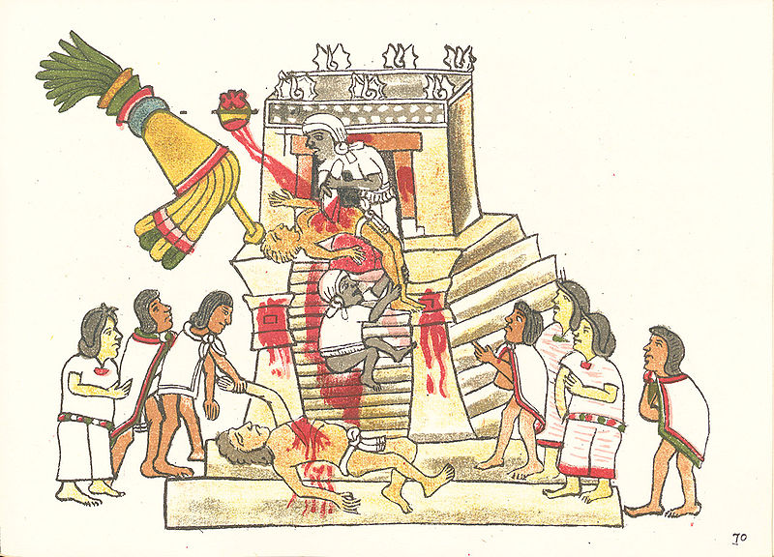
The Codex Magliabecchi from which the above illustration is taken is an ancient manuscript that offers historians a primary source with possible evidence about Aztec society. If you were developing an argument about the Aztec population’s attitude toward religion, what evidence might you use from this illustration, and what argument might it support?
________________________________________________________________________________________________________________________________________________________________________________________________________________________________________________________________________________________________________________________________________________________________________________________________________________________________________________________________________________________________________________________________________________________________________________________________________________________________________________________________________________________.

Learning Outcomes:
Thematic Focus: Governance - A variety of internal and external factors contribute to state formation, expansion, and decline. Governments maintain order through a variety of administrative institutions, policies, and procedures, and governments obtain, retain, and exercise power in different ways and for different purposes.
EQ #1: EXPLAIN how and why states in the Americas developed and changed over time.
____________________________________________________________________________________________________________________________________________________________________________________________________________________________________________________________________________________________________________________________________________________________________________________________________________________________________________________________________________________________________________________________________________________________________________________________________________________________________________________________________________________________________________________________________________________________________________________________________________________________________________________________________________________________________________________________________________________________________________________________.

Illustratives Examples to know:
- Maya City-states
- Mexica
- Inca
- Chaco
- Mesa Verde
- Cahokia

Topic 1.5: State Building in Africa
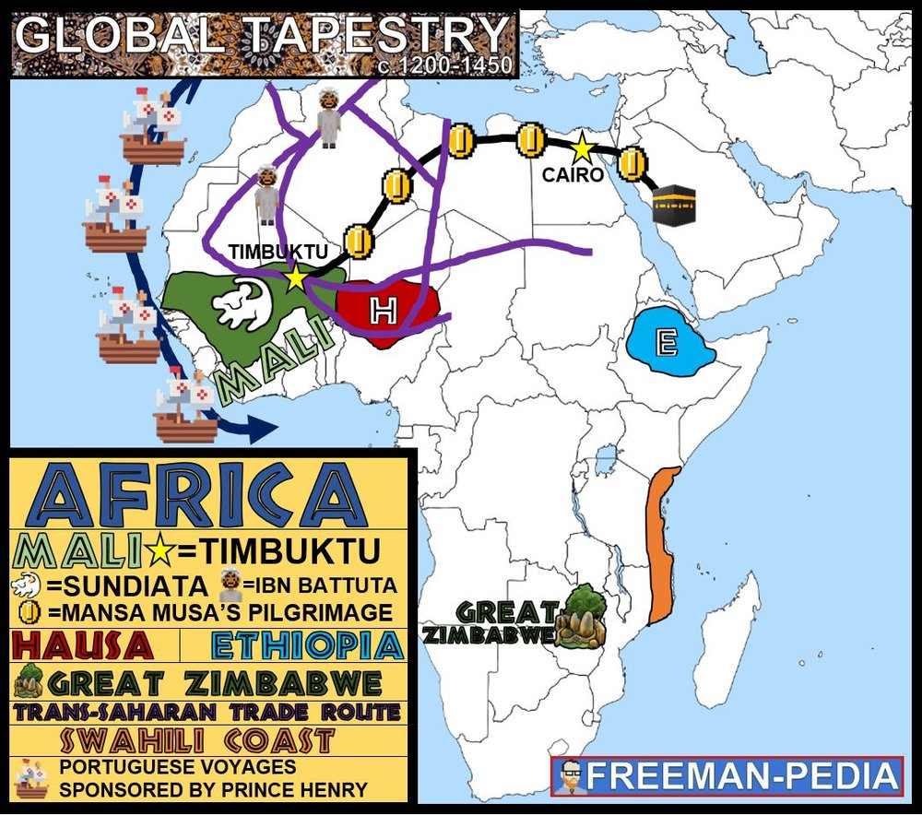

Introduction
In Africa, as in Eurasia and the Americas, state systems demonstrated continuity, innovation, and diversity, and expanded in scope and reach. When historians refer to Africa in premodern times, they are speaking generally of a geographic concept, a continental landmass, and not a cultural identity. Few, if any, people living on the continent at that time thought of themselves as Africans. Like Eurasia or the Americas, Africa hosted numerous separate societies, cultures, and civilizations with ast differences among them as well as some interactions between them.

Suggested Skill: Developments and Processes
1.B Explain a historical concept, development, or process.
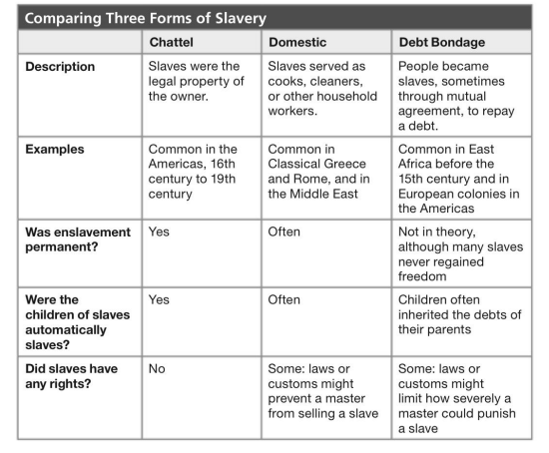
Prisoners of War, debtors, and criminals were often enslaved. Most women and some men served in households. In many kin-based societies, people could not own land privately but they could own other people. Owning a large number of enslaved people, increased one’s social status. What historical concept, development or process is depicted in the chart above and what claim can you make based on this evidence? __________________________________________________________________________________________________________________________________________________________________________________________________________________________________________________________________________________________________________________________________________________________________________________________________________________________________________________________________________________________________________________________________________________________________________________________________________________________________________

Learning Outcomes:
Thematic Focus: Governance - A variety of internal and external factors contribute to state formation, expansion, and decline. Governments maintain order through a variety of administrative institutions, policies, and procedures, and governments obtain, retain, and exercise power in different ways and for different purposes.
EQ #1: EXPLAIN how and why states in Africa developed and changed over time.
____________________________________________________________________________________________________________________________________________________________________________________________________________________________________________________________________________________________________________________________________________________________________________________________________________________________________________________________________________________________________________________________________________________________________________________________________________________________________________________________________________________________________________________________________________________________________________________________________________________________________________________________________________________________________________________________________________________________________________________________.

Illustratives Examples to know:
- Great Zimbabwe
- Ethiopia
- Hausa Kingdoms

AP WORLD 2021-22 - KELLY Name:

Chapter 10: Topic 1.6 Period:
Developments in Europe from 1200 - 1450
Topic 1.6: Developments in Europe from 1200 to 1450
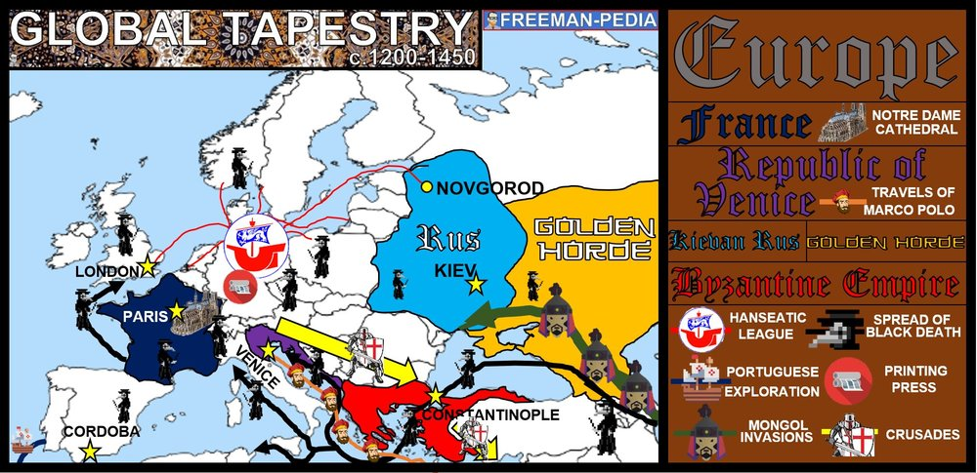

Introduction
Between c. 1200 and c. 1450, states in core areas of civilization grew larger while smaller states declined. In this way, much of the world followed the same trend of building more centralized, more powerful states. However, the process varied from place to place. In most of Asia, the military strength of the Mongols created the largest land-based empire in world history. In West Africa, the Middle East, trade, both internal and with the more advanced civilizations of the Middle East, had a greater impact.

Suggested Skill: Developments and Processes
1.A Identify a historical concept, development, or process.
See “Europe 1200 - 1450 - document Analysis Activity”

Learning Outcomes:
Thematic Focus: Governance - A variety of internal and external factors contribute to state formation, expansion, and decline. Governments maintain order through a variety of administrative institutions, policies, and procedures, and governments obtain, retain, and exercise power in different ways and for different purposes.
EQ #1: EXPLAIN the causes and consequences of political decentralization in Europe from c. 1200 to c. 1450.
____________________________________________________________________________________________________________________________________________________________________________________________________________________________________________________________________________________________________________________________________________________________________________________________________________________________________________________________________________________________________________________________________________________________________________________________________________________________________________________________________________________________________________________________________________________________________________________________________________________________________________________________________________________________________________________________________________________________________________________________.
Thematic Focus: Cultural Developments and Interactions - The development of ideas, beliefs, and religions illustrates how groups in society view themselves, and the interactions of societies and their beliefs often have political, societal, and cultural implications.
EQ #1: EXPLAIN how the beliefs and practices of the predominant religions in Europe affected European society.
____________________________________________________________________________________________________________________________________________________________________________________________________________________________________________________________________________________________________________________________________________________________________________________________________________________________________________________________________________________________________________________________________________________________________________________________________________________________________________________________________________________________________________________________________________________________________________________________________________________________________________________________________________________________________________________________________________________________________________________________.
Thematic Focus: Social Interactions and Organization - The process by which societies group their members and the norms that govern the interaction between these groups and between individuals influence political, economic, and cultural institutions and organization.
EQ #1: EXPLAIN the effects of agriculture on social organization in Europe from c. 1200 - 1450.
____________________________________________________________________________________________________________________________________________________________________________________________________________________________________________________________________________________________________________________________________________________________________________________________________________________________________________________________________________________________________________________________________________________________________________________________________________________________________________________________________________________________________________________________________________________________________________________________________________________________________________________________________________________________________________________________________________________________________________________________.

AP WORLD 2021-22 - KELLY Name:

AMSCO: Topic 1.7 Period:
Comparison in the Period 1200 - 1450

Introduction
Between c. 1200 and c. 1450, states in core areas of civilization grew larger while smaller states declined. In this way, much of the world followed the same trend of building more centralized, more powerful states. However, the process varied from place to place. In most of Asia, the military strength of the Mongols created the largest land-based empire in world history. In West Africa, the Middle East, trade, both internal and with the more advanced civilizations of the Middle East, had a greater impact.

Suggested Skill: Argumentation
6.A Makes a historically defensible claim
See “APWH LEQ Organizer”

Learning Outcomes:
Thematic Focus: Governance - A variety of internal and external factors contribute to state formation, expansion, and decline. Governments maintain order through a variety of administrative institutions, policies, and procedures, and governments obtain, retain, and exercise power in different ways and for different purposes.
EQ #1: EXPLAIN the similarities and differences in the processes of state formation from c. 1200 to 1450.
____________________________________________________________________________________________________________________________________________________________________________________________________________________________________________________________________________________________________________________________________________________________________________________________________________________________________________________________________________________________________________________________________________________________________________________________________________________________________________________________________________________________________________________________________________________________________________________________________________________________________________________________________________________________________________________________________________________________________________________________.

